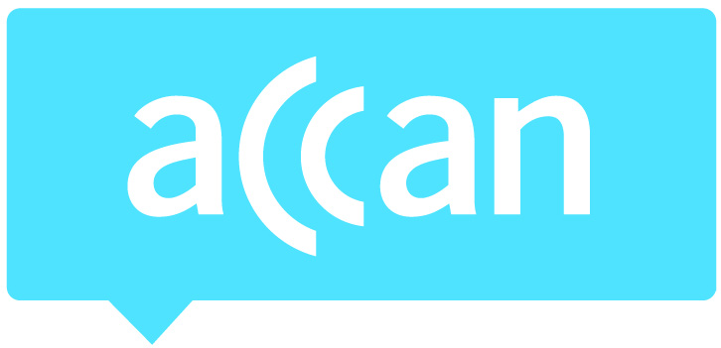
For immediate release 20th April 2015

Website blocking bill should address legality of VPNs to reduce piracy
In a submission on the Copyright Amendment (Online Infringement) Bill 2015, the Australian Communications Consumer Action Network (ACCAN) has called on the Government to remove ambiguity around Virtual Private Networks (VPN) and subject the scheme to a cost benefit analysis.
Online piracy is a significant issue in Australia which has been caused by a lack of access, delayed release dates and affordability of content. Giving consumers’ choice will solve the worst of the piracy problem, so the introduction of streaming services such as Netflix, Presto and Stan is a positive step. The bill requires the blocking of websites which ‘facilitate’ copyright infringement. This may pick up a number of VPN services which allow Australians to buy content overseas.
“Many Australian consumers are already using Virtual Private Networks to access content that is geo-blocked in Australia, but there is much ambiguity around the legality of these,” said ACCAN CEO, Teresa Corbin. “The Bill is an opportunity to clarify the status of VPNs so that these services are not themselves subject to blocking, limiting consumer access to paid overseas content.”
Under the Bill, a judge will be required to consider the ‘public interest’ before ordering a website block, but there is no way for affected parties to give evidence on the public interest. In these cases the judge may solely rely on the word of a rights holder before deciding to shut down a website. ACCAN believes that the quality of the evidence for assessing the public interest could be improved if people whose rights are affected are allowed to give evidence.
ACCAN also recommends that the Government conduct a cost benefit analysis of the Bill before it is implemented. Dutch research found that site blocking against file sharing often has an immediate effect, but this fades out after a period of six months as new sources of pirated material emerge.
“Our concern is that this website blocking Bill may become an expensive game of ‘whack-a-mole’ with consumers footing the bill,” said Ms. Corbin.
For more information, please contact Luke Sutton on 0409 966 931 or luke.sutton@accan.org.au.

