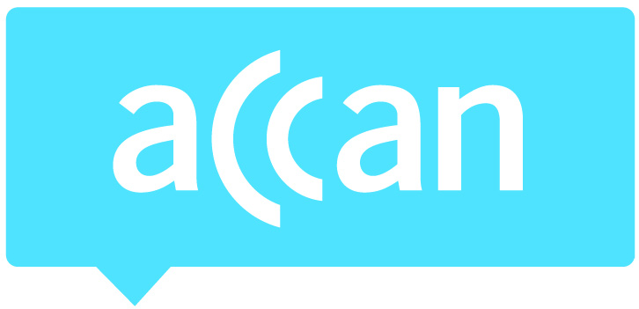
For immediate release 15th April 2015

ACCAN congratulates Netflix on introducing Audio Description
The Australian Communications Consumer Action Network (ACCAN) congratulates Netflix on its introduction of Audio Description for its original programming. In a blog post, the streaming service announced that it will offer Audio Description on select titles, beginning with its new series, Marvel’s Daredevil. Audio Description will also be rolled out to previous seasons of its original programs including House of Cards, Orange is the New Black, Unbreakable Kimmy Schmidt and Marco Polo.
Netflix’s announcement overnight follows the launch of the ABC’s Audio Description trial on its iview catch-up service which launched yesterday. Audio Description is additional verbal narration that describes visual elements shown on screen during pauses in dialogue. It can describe elements such as scenes, costumes and actions.
“This is a significant step towards making content more accessible for consumers who are blind or have a vision impairment,” said ACCAN Disability Policy Advisor, Wayne Hawkins. “However, our initial experience viewing content using a screen reader on the Netflix platform presented accessibility issues.”
“People who are blind or vision impaired need to be able to access the service independently and with the same functionality that sighted users have when navigating the platform. We look forward to improvements in the service that will make it accessible to all consumers.”
ACCAN has been calling on Australian TV networks to introduce Audio Described content for a number of years. With the launch of Netflix, Presto and Stan, a lack of Audio Described content on these streaming services has also been apparent. It is hoped that the launch of Audio Description on Netflix and the ABC iview trial will lead to Audio Described content being available on more streaming services and TV networks.
Netflix has said that it is committed to expanding its catalogue of Audio Described content for its English-language movies and TV shows. It will also look into adding Audio Description in other languages in the future and it will work with studios and content owners to increase the amount of Audio Description across a range of devices.
For more information, please contact Luke Sutton on 0409 966 931 or luke.sutton@accan.org.au.

