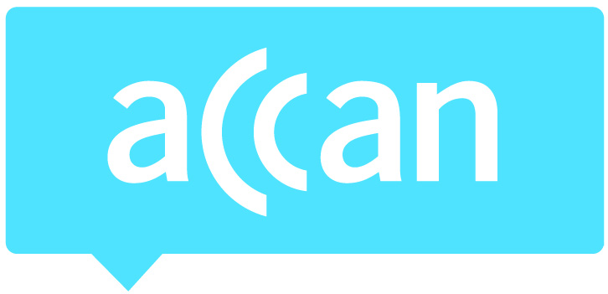
For immediate release 13th March 2015

ACCAN opens up discussion on the Universal Service Obligation
The ACCAN event Rethinking the Universal Service Obligation (USO), held in Sydney yesterday, aimed to open up discussion about the USO, and unravel the issues confronting consumers, policy makers and industry in a rapidly changing communications landscape.
The USO is a fundamental consumer protection that ensures a standard telephone service (generally fixed line voice services) and pay phones are accessible to all people in Australia.
“As the technology we use evolves and is used to access more and more services, it’s important to examine the current Universal Service Obligation to ensure it is still fit for purpose,” said ACCAN CEO, Teresa Corbin. “Our sessions throughout the day saw some interesting debate and discussion on what services consumers require today and into the future and how to ensure the right protections are in place. These discussions with stakeholders and key industry players will help inform ACCAN’s work in this area.”
"Complexity and telecommunications go hand in hand. A perfect example is the arrangements that guarantee the delivery of a minimum level of services to consumers and how this is funded. We found international comparisons are a useful guide, because USOs exist in some form in most countries.”
ACCAN research has found that in some countries, access to broadband and mobile services are included as essential services for every citizen. This policy often complements other targeted arrangements to support inclusive and affordable access to telecommunications. Australia has several approaches; a USO for telephones and payphones and a National Broadband Plan for broadband and targeted schemes for mobile. ACCAN believes this could be streamlined to deliver better services for consumers especially with emerging developments in E-government.
Paul Fletcher MP, Parliamentary Secretary Assisting the Minister for Communications, delivered the keynote presentation at the event. His presentation covered the purpose of the USO, questions regarding the current USO as well as some possible reform directions. The speech can be accessed online.
The Forum was attended by a broad range of delegates from consumer organisations such as Broadband for the Bush, the Isolated Children’s Parents Association, and the Indigenous Remote Communications Association, as well as the telco industry, government, academics and telco industry experts. Rosemary Sinclair, Chair of the last Regional Telecommunications Review, facilitated the event.
Topics included shortcomings in current arrangements, which services will qualify in the future, and how these services could be delivered in an NBN environment.
“Whatever form a future USO takes it’s clear that is must provide accessible and affordable telecommunications for all Australians,” added Ms Corbin. "ACCAN will continue to work with stakeholders to ensure that a future USO would also support new initiatives for government services that emerge as a result of the establishment of the Digital Transformation Office.”
For more information, please contact Luke Sutton on 0409 966 931 or luke.sutton@accan.org.au.

