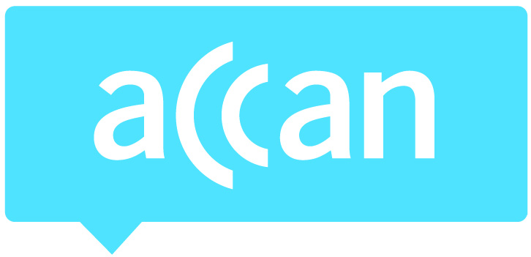
- For immediate release 6am AEDT Thursday 20th March 2013

Data still a problem for consumers, while NBN connections a cause for concern
MEDIA
CONTACT
Mark Callender
Mobile: 0409 966 931
mark.callender@accan.org.au
Phone: 02 9288 4017
TTY: 02 9281 5322
The Australian Communications Consumer Action Network (ACCAN) is Australia’s peak communications consumer organisation. The operation of ACCAN is made possible by funding provided by the Commonwealth of Australia under section 593 of the Telecommunications Act 1997. This funding is recovered from charges on telecommunications carriers.
Peak communications consumer group ACCAN says quarterly complaints data released today by the Telecommunications Industry Ombudsman (TIO) shows an overall decrease in complaints, yet excess data charges and connections in NBN areas are a concern.
While ACCAN welcomes the overall decrease in complaints, in particular mobile coverage complaints, too many consumers are still running into data bill shock on their smartphone, tablet or Wi-Fi dongle.
“The combination of smartphones, tablets, 4G speeds, and the abundance of apps means consumers can chew through their data allowances quicker than ever,” says ACCAN spokesman Mark Callender. “We’re concerned with these increases in data bill shock,” says Mr Callender.
In addition to the increase in excess data charge complaints, there’s been a 14% increase in complaints regarding a lack of SMS usage notifications – the tool specifically designed to curb mobile bill shock. SMS alerts are required to be sent to customers when they hit 50%, 85% and 100% of their mobile usage allowance, however sometimes consumers never receive them or they are too late. Telstra has recently made a commitment to introduce real-time billing.
“We’re encouraging all providers to introduce real-time billing to make sure their customers stay clear of bill shock,” says Mr Callender.
ACCAN is also concerned with a significant number of complaints in current NBN rollout sites. Kiama in NSW and Ngunnawal in ACT both figured in the top complaint suburbs for their respective states regarding connection delays, strongly suggesting that residents are having issues connecting to the NBN. This is of particular concern for parts of Kiama, as the existing copper network is set to be switched off in May 2014. Some Ngunnawal residents will have their existing connections switched off in December 2014.
“We are extremely concerned that some residents may not be connected to the NBN when the existing copper lines are switched off. This affects everyone with a home telecommunications service, even those who only use a landline phone,” says Mr Callender.
NBN Co strongly recommends that consumers order a service at least 8 weeks before the copper cut-off date to allow enough time to install and connect NBN equipment. ACCAN has heard of consumers waiting over three months to get an NBN connection.

Telstra recently made a submission to the NBN “cost-benefit analysis and review of regulatory arrangements”, stating that the NBN migration process was not running according to plan. Telstra stated that they are required to disconnect copper for premises that have been passed by the NBN, but there are no assurances that these premises are actually connected to the NBN before the copper’s switched off.
“As Telstra has suggested, the government should be taking another look at this issue. Residents should not be left in limbo regarding something as important as their home phone or internet connection,” says Mr Callender.
Ends
Media contact: Mark Callender 0409 966 931 / 02 9288 4017 or mark.callender@accan.org.au

