Connectivity and digital inclusion in the Northern Gulf: Participant-focused report
Dr Amber Marshall
Professor Allan Dale
April 2019
Connectivity and digital inclusion in the Northern Gulf: Participant-focused report
Authored by Dr Amber Marshall and Professor Allan Dale
Published in 2019
The research project was funded by a grant from the Australian Communications Consumer Action Network (ACCAN).
The operation of the Australian Communications Consumer Action Network is made possible by funding provided by the Commonwealth of Australia under section 593 of the Telecommunications Act 1997. This funding is recovered from charges on telecommunications carriers.
The Cairns Institute, James Cook University
Website: https://www.cairnsinstitute.jcu.edu.au/
Email: cairnsinstitute@jcu.edu.au
Telephone: +61 7 4232 1888
Australian Communications Consumer Action Network
Website: www.accan.org.au
Email: grants@accan.org.au
Telephone: 02 9288 4000
If you are deaf, or have a hearing or speech impairment, contact us through the National Relay Service: https://www.communications.gov.au/what-we-do/phone/services-people-disability/accesshub/national-relay-service
ISBN: 978-1-921974-60-1
Cover image: Amber Marshall

This work is copyright, licensed under the Creative Commons Attribution 4.0 International Licence. You are free to cite, copy, communicate and adapt this work, so long as you attribute the authors and “The Cairns Institute, James Cook University supported by a grant from the Australian Communications Consumer Action Network”. To view a copy of this licence, visit http://creativecommons.org/licenses/by/4.0/
This work can be cited as: Marshall, A. & Dale, A. 2019, Connectivity and digital inclusion in the Northern Gulf: Participant-focused report, Australian Communications Consumer Action Network, Sydney.

Foreword
This research project is about giving a voice to cattle farmers in Far North Queensland (FNQ) who are among the most digitally excluded people in Australia (Thomas et. al., 2018). As a former resident of Chillagoe and remote parts of the Northern Territory I am familiar with the personal and economic challenges associated with getting connected and staying connected in the bush. I wanted, however, to explore issues beyond those of obtaining an internet connection (be it via a mobile network, NBN fixed wireless or satellite, or an ADSL phone line). I wanted to understand how internet connectivity (or, in some cases, lack thereof) impacts the lives and livelihoods of agricultural communities in the Far North, including the social and economic impacts of poor connectivity. Primarily, I wanted to find out how the internet helps (and hinders) people to get things done and lead happy, healthy lives in the bush. This includes staying connected to friends and family; establishing, operating and expanding businesses; and participating more generally in the ‘digital economy’ beyond geographic isolation.
To conduct the research, I partnered with the Northern Gulf Resource Management Group, a community-based natural resource management (NRM) organisation working with property owners to balance economic, cultural and environmental interests in managing land in the region. Between June and October 2018, I attended social and educational events across the Gulf Savannah in Mareeba, Chillagoe, Almaden, Mount Surprise and Georgetown. I was also privileged to visit several properties, including Sugarbag Yards, Wetherby Station and Pinnarendi Station. These visits enabled me to see firsthand the on-farm connectivity setup and spend more time talking with people, which provided me deeper insights into how households and businesses rely on and use internet in the bush. This provided the basis for three case studies, which accompany this report.
In this report I will share what those who participated in the study told me about how the internet and telecommunications generally impacts their lives, for better or for worse. By analysing these insights and drawing out key themes, I make some broad observations about critical issues regarding bush internet, specifically in agricultural contexts. I also make suggestions for what could be done to improve digital inclusion in rural FNQ.
The research was funded by the Australian Communications Consumer Action Network (ACCAN), which is Australia's peak body for consumer representation in communications. I was employed by The Cairns Institute at James Cook University under the supervision of Professor Allan Dale for the duration of the project. I also received support and guidance from Associate Professor Michael Dezuanni from the Digital Media Research Centre at the Queensland University of Technology.
Dr Amber Marshall
Adjunct Research Fellow
The Cairns Institute
James Cook University

Table of Contents
Foreword i
Table of Contents ii
Introduction iii
Methodology 1
Digital inclusion in households 2
“Layering-up” of internet services and devices 2
Data is a contested resource, but people manage 3
Internet use across generations and gender 4
Digital inclusion in the community 6
Critical operations rely on internet connectivity 6
Progression and reputation of FNQ cattle industry 8
Expectations and fairness 9
Digital inclusion ‘in between’ households and communities 10
Summary of Findings 12
Recommendations 13
References 16
Authors 17

Introduction
This research investigates digital inclusion in FNQ agricultural communities. It builds on findings from the Australian Digital Inclusion Index (ADII), which is an annual nation-wide survey of access and affordability of internet services, as well as digital ability (people’s capacity to use the internet in daily life). Each year, 50,000 people are surveyed across these three indices: access, affordability, and digital ability. The ‘perfectly included’ individual would score 100, with the average Australian scoring 60.2 in 2018.
In 2018, the average Queenslander scored 58.9. Digital inclusion was 8.5 points higher in capital cities (62.4) than in country areas (53.9). Figure 1 below shows that North West Queensland (52.8) – which includes rural FNQ - is the least digitally included region in Queensland. Furthermore, ADII reports explicitly suggest that more work is needed to understand the needs, issues, challenges and opportunities for digital inclusion in rural and remote areas (Thomas et. al. 2017, 2018). This project is a direct response to this challenge.
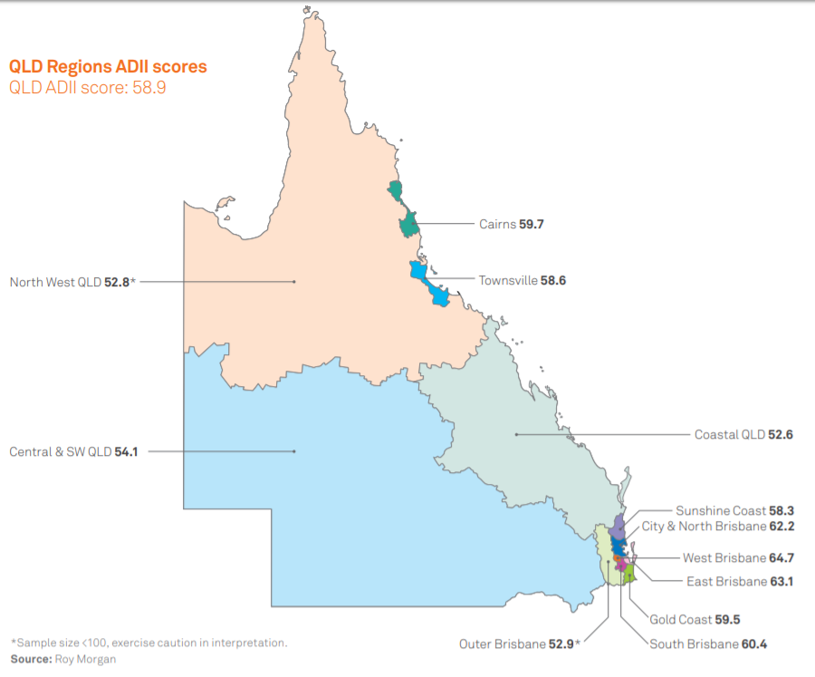

Figure 1: Australian Digital Inclusion Index scores in Queensland, 2018.
Digital inclusion is important to rural and remote communities because being online enables people to participate in modern society. According to the Australian Digital Inclusion Index (2018), “digital inclusion is not just about computers, the internet or even technology. It is about using technology as a channel to improve skills, to enhance quality of life, to drive education and to promote economic well-being across all elements of society.”
Lower levels of digital inclusion in rural and remote Australia can be explained somewhat by the comparative lack of telecommunications infrastructure to support internet access and telecommunications services across our vast country (Rooksby, Weckert & Lucas 2002; Willis and Tranter 2006). This has been compounded by instability in telecommunication and internet policy and operations in Australia. For example, the Universal Service Obligation (USO), a promise by the federal government that all Australians will have access to telecommunications, has been updated many times but continues to be contentious (Freeman & Park 2015).
Readers will be aware that the design and rollout of the National Broadband Network (NBN) has been fraught, particularly in sparsely populated areas. As a rule, the fixed line services offered in urban areas are faster and more reliable than fixed wireless and satellite in remote areas and experience less value for money. Therefore access, availability, affordability and quality of internet services in Australia – the underpinnings of digital inclusion – depend significantly on where you live.
This report aims to unpack how low levels of digital inclusion impact rural FNQ individuals, families and communities across all aspects of life: business, social life, education and health.

Methodology
In 2018 I took three data collection trips of one week each to the Gulf Savannah (a sub-region of FNQ) during which time I shadowed Northern Gulf’s drought ambassador Kathy Rowling and her colleagues. At events and station visits, I conducted interviews and focus groups to try to understand the specific challenges and opportunities for digital inclusion in the Gulf Savannah.
In May I had the pleasure of attending the Basalt Bash in Mount Surprise, an event focused on empowering remote women, providing practical knowledge and skills, and giving them a chance to take a break from life on the land. These women were extremely generous with their time and insights into how internet connectivity is managed in their households where there are competing demands from school-aged kids, farm workers and visitors. In August I attended events and visited stations in Chillagoe, Almaden, Mount Surprise and Mount Molloy. I gained insight into the online reporting and training required of property owners at a toolbox talk in Almaden. I sat with the entrepreneurs at Bush Business in Mareeba, and chatted with the families at Wetherby and Sugarbag Yards. Finally, in October I joined several of John Feehan’s Dung Beetle Workshops (hosted by Landmark) in Almaden, Georgetown, and Pinnerandi Station where I concluded my data collection and consolidated observations from previous trips.
I had the opportunity to speak with a very broad range of farmers from Normanton to Mareeba, large and small business owners, and multiple generations (sometimes on the same property). During each of my encounters – whether it was chatting over coffee or sitting down for a formal interview – I learned new things about the unique challenges and opportunities faced by of the individuals, families and businesses. There was a huge array of opinions, experiences and emotions to be garnered, from contentment and optimism to frustration and disillusionment.
I now present some key insights from this project. The aim is to combine what was told to me with existing research to provide new insights into the reality of digital inclusion in rural Australia, particularly in communities and in households across the Gulf Savannah. These insights will be discussed in relation to the three pillars of digital inclusion: access, affordability and digital ability.

Digital inclusion in households

“Layering-up” of internet services and devices
Households in rural FNQ connect to the internet in various ways. They use several different devices (e.g. mobile phone, desktop computer, tablet etc.) to access various internet services (e.g. 3G/4G, satellite, fixed wireless etc.) through many different providers (e.g. Telstra, Optus, Activ8Me, Harbour ISP etc.). Many households employ a complex combination of these digital technologies and services in ways that are largely determined by geographic location. The research suggests two typical arrangements:
- Rural properties are close to town (within about 5-10km) and generally have 3G or 4G mobile coverage (albeit intermittent/unreliable in places) and/or access to NBN fixed wireless, and sometimes an ADSL connection.
- Remote properties are situated out of town (sometimes hundreds of kilometres) and are out of proximity to mobile and fixed wireless coverage. People in these regions principally access the internet via satellite and use mobile phones when in range.
People under both arrangements continue to rely on more traditional telecommunications such as landlines, two-way radios and satellite phones/sleeves for day-to-day living and business operations. Many participants from both groups expressed frustration with unreliable internet connections, slow speeds, data capping and shaping, comparative cost of plans, and lack of technical support and installation delays, which have previously been documented by BIRRR and others.
Congestion on internet networks (mobile and NBN) was a recurring point of contention, mainly because it forces consumers to do essential (and non-essential) tasks at unconventional hours. Farmers told me about paying wages in the middle of the night because the web-based system is inaccessible in daylight hours. Others told me that they download their favourite Netflix shows when they wake up in the morning (say 6am, which is off-peak as defined by the telco) so they can watch them later in the day (say 8pm, which is on-peak as defined by the telco).
Contrary to my expectations, however, I found that the most disgruntled consumers are not those that live in the most remote areas; they are those living on the cusps of towns. These consumers “layer-up” on several services - including one or more mobile accounts, fixed wireless, ADSL and landline phones - in the hope that one of them will work at any given time. On the other hand, in very remote areas where there is no promise of mobile service or fixed wireless, people seem to be relatively content with satellite internet, notwithstanding data caps and speed issues. In cases of emergency, for example, very remote consumers have other systems in place to raise the alarm, including two-way radio, satellite phones, emergency position indicating radio beacons (EPIRB), and landlines.
This finding has implications for affordability. People on rural properties (and some remote properties) often pay for multiple plans which they must access through multiple devices, which also cost money. Furthermore, they often must deal with several internet providers because there is no “one stop shop” for internet service provision (e.g. Telstra does not offer satellite plans) and many providers do not operate where participants live (e.g. Optus mobile coverage exists in Dimbulah but not Chillagoe). Not only do rural and remote consumers generally pay more for less in terms of data, speed, reliability and service, they do this for several devices with several providers.

Data is a contested resource, but people manage
Regardless of the type of internet connection participants have, almost all expressed frustration with data caps, costs and the times at which data is available. For example, people told me that data packs for mobile phone services are very expensive once the monthly allocation is used. Data is scarcest on remote properties with only satellite connection, which is capped at 60GB per month, with more than half the data only available in off-peak times (e.g. 12 midnight to 7am). Under these conditions – sometimes referred to as the ‘data drought’ - data management becomes complex and contested, which influences and informs domestic relationships and dynamics.
Unlike urban-dwellers who often have access to unlimited data, rural and remote consumers must manage their data as a finite resource across several people (e.g. adults, children, workers, visitors) and priorities (social life, business, schooling). The decision of which internet plan is suitable – and therefore what data package should suffice for household operations – is at the discretion of the bill payer. If the bill payer, often the most senior male on the property, does not place importance on digital activities, other family members can be digitally isolated, which may compound their sense of physical isolation. Furthermore, in instances where decision makers lack the will and/or skills to actively monitor use, data can be used up inadvertently - and very quickly - by visitors who may take the Wi-Fi connection for granted.
Deciding who gets ‘first dibs’ on data can be difficult when so much of modern life is reliant on internet connection. In rural contexts where traditional gender roles are prevalent, women often have the responsibility of prioritising domestic resources - of which internet is one – and many put their needs last. Furthermore, their own allocation could be largely consumed by administrative tasks for the house and business (many women do all the ‘books’ for several on-property businesses). This can mean women miss out on economic and social connections and opportunities that are critical to their own well-being.
Several women told me about elaborate, frugal and creative ways that they allocate and monitor data use over the course of the month. For example, one mother of two told me she allocates specific amounts of data to the farm business, the children’s education, and social life of the parents, and then allows her children to “go nuts” on YouTube on the seventh of every month before the new cycle begins (if there is any data left).
When there is enough data to go around (usually on properties closer to town and infrastructure), I observed women thriving through their connections on the internet. Women in regional, rural and remote areas are fast becoming recognised for their online community building and entrepreneurialism (e.g. WIRE), and the Gulf Savannah is no exception. For example, I saw women staying connected on Facebook across many thousands of kilometres and many months between events and meetings, such as Basalt Bash where they enjoy each other’s company in person. I also witnessed emerging female entrepreneurs from across the Gulf Savannah learning how to build their businesses – including administrative set-up, product development and marketing - which is mostly done online. Ironically, in some instances, women who get stuck with the book work (computer work is often classed as “women’s work”) have gained digital skills and connections that lead to more opportunities.

Internet use across generations and gender
Properties in rural FNQ often house several generations in multiple dwellings. Dwellings may share a single source of internet connection (e.g. ADSL distributed by Wi-Fi), each dwelling can have its own internet connection (e.g. mobile broadband), or some dwellings may have no connection at all (e.g. out of mobile service and Wi-Fi range). Clearly, then, the affordability of the internet and how costs are split between residents varies depending on availability of, and demand for, each type of connection.
On many properties, there is a hierarchy of residents: farm owners, their adult children, their young children, and workers. As a general rule, farm owners are older and, while they are still active on the farm, have handed much of daily operations to their adult children. These adults – some who have returned to the land after attaining their secondary and tertiary qualifications in regional or city centres – have their own school-aged children. Workers may be permanent or seasonal.
The level of interest in technology and digital activities varies across the generations. Typically, farm owners in their 60s and 70s are less interested and digitally literate than their adult children who have been exposed to the opportunities afforded by digital technologies and have acquired the skills to use them. Some of these adults who have entrepreneurial drive struggle to convince the farm owners (who hold the ‘purse strings’) to invest in digital technologies - such as weigh stations, drones and sensors - particularly in tough economic times where outlay for capital is risky. This can cause tension amongst family members, especially in relation to succession planning.
School-aged kids on properties also have varying levels of digital ability, which they acquire at school in town, via school of the air or homeschooling, or through mentoring by their parents/families. Children’s capacity to develop digital skills can be thwarted by issues relating to access and affordability, such as the ‘data drought’ mentioned earlier. Furthermore, some children in remote areas receive little or no digital mentoring (see Case Study 3 for an exception). While digital skills may not seem all that necessary for farm work, lack of digital skills will significantly thwart opportunities to work outside the family business or to evolve that business to improve productivity and compete in the digital economy.
I also found that remote men and women experience digital exclusion in different ways. Previously I mentioned that women’s access to the internet can be limited because there is simply not enough to go around. In my observation, men experience digital exclusion for different reasons including disinterest in, and lack of opportunities to learn about, digital technologies. Older men in particular who have spent their whole lives in the paddock have had little opportunity to go to school. They therefore have poor general literacy, which further inhibits their digital literacy. For these men it can be easier to ask other family members, such and their wife or children, to complete essential tasks online on their behalf, such as answering emails.
Across all generations and genders, where there was disinterest in digital technologies it seemed to be largely a case of ‘you don’t know what you don’t know’. Put another way, lack of exposure to digital technologies can mean rural and remote residents have little understanding of the opportunities connectivity could afford families, businesses and communities. And even when people are willing to learn, there are huge barriers to acquiring digital skills in the bush.
Notwithstanding access and affordability issues, rural and remote residents are isolated from programs and support that are readily available to city-dwellers (e.g. Tech Savvy Seniors). I spoke with people who try to teach themselves – or ask others to help – but are hampered by a lack of fundamental understanding of the logic of computing and the internet. This essential knowledge – such as how to use a folder structure, browse the web, and populate an online form - is taken for granted by ‘digital natives’ who grew up with technology.
There are virtually no digital literacy programs in FNQ apart from the ad hoc sessions run by community groups and councils. Furthermore, self-led online courses are largely inaccessible because they are too data heavy (e.g. videos cannot be viewed or downloaded). Some programs, such as Northern Gulf Resource Management Group’s (NGRMG) Bush Business, are offered in rural centres like Mareeba, but attendees must travel hundreds of kilometres and leave properties unattended in order to participate, which is often not possible.
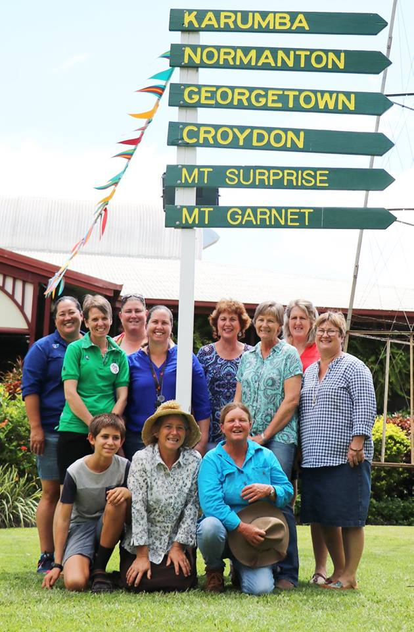
Image 1: Participants in NGRMG’s Bush Business program (Image courtesy of NGRMG).

Digital inclusion in the community

Critical operations rely on internet connectivity
The agricultural communities I visited in FNQ operate in an uncertain environment. While talking to people it became clear that several economic, social and environmental issues underpinned the challenges (and successes) people face in getting and staying connected in the bush. Drought, fires, attraction and retention of workers, and industry regulations all put financial, physical and emotional pressure on families, businesses and communities. The recent hundred-year flood event (which occurred after data collection and impacted some participants) only highlights and exacerbates the need for rural and remote people to be connected to each other and the outside world in times of crisis.
A key issue that stood out to me was FNQ cattle producers needing to comply with mandatory LPA accreditation requirements in various topics (e.g. biosecurity, livestock transport, animal welfare etc.). As is the trend with many government services, these modules are delivered online which presents obvious and significant challenges to many remote cattle producers. There are also new vegetation clearing laws in Queensland, whose property and vegetation maps are only available online.
I was able to sit in on several workshops run by Tahna Jackson from AgForce, designed to help people to access and complete an LPA compulsory accreditation module on animal welfare. Unfortunately, during the sessions in Almaden and Mount Surprise there were Telstra 4G outages, which caused delays and interruptions to learning, and many struggled to navigate the online platforms. At home, people experience problems completing these courses to a greater or lesser extent depending on where they live, the types of exposure to digital technologies they had, and their interest levels in getting online.
Many people I spoke with said that moving these compulsory courses online sets producers up for failure because many simply do not have the access or skills to deal with them. There are real risks to individuals, businesses and the cattle industry if producers cannot (or will not) get online to meet these obligations. I met several people who admitted that, if they were to be audited, they would be non-compliant, which could lead to fines or legal action.
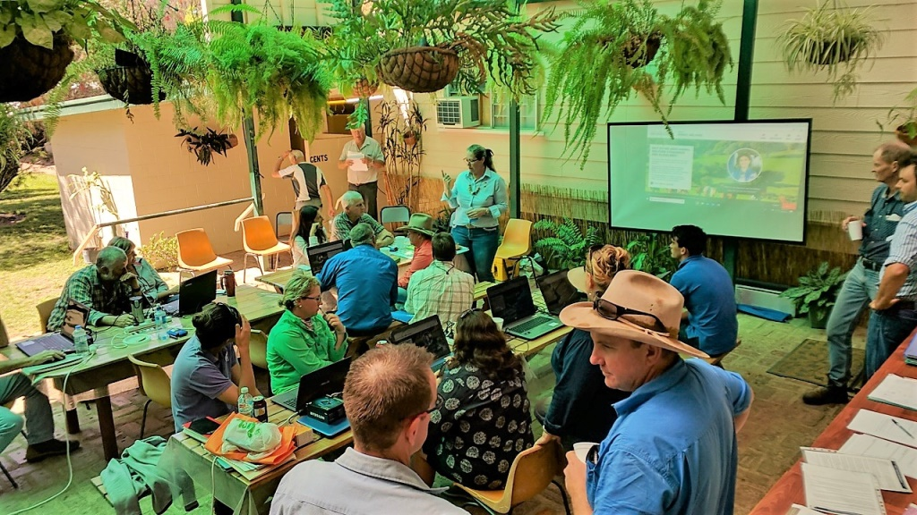
Image 2: Online LPA animal welfare module workshops at Northern Gulf’s toolbox talk, Almaden Pub.

Rural FNQ households are also increasingly reliant on mobile and internet coverage across properties and between townships. Mothers spoke to me about trouble coordinating school drop off and pick up (up to an hour each way), particularly if the mobile network is down, which is a common occurrence. Others spoke of their inability to respond to emergencies, such as a vehicle accident or bush fire, because of the limited options available to raise the alarm and coordinate resources. While two-way radios are tried and true technologies in the bush, they rely on people being in range and on the correct channel. This limits the network of respondents to those in physical proximity to the incident.
Emphasising the above, during the data collection I found it very difficult to get a hold of people via telecommunications. Mobile services or satellite connections were often down, sometimes for hours or days, as was the case when I visited Almaden, Chillagoe and Mount Surprise. This can be caused by interruptions to power which, unlike in the city, are frequent (also some remote people rely on generators which can fail). Secondly, reliable internet can often only be accessed from the farm house and participants were often in the paddock or on the road. I also found that people move around a lot - especially during mustering season - as they own several properties or are helping neighbours, making them even more difficult to reach via internet and telecommunications.
The point is, in so far as internet connectivity is essential to operations, it is the network that is critical. It is not enough to have an internet-connected PC in the home or office. Nor is it sufficient to have mobile broadband coverage in townships separated by enormous black spots. Families need to share Wi-Fi across several devices in the home, workers in the field need to communicate across the whole property (hundreds or thousands of acres), and businesses need to communicate and coordinate from and between townships (See case study 2 for more insight into the importance of the network).

Progression and reputation of FNQ cattle industry
Agricultural markets, trends, policies, regulation and processes are all changing rapidly, and most of the information, services and products needed to operate and compete in the digital economy rely on digital technologies and access. For example, industry updates are published on websites (e.g. Agforce), training videos are posted on YouTube, and animal auctions are conducted online (in tandem with the physical event).
I spoke with some operators who are investing in agtech (agricultural technology) (e.g. Gallagher’s weighing and EID, wireless monitoring and information software). While connectivity is still flimsy, they are hopeful that the mobile and broadband networks in the future will be able to give them return on investment. On the other hand, I found that many producers were struggling to get online and stay online, and were sceptical of investing. Therefore, some businesses struggle to remain up to date and grow their businesses.
In today’s fast-paced digital economy, it stands to reason that the FNQ cattle industry is at risk of falling behind owing to widespread lack of reliable access, high cost of digital devices and internet plans, and low levels of digital ability. For example, Meat and Livestock Australia’s Strategic Plan (2016-2020) says that to increase productivity and profitability across the industry, farmers need access to timely, accurate and relevant tools, technologies and information to better inform business decisions. This could include animal sensors, drones, geographic information system (GIS) and much more.
Contentious agricultural issues, such as drought assistance and animal welfare, are often raised and debated in the national (and international) media, including social media. Several people I spoke to expressed frustration with the spreading of misinformation about farming practices on Twitter and Facebook, where people from all sectors and walks of life weigh in on agricultural issues. Unfortunately, those at the forefront of the issues often cannot or do not participate in the conversation. I observed that lack of digital access and digital skills excludes many FNQ farmers from participating in the debates that impact them. As such, views are formed and decisions made about the cattle industry without proper understanding or consultation. Several people cited the live export ban of 2011 as an example of this.
Fiona Lake, an outback photographer and activist who presented at the Basalt Bash event in Mount Surprise, suggested that property owners should help protect the reputation of their industry by actively participating in online debate. She further stressed the need for property owners to have social media policies to provide their staff guidance on appropriate sharing of photos, videos, opinions and other content. There is a real risk that a photo posted online out of context (e.g. a calving complication) could go viral very quickly, with damaging social and economic consequences to the reputations of industry, communities, families and individuals. Advocacy bodies such as the National Farmer’s Federation (NFF) (national level), Agforce (state level) and NGRMG (local level) all play an important role in making informed representations for cattle farmers. However, empowering individuals to get online will bring more voices to public debate.
A key challenge is how FNQ cattle producers can acquire the skills to meaningfully and constructively participate online. It should not be taken for granted that people know how to actively manage their social media presence to help steer debate and combat inaccurate stereotypes (e.g. that farmers are uneducated, ultra conservative, environmental vandals, etc.). There is a distinct lack of programs and support available to rural and remote FNQ residents to develop these skills.

Expectations and fairness
There was a general sentiment amongst participants – particularly those on the fringes of urban areas - that internet service providers in rural and remote FNQ promise much but deliver little. The NBN promised broadband access for all, but many satellite and fixed wireless consumers in rural/remote areas experience connection delays, intermittent service and expensive plans. Telcos insist that, according to their service maps, there is 3G/4G coverage, but in reality, service can often only be obtained in certain corners of the house or property. Also, the lack of a reliable and full coverage signal between townships along the Savannah Way continues to be problematic.
Despite these issues, on the whole people reported that their basic needs were met by existing services. I observed that, for a modest household of 2-4 people who use the internet for essential services only (e.g. email, banking, basic web-browsing), their current connection is sufficient. This positive sentiment has steadily increased over the last few years with improvement to services, notably the stabilisation of NBN SkyMuster in rural and remote Australia more broadly (including new unmetered essential use) and expansion of the Mobile Black Spot Program.
Issues arise, however, when property owners wish to extend their businesses, children’s education, access to health services, or social participation beyond ‘survival mode’. In particular, participants expressed frustration that the limited data, slow speeds and unreliability of the internet prevented them from seizing economic opportunities, including investing in digital technologies, developing local and international markets, and up-skilling through online training and networking. It also seems that the gradual moving of critical government services to online platforms (e.g. MyGov, MyTax) has been undertaken by state and federal government with little consideration for how they can be accessed and used by people in rural and remote areas.
Overall, rural and remote residents do not expect the same internet options or services as city-dwellers. People I spoke to understand and accept that telecommunications infrastructure is difficult and expensive to build and maintain and they expect to deal with interruptions to services. In the face of challenges, participants overwhelmingly displayed a culture of ‘getting on with it’ by coping with outages, adapting their working times around high-congestion periods, and actively managing data consumption around the clock. People also respect that return on investment is difficult for telecommunications companies to achieve in sparsely populated areas but think that government has a role to play in ensuring all citizens receive essential services. Finally, people felt that city-dwellers tend to take internet connectivity for granted and that more could be done to educate across the physical and digital divide.
It is worth noting that not everyone in rural and remote FNQ is interested in joining the fast-paced digital world. For some, the internet is a threat to their quiet lifestyle and ‘tried and true’ farming practices that have sustained them for generations. For example, installation of some small cell 4G mobile phone towers required residents in some small towns to spend money upgrading their mobile phones to be able to access the service (they were previously happy with 3G service when they went into town). Also, some people expressed a preference for the physical cattle ledgers that go with the truck driver over the digital National Livestock Identification System (NLIS). Others saw responding to emails (e.g. from grey nomads and families who pay to camp in their property) as a necessary nuisance. By and large, however, people see the need to “get on board” even if they are not happy about it.

Digital inclusion ‘in between’ households and communities
The research further revealed a group of people who are almost always in transit. Contract mustering teams – complete with people, horses, vehicles and equipment - move around North Queensland, Northern Territory and Western Australia during the dry season herding cattle in some of the most remote parts of Northern Australia. Mustering teams of 8 to 10 people who may be contracted from 2 weeks to 4 months at a time often include young families, couples, and single men and women of varied ages. These people do not inhabit conventional households and communities such as those described above; for most of the year they live, work and play in camps that are set up out the back of large cattle stations, often a long way from the homestead (one person reported a distance of 60km).
Internet access for this group is intermittent to say the least. Some larger commercial operations provide Wi-Fi hot spots for their staff in the paddock via a satellite connection, sometimes with a ticketing system for data which is very limited. However, teams often rely solely on a satellite phone for communications with the outside world. If they have an urgent need to contact someone, the mustering boss will lend the satellite phone or a landline at the homestead is used. People told me that if someone needs to go into town for supplies during a job, they take everyone’s mobile phones with them so that the text messages can come through.
Many of the digital inclusion issues that were raised regarding households and communities are relevant, and sometimes exacerbated, in this group. The need to access social media is vital for this group. For example, social media is widely used for recruitment. Therefore, when they are in range, contract musterers are very active on Facebook, sharing stories and advertising jobs (e.g. Ringers from the Top End).
There are also unique connectivity-related issues for contract musterers, many of whom only access the internet on their mobile phone. We already know from the Australian Digital Inclusion Index (Thomas et al 2017) that mobile-only users are at a disadvantage because the functionality of apps on phones is substantially less than full websites on computers. It can therefore be much more difficult for mobile-only users – particularly those who spend large amounts of time out of range – to access online services, such as Centrelink, Medicare and banking.
Persistent lack of access can greatly impact individuals and families in these mustering teams who are seasonal, casual workers. One woman told me about her pregnant daughter who was working as a jillaroo on a remote property without phone or internet access. Not only could she not reach her daughter to check on her, but her daughter could not make medical appointments unless the team was in mobile range or she took unpaid time off work to travel to the nearby town for mobile phone reception.
Finally, these insights call into question the affordability of mobile-only internet connection. To get the best deal with phones included, jackeroos and jillaroos purchase one or two-year contracts with unlimited data, calls and texts (one person quoted $130/month). They only use the mobile regularly 3-4 months of the year, but unlimited plans are needed because when they are in range they are furiously catching up with family, friends and the world. The way mobile plans are structured does not accommodate this heavy use in short spurts.

Summary of Findings
In the digital age it is imperative that individuals, families and businesses are connected to the internet and each other. Yet in our vast and dispersed nation the reality is that all connections cannot be equal. But what should rural and remote FNQ residents reasonably expect? What would be a fair arrangement that would enable people to survive and thrive in rural and remote areas?
In speaking with people, several principles for understanding what is ‘fair’ came to the fore.
- We need people in rural and remote areas: Policy makers, industry representatives and everyday citizens should recognise that Australia needs people to live and work in rural and remote areas, including very hard-to-reach places. Agriculture is a key Australian industry that facilitates much economic activity in rural and remote areas. These people need to be supported and incentivised to stay.
- Telecommunications is an essential service: Decision makers need to truly accept that competing in the digital economy without connectivity is akin to trucking cattle interstate without highways. Where we need people and industry, we need roads, water, power and internet, and they must be affordable. Telecommunications are also essential for attracting and retaining a skilled and younger workforce.
- All Australians have a right to digital citizenship: Digital connectivity is not just an economic imperative, it is social one. All Australians have the right to access services and participate in civic life, which nowadays is principally achieved through the internet.
- People deserve to get what they are promised: Rural and remote consumers do not expect the unlimited data and fast internet speed that many city-dwellers have come to take for granted. But these consumers deserve to be told the truth about their internet options and for the chosen option to be delivered upon.
- Most (but not all) want to be connected: We should seek to understand what rural and remote farmers want and need from internet connectivity, and respect people’s desire to be connected or not. Governments should ensure people receive the education and options necessary to make informed choices about if and how they connect to the internet.
- Digital skills are key: Affordable access to internet services needs to be accompanied by digital skills so that people can put the internet to work to improve lives and livelihoods. Digital skills programs and resources need to be tailored to individuals’ needs and be delivered in communities, by communities.
- Prioritise the network, not just connections: A single point of connection on a farm provides limited scope for internal-based activities. The power of digital participation is in real-time and sustained connections being made across distance so that people can be responsive to opportunities and challenges.
If agreement on these principles could be achieved in local, state and federal governments, and in industry, this framework could be used as a basis for developing and improving telecommunications policy and programs in rural and remote areas, including in the Gulf Savannah.

Recommendations
Using the above-mentioned principle as a guide, I now make some more concrete recommendations and actions that could be adopted by governments, regulatory organisations and industry to help improve digital inclusion for FNQ (and other rural areas in Australia) in the short-medium term. I begin with digital ability-related recommendations, as I believe this is where the least is being done and where the greatest gains can be made. I follow with recommendations for improving accessibility and affordability which go hand in hand and conclude with a call for more support for local governments from state and federal levels to foster digital inclusion generally in their communities.
1. Deliver targeted digital ability programs
We need targeted digital ability programs to be delivered in rural FNQ that meet the specific needs of farmers. By targeted, I mean they should be delivered in local places, by local people, on local topics. Local councils (Mareeba, Etheridge, Croydon) could employ staff and/or volunteers to mentor their peers in topics and skills that matter in rural contexts, for example accessing essential government services (e.g. Medicare, ATO), completing online accreditation (e.g. MLA), using social media for business and social life (e.g. Facebook), and staying abreast of industry news and trends (e.g. Twitter, websites).
With support from State Government, these new and tailored programs could be delivered in libraries or town halls on the Savannah Way (e.g. Chillagoe, Georgetown, Mount Surprise) and funded through community development grants programs (e.g. Regional Development Association (RDA)). Another option is to introduce some existing community-based learning programs (e.g. Digital Springboard) into remote areas, but they would need to be adequately resourced and tailored to rural and remote learners.
2. Develop digital mentors and up-skill remote workers
In tandem with digital ability programs, we need to recruit, develop and support people in the community to become digital mentors. These digital mentors could perform both formal and informal mentoring. First, they could lead participants through formal courses (such as those mentioned above). Second, they could provide one-on-one, user-led support for people trying to get connected at home or in the community. Digital mentors could do much more than impart technical skills to others; they could empower others to improve their circumstances through digital participation.
Recruiting these mentors will be challenging, given the scarcity of people, time and resources in rural and remote areas. One idea is to up-skill people already working in remote areas to become digital mentors. Librarians, rural financial counsellors, drought ambassadors, natural resource management (NRM) workers and post office workers could help others in their communities to access and use digital technologies to assist them in everyday life. Digital mentors could do this by actively incorporating the internet and technology into discussions they already have with property owners. For example, searching weed management techniques online, applying for permits or grants, paying bills online, or building a social media profile for their business.
Finally, digital mentors working in rural and remote communities could be further educated about the types of issues underlying digital exclusion, such as those raised in this report, so that they can better reach and support people.
3. Embrace alternative modes of digital connectivity
In partnership with state government, local councils could invest in or subsidise alternative, innovative connectivity solutions that are reliable and cost effective in rural and remote areas. The standardised offerings of internet service providers (ISPs) and large telcos are not meeting the needs of rural families and businesses right now. DIY improvements to connectivity (such as Yagis) are often ineffective in remote areas and cause more frustration for consumers.
Small-scale, relatively cheap alternative technologies include on-property towers that can harness internet services from neighbouring towns and/or provide on-property networking of sensors, cameras, testers and devices (e.g. St George, South East Queensland). Further investment could be made into Long-Term Evolution (LTE) technology which distributes and amplifies existing connections (such as satellite) over greater distances (e.g. LTE trials in WA). As another example, WA farmers have partnered with the WA state government to connect 50 properties within a 100km radius to the NBN fibre optic network though a base station.
Not all these solutions will support data-hungry programs and services, the Internet of Things (IoT) and precision farming in the long term, but they will support basic on-property connectivity to enable localised networks that will, in turn, support critical operations and safety. Furthermore, investing in innovations by nimble providers who are filling gaps in the market not met by large telcos, promotes competition and may help future-proof telecommunications in remote areas.
4. Maintain and improve basic infrastructure and services
While telecommunication in rural and remote areas remains contentious, state and federal governments need to ensure energy and telecommunications infrastructure are reliable and affordable. This includes continuing to guarantee access to landlines and payphones (which is the case under the recently reviewed USO), continuing to pursue affordable energy to power telecommunications, and compelling energy and telecommunications providers to maintain assets and make repairs in a timely fashion.
Incremental improvements to rural consumers’ rights and offerings should continue to be made (e.g. recent NBN SkyMuster data changes). However, more drastic measures must also be taken to revise current offerings by NBN Co, ISPs and telecommunications providers to better meet the needs of rural and remote customers. For example, mobile broadband in small towns and along arterial routes often becomes overloaded at certain times of the day (e.g. after school hours), resulting in download speeds of only a few megabits per second. Therefore, capacity of these networks needs to be increased.
5. Redefine affordability
We need to redefine ‘affordability’ to include the reality of “layering up” of devices and services when developing telecommunications policy (e.g. Customer Service Guarantee) and doing research (e.g. Australian Digital Inclusion Index).
Current methods to determine affordability do not accurately depict the true cost and value for money of digital connectivity in rural areas. For example, the Affordability sub-index of the ADII has two components: Relative Expenditure (share of household income spent on internet access); and Value of Expenditure (total internet data allowance per dollar of expenditure).
These measures do not, however, include the cost to purchase and maintain hardware and software for the several devices that are necessary to access “layered up” services. Nor do they factor in the cost to businesses of delayed or lost opportunities owing to unreliable or inadequate internet service.
Furthermore, telecommunications service offerings (such as mobile phone plans) need to be more flexible and tailored to the needs and constraints of rural and remote consumers. A mobile phone plan that caters to heavy use in short spurts would be ideal for contract musterers, for example.
6. Empower rural local governments
This research has demonstrated that rural and remote households and communities face specific challenges and opportunities in relation to digital inclusion. Local governments are best placed to understand and support locals to overcome barriers to access, affordability and digital ability, but are vastly under-resourced compared to state and federal governments.
A Rural and Remote Digital Inclusion Strategy could be developed to assist small, rural councils to better support their communities towards digital inclusion. This could include information for community leaders (e.g. councillors) about access (including alternative/complementary infrastructure options), affordability (supplier options/offerings in rural areas), and digital ability (relevant to rural populations).
This toolkit could be developed in conjunction with state and federal policy, programs and funding designed to support digital inclusion in remote agricultural communities across Australia (See industry/policy-focused report).

References
Australian Digital Inclusion Index (2018) About Digital Inclusion in Australia, Retrieved 24 March 2019 from https://digitalinclusionindex.org.au/about/about-digital-inclusion/
Freeman, J., & Park, S. (2015). Rural realities. Transforming Government: People, Process and Policy, 9(4), 465-479.
Thomas, J, Barraket, J, Wilson, CK, Cook, K, Louie, YM & Holcombe-James, I, Ewing, S, MacDonald, T, (2018) Measuring Australia’s Digital Divide: The Australian Digital Inclusion Index 2018, RMIT University, Melbourne, for Telstra.
Thomas, J., Barraket, J., Wilson, C., Ewing, S., MacDonald, T., Tucker, J. & Rennie, E. (2017) Measuring Australia’s Digital Divide: The Australian Digital Inclusion Index (2017) RMIT University, Melbourne, for Telstra.
Rooksby, E., Weckert, J., & Lucas, R. (2002). The rural digital divide. Rural Society, 12(3), 197+.
Willis, S., & Tranter, B. (2006). Beyond the 'digital divide': Internet diffusion and inequality in Australia. Journal of Sociology, 42(1), 43-59.

Authors
Dr Amber Marshall
Dr Amber Marshall is an Adjunct Research Fellow to The Cairns Institute. In June 2014, Amber (and her park ranger husband) relocated from Brisbane to Kings Canyon – a national park 350kms SW of Alice Springs – where she completed her PhD (Digital Communications) from UQ Business School via unreliable satellite internet. Her struggles to stay connected in the desert fuelled her passion for her current research track. More recently she lived in Chillagoe and Croydon (both in rural/remote Far North Queensland) where she built the networks necessary to undertake research on digital inclusion in regional, rural and remote Australia. Amber is now a Research Fellow at the Digital Media Research Centre (Queensland University of Technology) where she is helping to develop a national research agenda for digital inclusion, particularly in rural and remote areas.

Professor Allan Dale
Allan Dale is a Professor of Tropical Regional Development at The Cairns Institute, James Cook University and a University Fellow with Charles Darwin University’s Northern Institute. Allan has a strong interest in integrated societal governance, with a particular focus across the tropical world, northern Australia and the Great Barrier Reef. He leads JCU’s contributions to Queensland’s Rural Economies Centre of Excellence (RECoE) and the Clean Growth Choices Program, the Human Dimensions of the GBR, the Northern Development agenda and emerging approaches to Collective Impact. He has both extensive research and policy expertise in building strong societal governance systems, but particularly those related to regional economic development, social development and natural resource management.

A few people mentioned use of a Yagi antenna to boost mobile signal, but they were not widely used by participants in this research.
Following the data collection period, NBN announced new SkyMuster plans that use of essential internet services (e.g. email, web browsing, critical software updates) will be unmetered.

