National Broadband Network:
A Guide for Consumers
A project prepared by the Internet Society of Australia (ISOC-AU) and the Australian Communications Consumer Action Network (ACCAN).

January 2012

This work is licensed under the Creative Commons Attribution-NonCommercial 3.0 Australia License. To view a copy of this licence, visit http://creativecommons.org/licenses/by-nc/3.0/au/

PREFACE

The internet has changed most people’s lives in the past decade. But the technology that enables us to get connected can seem hard to understand. This Guide will try to answer common questions about the internet, broadband connections and the National Broadband Network (NBN).

The following guide has been prepared on the basis of early plans for the design and rollout of the NBN and contains information which will be subject to change and further refinement. It has been compiled using information publicly available at the time of writing through NBN Co, government agencies, industry forums and standards bodies.

Check for current information with your service provider when making decisions about phone or broadband services.
THE BASICS: THE INTERNET AND BROADBAND

KEY POINTS TO KNOW:
- Broadband means a high-speed, ‘always on’, communications link that carries information between one location and another.
- Today, fixed broadband usually uses the copper-wire telephone network.
- You can use a broadband connection to access the internet or a range of other services which are separate from the internet.
- The National Broadband Network (NBN) is going to make available a very fast broadband link to just about everyone. It will mainly use fibre-optic cable.
- Fibre-optic cable has many advantages over other technologies.

What is Broadband?
The term broadband generally means a high-speed, ‘always on’, communications link that carries information between one location and another. A broadband link connects your premises to your service provider’s network. Major service providers are companies like Telstra, Optus, iiNet, Internode, Primus, TPG and others. These companies are also referred to as internet service providers (ISPs), although they usually sell both phone services and internet access.

Your broadband link goes through infrastructure like wires, poles, cables, antennas and dishes.

Today we use one of several existing technologies to connect households:

- pairs of copper wire running to the local telephone exchange (DSL or ADSL connection)
- co-axial cable also used to supply cable television (HFC cable)
- antenna and radio waves (WiMAX, WiFi, or satellite technologies)
These household connections are mostly considered to be 'fixed broadband' as distinct from ‘mobile broadband’ used via devices like mobile phones and iPads. Households with fixed broadband links have a cable, antenna or satellite dish to a small box on the side of the house or apartment building, with another cable going to a modem linked to your computer.
What is the difference between the internet and broadband?
While many people use the terms interchangeably, the internet is not the same thing as broadband. In fact, you can use a broadband link to receive many different services which are completely unrelated to the internet, such as videoconferencing, security monitoring and health monitoring services.

The internet is a collection of networks and computers all joined together using the same basic communications technology. A broadband service is simply a fast, always-on way of linking your premises to the internet and other services.

Think of the internet as a city. Broadband is the highway leading there.

You can connect to the internet without a broadband connection. For example some people still use a slow ‘dial-up’ connection using a phone call.

People subscribe to an internet service from an ISP. The ISP usually supplies you with a modem to plug into your computer. You link to your ISP’s network and then can access the internet to check your email, look at websites, do online banking or shopping, download podcasts, watch videos, share your photos, do social networking and everything else the internet offers.

Currently the majority of people can get a broadband connection using DSL over the telephone lines or with HFC cable. (See table: Current Broadband Technologies) If they can’t get these, they might have to use the much slower dial-up method via the phone, link through a satellite, or use fixed wireless.

Some houses in new estates are lucky enough to have fibre-optic cable, which means they can get a very fast broadband service.

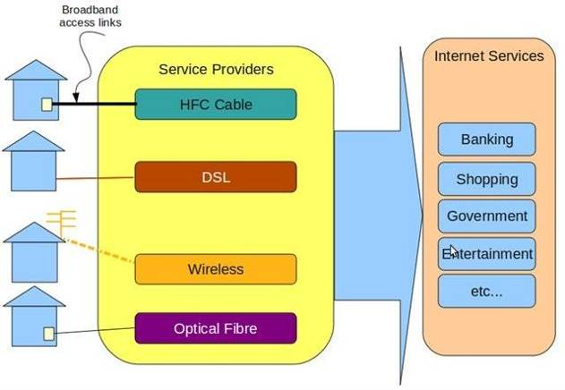

Service Type | Physical connection | Connection type | Household gadget | Peak Speed range | Practical Distance
DSL | Copper wire | Telephone plug | DSL modem | 0.5Mbps – 24Mbps | 400m – 4km
HFC Cable | Coaxial Cable | Customer Access Unit | Cable modem | 0.5Mbps – 100Mbps | 100km
WiFi | Public spectrum | Antenna | Wireless adaptor | 0.5Mbps – 50Mbps | 180 m
WiMAX | Licensed/Public Spectrum | Antenna | WiMAX modem | 10 Mbps | 30 km
Satellite | Licensed spectrum | Antenna | satellite modem | 1 Mbps – 12 Mbps | National
3G | Licensed spectrum | Internal antenna | Dongle / 3G modem | 100 Kbps – 3 Mbps (real-world average) | 5 km
FTTP | Fibre-optic cable | Termination unit | Gateway / router | 100 Mbps – Gbps | 20 km
Above: The table shows the differences between broadband technologies using commonly available equipment. Upload and download speeds have been combined and each can vary considerably. All figures are approximate and subject to change. Mbps = Megabits per second. Gbps = Gigabits per second.

Note that distances and speed can vary depending on local conditions, and all wireless systems, even mobile ones, can reach greater distances with a more effective antenna or when there are few users. Fixed antennas can give much greater speed and range than a mobile handset because they are bigger, and can be pointed very precisely towards the tower to pick up the maximum signal strength.

Speeds will be affected by:

- your computer’s hardware and software configuration
- connection method within the premises (wireless or fixed)
- type of content being downloaded
- source of the content being downloaded, and
- number of people within a residence using the service at the same time

Why build the NBN?

Access to the internet and new services

The technology available to most people today has limited coverage and variable performance. Many people cannot connect to any form of broadband at an affordable price.

Access to the internet used to be considered a luxury. But these days it is a necessity for many people. Many small and home-based businesses rely on always-on connectivity. For a person who is house-bound, or has school-aged children, reasonably fast access to the internet is essential for daily life, for participation in society and for success in education.

But it’s not only about fast internet. When all Australians have access to the NBN, it can begin to serve as the platform for the delivery of a range of government services, such as health and education, as well as a platform for new services.

The NBN will be an open platform for all service providers to use, so it will support fair competition that hopefully will benefit consumers.

More choice
Currently, a single broadband link can only connect to a single service provider. With the NBN, the single link will allow the household to access many different providers of internet and non-internet services at the same time.

Eventually you should be able to subscribe to education, security monitoring services and health monitoring services. Watching high-definition movies and TV programs (IPTV) and activities like high-definition videoconferencing will become much more common.

Different people in the same house will all be able to connect to different service providers at the same time. People in shared accommodation can therefore be billed individually.

In this sense, the NBN will be like a multi-lane highway: all types of vehicles can drive on it for all sorts of purposes.

How might people use high-speed broadband?
Jim has high blood pressure and some other health issues that need regular monitoring. Rather than queue for his local doctor every day, his health vitals are measured daily at home through a simple electronic system and sent through to his doctor. He spends the time he used to spend in the doctor's waiting room in the garden. Sometimes an appointment is made with his doctor or he has a video call with a nurse to discuss any changes in his condition. Jim doesn't use the internet at all.

Naomi is a qualified Japanese-English translator and runs her own translation business from a home office. In the past, she often missed out on lucrative jobs because potential corporate clients needed her to access their engineering databases overseas and view high resolution diagrams. Her ADSL internet connection was not fast enough for this type of work. Now she is able to take on new clients in the knowledge that her connection is fast enough both upstream and downstream.

Ben is a student doing a degree in sports science. He watches a lot of sports, listens to music online, chats with his friends and constantly posts updates on his favourite social networking site. He has an internet service plus a special education service from his university that guarantees his lectures and tutorials are fully interactive and the highest video quality. Ben has a significant physical disability, uses a wheelchair and sometimes finds it difficult to attend lectures in person, so it’s essential that his broadband connection is highly reliable.

Margaret is an active 90 year old who plays Scrabble online daily. She subscribes to a games pack where her Scrabble board is connected to four other players across the world. The board appears realistically on her computer screen and is also coupled with a rules advice service and a Scrabble dictionary. Margaret has live video calls with her online Scrabble friends, including her grandchildren, during the game. Margaret has a hearing impairment but the high resolution of the video allows her to lip-read. Margaret also buys a separate chat service and a book service.

Why fibre?
Fibre-optic cable (often shortened to “fibre”) has a number of distinct advantages over other technologies, such as the existing copper telephone wires, or wireless-based systems, and will continue to do so even as the technologies improve.

Some of these advantages are:

- Distance. Fibre can carry the signals at full speed from an exchange much further than ADSL and is immune from nearby interference. In contrast, ADSL over the telephone wires starts slowing down after one kilometre, and the signal disappears after about four kilometres.

Upstream speed. Most broadband networks today are like one-way roads. In the direction towards the house (known as the ‘downstream’ direction) they can go fairly fast. In the direction away from the house (‘upstream’) they are very slow. ADSL, which the majority of internet users have today, cannot go faster than 1 Mbps upstream, and even new 100 Mbps cable TV connections are limited to just 2 Mbps in the upstream direction. A few hundred photos might be downloaded in seconds. But to send that number of photos today takes hours and even days.

With fibre, the upstream speed can be faster than other technologies, enabling a whole range of business and creative activities that cannot be done today. Faster upstream speeds can be especially useful for video applications.

- More data capacity for each home and business. The NBN’s capacity will allow households and businesses to use a wide range of high bandwidth online applications, simultaneously.

- Stability and reliability of service. Fibre is a reliable broadband technology that supports applications that need guaranteed levels of performance.

- Future-proof speed. Fibre can support increasingly faster speeds simply by replacing the technology at each end. Fibre is more durable and should have a longer lifetime on average than metallic cables.

NBN: THE BASICS

KEY POINTS TO KNOW ABOUT THE NBN
- The National Broadband Network (NBN) is public utility infrastructure that will cover all premises in Australia.
- It is being built by NBN Co Limited – a wholly Government-owned company.
- The NBN will consist of fibre-optic cable to 93% of premises. The remaining 7% of premises mostly in rural and remote areas will get fixed wireless or satellite connections.
- You will still buy your phone and internet from service providers such as Telstra, Optus, iiNet, Primus and TPG. You won’t deal with NBN Co.
- Connecting your premises to the NBN doesn’t mean you have to sign up for a phone or internet service if you don’t want to.
- The NBN will be used first for the internet and for carrying phone calls, with more services such as TV, movies, video telephony, smart metering and health monitoring becoming available in the future.
- If you are happy with your existing phone handset, in most cases you can keep it.
- The existing copper-wire telephone network will be disconnected in stages as the NBN is rolled out. In wireless and satellite areas, the copper network will be maintained for at least 20 years.
- When you sign up for a service which uses the NBN, your service provider will arrange to have a Network Termination Device or “NBN box” installed inside your premises.
- NBN Co will provide a one-off back-up battery to people who get connected. This back-up battery will power a regular phone (not a cordless) for up to five hours in the event of a power failure.
- In apartment blocks, some equipment will be installed in a central location such as a basement and then each apartment will have its own NBN box.

So what is the NBN?
The National Broadband Network, known as the “NBN”, is a telecommunications network being constructed by NBN Co Limited, a company set up by the Commonwealth Government in 2009.

The NBN gives everyone a high-speed link between their premises and their service provider. Today this type of high-speed broadband is only enjoyed by a very small number of Australians. It is expected that the NBN will be fully completed by 2021.

What is the technology?
NBN Co will use three types of technology to deliver broadband to all Australians:

- Fibre-optic cable capable of delivering speeds of up to 100 megabits per second (Mbps) to 93% of premises;
- Fixed wireless and satellite connections capable of delivering up to 12 Mbps to the 7% of premises that are unable to be connected via the fibre-optic cables.
Fixed wireless and satellite will be used mostly in rural and remote areas.

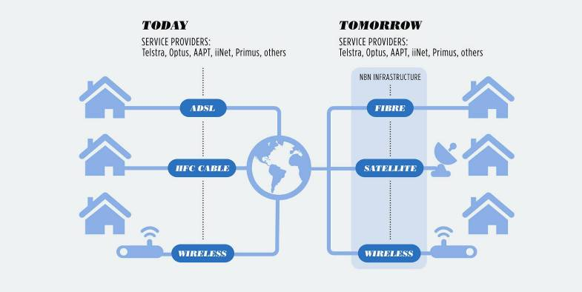
The difference between fixed and mobile wireless

For its fixed wireless service, NBN Co will control the number and strength of connections in each area, so they will be able to guarantee that each user will receive the full speed they have signed up for. This is in contrast to mobile broadband where the network is shared among users moving in and out of an area and the network slows down when many people are trying to use it.

Will I deal with NBN Co?
NBN Co won’t deal directly with consumers except during the installation of your NBN box. NBN Co deals with service providers and is required to allow all service providers to plug into the network for the same price.

You will deal with your service provider as you do now – i.e. companies such as Telstra, Optus, iiNet, Internode, Primus, TPG and others.

What will the NBN be used for?
The NBN is public utility infrastructure that will cover all premises. Think of it as similar to the power grid. A hundred years ago, the first electricity network was built for one purpose: street lighting. Much later, it started being used for indoor lighting in homes. Later still, it started being used for new appliances like electric stoves, heaters and refrigerators.

In the same way, the NBN will first be used for high-speed access to the internet and for phone calls. But soon it will start being used for a range of other services which are separate from the internet. In the future you may get TV delivered over the NBN, or you might have video consultations with your doctor, or a range of other in-home services.

What if I don’t want a phone or the internet?
Some people are worried they will be forced to pay for a service they don’t want. There is no need to worry. For example, currently almost all premises in Australia are connected to the phone network but that doesn’t mean everyone must sign up for a phone service.

Even if you don’t want any service, connecting to the NBN will at least ensure your premises are ready if you or someone else wants to sign up for a service in the future.

What if I’m happy with my current phone handset?
If you are happy with your existing phone handset and don’t want anything else, in most cases you can keep it. Note that some much older handsets (e.g. rotary dial ones with the finger wheel) will have to be replaced. When the NBN arrives in your area, you will just plug your phone into the NBN box.

How do I give permission?
When the NBN is ready in your area, NBN Co or your service provider will send you a consent form to fill out. Each property owner will be asked if they want their house, apartment or office connected to the NBN. At this initial stage, connection will be free and you won’t have to change your existing service if you don’t want to – your premise will simply be “NBN-ready”.

If you miss out on the initial connection opportunity, you can also arrange with your service provider to get connected later on.

To connect premises in strata units, NBN Co will need permission from body corporates. Renters will need to get approval from landlords.

In the meantime, be wary of unexpected door knockers seeking entry to your premises. Always check ID.

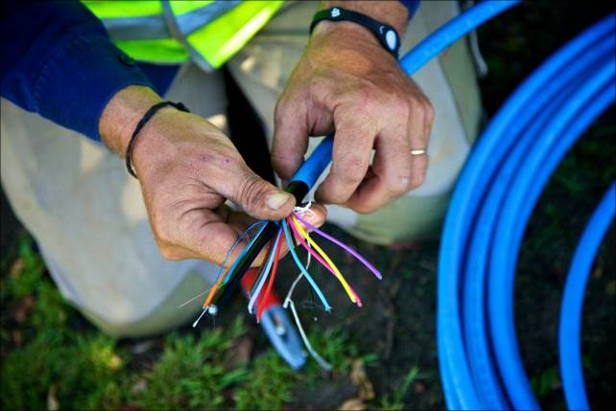

Will I get fibre, wireless or satellite?
NBN Co is currently developing detailed plans for which areas will get fibre-optic cable, fixed wireless or satellite services. See NBN Co’s maps and list of towns here. The construction plans for particular areas are being posted here as they are announced. Note that services will probably become available only around one year after construction starts in a particular area.

NBN Co will not know exactly which premises will get wireless or satellite instead of fibre until field surveys have been conducted on a site-by-site basis during the rollout.

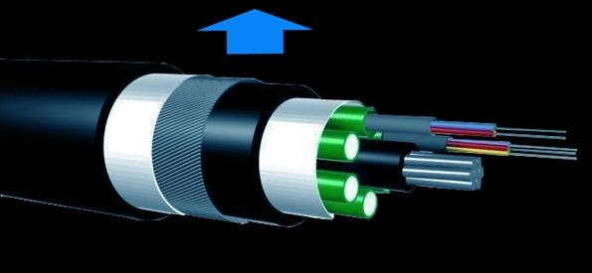

Above: Close-up of fibre-optic cable interior

GETTING CONNECTED TO THE NBN

KEY POINTS TO KNOW:
- An NBN Box will usually be placed inside your premises. The NBN box has 2 phone ports and 4 data ports.
- NBN Co will provide a one-off back-up battery. This back-up battery will power a regular phone (not a cordless) for up to five hours in the event of a power failure.
- When the NBN is being built in your area, NBN Co or your service provider will send you a consent form to fill out. Each property owner will be asked if they want their house, apartment or office connected to the NBN.
- If you don’t get connected during the construction period, your service provider will be notifying you later on when they are ready to move your service over to the NBN. They will seek your permission and arrange for the connection to be done at this time.
- Getting connected doesn’t commit you to immediately changing your existing service or signing up for a new service. However, around 18 months after the NBN fibre is ready in your area, the existing copper network will be switched off, so you would need to change to an NBN-based service by that date if you want to keep a fixed-line service.
- Note that in wireless and satellite areas, the existing copper network will be maintained for at least 20 years.

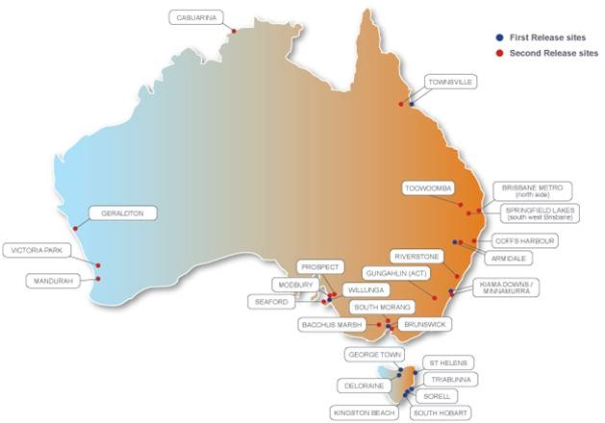

Above: First and second release sites. (Courtesy of NBN Co)

Check out the rollout schedule here.

What happens when the NBN arrives in my area?
When the NBN is ready in your area, and if you have consented, NBN contractors will extend a cable to your premises.

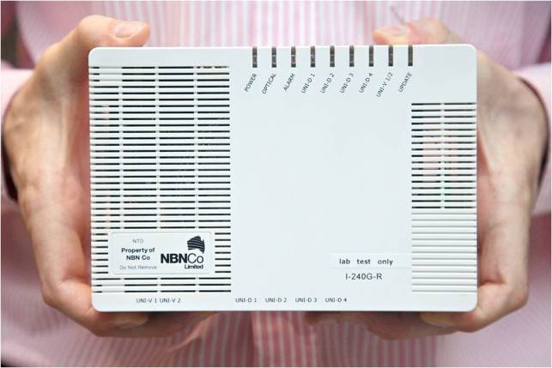

Above: The NBN Box (Courtesy of NBN Co)

When you sign up for an NBN-based service with your service provider, they will arrange for installers to come and put the Network Termination Device, or “NBN box” inside your premises. In a small number of cases, it may be placed on an outside wall. The NBN box has six ports: two for phones and four for internet and other data services. Someone will have to be home when the NBN box is being installed.

The NBN box is accompanied by a second box – the power supply unit with a back-up battery. You can choose where this unit will be placed, provided it is within NBN Co guidelines. NBN Co will provide instructions for all the equipment.

NBN Co installers will consult with you to determine the best place to put the NBN box. It will usually be placed somewhere near an existing power point so it can be easily plugged in.

For more detail on this, see two NBN Co booklets: NBN User Guide [pdf] and Preparing for the NBN [pdf]

Installation is being offered for free at the time of the initial rollout. If you have special requirements, it may involve some cost to you.

Remember, none of this commits you to changing your existing service immediately or signing up for a new service immediately. However, around 18 months after the NBN is ready in your area, the existing copper network will be switched off, so you would need to change to an NBN-based service by that date if you want to keep a fixed-line service.

What if I live in an apartment or other multi-dwelling unit?
In general, NBN Co will install fibre to every dwelling it can. Because there is a lot of variation in the layout and facilities in apartment buildings, the installers will check the buildings in advance and figure out the best way.

In some apartment buildings, they may need to install equipment in a central location, such as the basement of the building. This equipment will be owned by NBN Co, not by the building owner.

To connect premises in strata units, NBN Co will need permission from body corporates. Renters will need to get approval from landlords.

Underground or overhead?
If you are connected to the NBN by fibre, then the cable is likely to follow the same path as your current telephone wires. For the majority of premises this will be an underground cable, but there are also many premises where the existing copper wires are overhead. 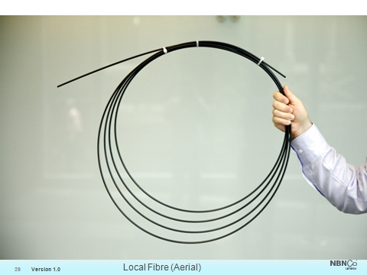

Above: Fibre-optic cable for overhead use. (Courtesy of NBN Co)

NBN Co will make these decisions on a case-by-case basis, so we can’t be sure what will happen in each case until the rollout is more advanced.

NBN Co is forecasting that around 25 percent of premises in the fibre area will be connected via an overhead cable from the existing street poles to a connection point on the eaves of premises.

If you are being provided with an NBN wireless or satellite connection, you will have an antenna and radio transmitter, most likely mounted on the roof or under the eaves. With a wireless connection, the antenna will be pointed to a nearby radio tower. With a satellite connection, a small dish will be pointed up to an orbiting satellite.

Should I connect now or later?
There are advantages in having the connection to your premises done at the time the network is first being rolled out. Advantages may include:

- Saving money on the installation. Connection is free at the initial rollout. It is uncertain whether people will have to pay if they decide to connect later;

- Avoiding hassles. Remember that around 18 months after the NBN fibre-optic cable is rolled out in your area, the existing copper-wire telephone network will be disconnected. When that happens, being connected to the NBN will be the only way to have a fixed-line phone service. To ensure you have an uninterrupted service, it makes sense to be connected at the start.

What if I’m renting?
If you are a tenant, there will be a procedure to follow which will be explained by either NBN Co or your service provider.

Once the NBN equipment is installed, tenants will be able to sign up for services without needing any further permission. Because there are four data ports on the NBN box, four people in a share house could each sign up for a different service with a different service provider and get separate bills.

What if I’m in a new development?
- If your development has 100 or more premises, was approved after 1 January 2011 and it is within the fibre area, NBN Co is responsible for installing fibre in your development. You are likely to get fibre ahead of the rest of the country. NBN Co requires developers to provide at least three months notice and to sign the NBN Co Developer agreement. Detailed information is here.

- If your development has less than 100 premises, Telstra will provide the usual copper wiring or other interim solutions until NBN Co comes to your area as part of its normal rollout timetable.

- Telstra is also responsible for wiring up developments of any size approved prior to 1 January 2011 that are still awaiting infrastructure.

Developers can choose another provider to install fibre if they want to.

Will my service change when the NBN arrives in my area?
Merely having an NBN cable connected to your house doesn’t mean anything will change.

If you have an existing service and don’t do anything, your service provider will notify you when they are ready to move your service over to the NBN. This will happen to everyone some time before the copper-wire telephone network is disconnected.

You may receive promotional material about new deals for higher speed internet. Whether your service will stay the same or you move to a new plan is a matter for you.

If you are shopping around, the various service providers will be able to advise you when they are ready to support services using the NBN in your area.

As always when changing to a new provider, you should check whether or not you are in the middle of a contract term with your existing provider. If you are, they may charge you exit fees or contract break fees.

What do I do when the switch-over happens?
You will need to unplug your phone from the current socket and plug it into the socket in the NBN box. If you have the internet, you plug your network cable into the NBN box. Your service provider may provide help with this.

Whether you are a new or continuing customer, your service provider might need to send you a new router or arrange for a technician to come out and check or install cabling before the service can be activated.

For more detail on this, see two NBN Co booklets: NBN User Guide [pdf] and Preparing for the NBN [pdf]

While your service provider and NBN Co coordinate the arrangements, your existing service will continue to work unchanged.

In most cases, when your equipment is disconnected from the old network and reconnected to the new network, your service should only be out of action for a few minutes.

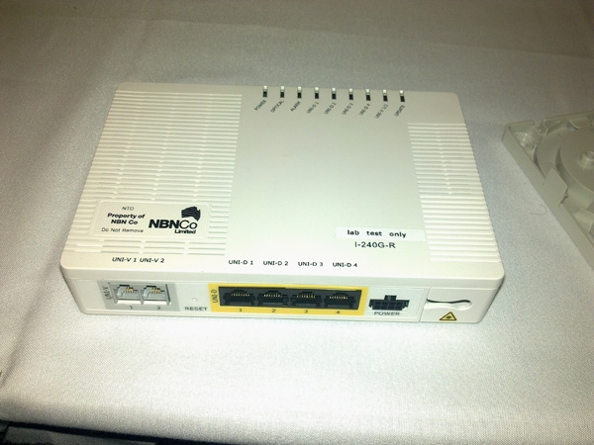

Must I get every service from the same service provider?
No. This is one of the powerful benefits of the NBN. Today’s technology can usually connect to only one service provider. In contrast, each port on the NBN box could potentially be connected to a different service provider and each service can be used simultaneously.

AFTER THE NBN SWITCH-OVER
KEY POINTS TO KNOW:
- Your phone number will stay the same.
- Prices will be set by service providers as happens now.
- Billing won’t change.
- In most cases, your regular phone handset will still work.
- You will contact emergency services in the same way as you do now.
- People with disabilities will still be able to use TTY’s and the National Relay Service.
- If you have a security alarm or a personal alarm that works by making a phone call, you should talk to your provider and check if the equipment will continue to work through the NBN.

What will I pay?
Service providers will decide on what prices will be. Expect to see advertising and promotion as the NBN begins to roll out. Current pricing examples are: iiNet, Internode or Exetel (See also: What makes up the price I am charged for broadband?)

Will my billing change?
Billing is expected to stay much the same. Some service providers offer a ‘bundle’ of services (voice, broadband, data services) for which you get only one bill, the same will be true with services over the NBN.

You will most likely be offered packages from a provider: phone, internet access, entertainment (TV channels, movies, gaming), security, education or health services – and your provider will most likely send one bill for all the services they sell you.

On the other hand, you may choose to have different service providers for different services: one for your phone, one for the internet, and yet another for entertainment services. In that case, you will be billed separately by each provider.

This explosion of choice may be a challenge for some households to manage – especially families with children and share houses where everyone wants something different.

Will my regular phone still work?
Yes. If you get fibre, the NBN box in your home will have two conventional phone ports. You will be able to plug a normal phone into these ports. The NBN equipment will convert the signals from the regular phone into signals that will travel over the new network. Note that some much older handsets (e.g. rotary dial ones with the finger wheel) will have to be replaced.

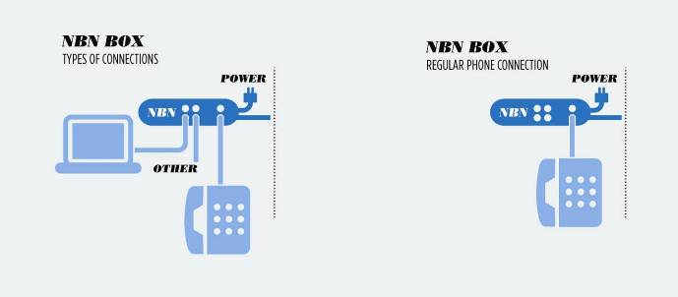

What about other devices?
If you have an IP telephone or internet VoIP service, you will use it through an internet service.

People with a security alarm, a personal medical alarm system or other system that works by making a phone call to an alarm response company, should talk to their service provider and check if the equipment will continue to work through the NBN-based phone service. You should check what support, if any, is required in order to use the backup battery in the event of a power outage.

How will I contact the Triple Zero (000) and 106 Emergency Call

Service?
Everyone, including people with disability, will call emergency services exactly as they do now – using a telephone to dial Triple Zero (000), or using a TTY, dialling 106.

Some VoIP services cannot currently be used to make Triple Zero calls and this will not change when those services are carried over the NBN. If you have any doubt about whether your VoIP phone can be used to make Triple Zero calls, you should contact your service provider.

More information on how to call Triple Zero (000) and 106 can be found at www.triplezero.gov.au

In addition, it is hoped that the NBN will lead to the increased reliability of other methods of contacting emergency services used by people with disability, such as video relay and internet relay services.

Will my disability equipment work with the NBN?
Older disability equipment, such as TTYs, work by making a phone call and sending digital data over the telephone connection. These should still work through the phone over the NBN. You should check with your service provider and ideally ask the service provider to test it. The National Relay Service Helpdesk may also be a point of contact.

There are also a number of ways that people who are Deaf, hearing-impaired or speech-impaired can make a ‘phone call’ using broadband.
- internet relay for people who are Deaf, hearing-impaired or speech-impaired
- captioned telephony for people who are hearing-impaired
- video relay for people who are Deaf
These are already available (some on a trial basis) but they may become quicker, more reliable and simpler to use if you are connected to high-speed broadband.

AT YOUR HOUSE: NBN GADGETS AND GIZMOS
KEY POINTS TO KNOW:
- In most cases, there is no need to re-cable your house. You will plug your existing equipment into the NBN Box.
- The NBN box has 2 phone ports and 4 data ports.
- You will need a mains power socket for the NBN box.
- NBN Co will provide a one-off back-up battery. This back-up battery will power a regular phone (not a cordless) for up to five hours in the event of a power failure.
- If you are switching over to the NBN from an ADSL service, which is what most people have today, then your DSL modem may not work. You will need a gateway with an Ethernet port on the internet side (often marked “WAN”).

Will I need to install new cabling throughout my home?

If you choose to have the NBN Box installed near your existing phone socket, you may simply be able to plug in your phone and your existing data cables or wireless router. If you choose to have the NBN box installed in another part of the house that is not near your phone and internet connections, or your phone socket and internet connection are each in different parts of the house, you will need to re-arrange your cabling or use a wireless router.

In situations like this, if you choose to change your cabling, always use a registered cabler. The SmartWired web site has a list of Smart Wired® Accredited Installers who are registered cablers. Alternatively, you can ask any cabler to tell you the name of the cable registrar they belong to and their registration number. You can contact the Registrar online or by phone to verify that the cabler is currently registered. (A list of all registrars can be found on this ACMA web page.)

These days many people use some sort of wireless access point (WiFi gateway) to set up a home network instead of using cables. These options will still exist for those that want them.

‘Ethernet-over-powerline’ gadgets are available that plug into a regular power point and can carry the network signals through existing electrical wiring. These have downsides too, so it is best to consult with a registered cabler.

People renovating or building a new home can also consider having a registered cabler install network cabling through the walls at the same time as the electrical cabling is being installed.

What is important is that you have the type of cabling, or wireless system, in place to support your requirements. Just as some people today have installed expensive, high-quality copper cables to connect their state-of-the-art home entertainment systems, it is also possible to have this done for computer networks if you want ultra-high quality sound and video across various devices in your home.

If you don’t need this, then you don’t need this sort of re-cabling.

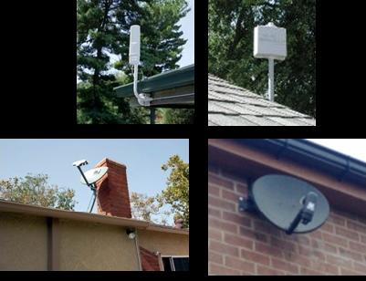

Above: examples of fixed wireless antennas (top) and satellite dishes.

The NBN Box
Regardless of whether the broadband signal reaches your home through fibre, wireless or satellite, a cable will connect the signal to a box called a Network Termination Device or “NBN box”. It will belong to NBN Co.

This NBN box will usually be placed inside premises, but there will be some cases where it will be mounted on the outside wall. NBN Co will choose the style of box that best suits your building type.

The box converts the signals from the broadband network into signals recognised by your home equipment. It also provides a point where the network provider can check if the services are working properly.

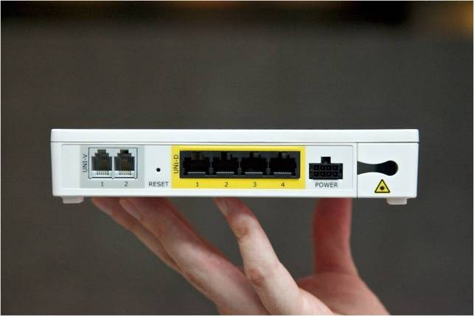
The NBN box has six ports: two phone ports and four data ports. (Courtesy of NBN Co)

Each port can be connected to a different service provider. As an example, you might have one phone port used for a home phone line, the other phone port used for a separate home office line, one data port connecting to your computer for a fast internet connection, while another data port might connect to a TV set-top box for your subscription to a digital TV service.

What about power failures?
For most conventional phones today, the transmission link between your home phone and local exchange is copper wire. Because it is metal, it can carry electrical current. If there is a power failure affecting your premises, back-up generators in the telephone exchange can send power down your phone lines so you can still use your phone (as long as it isn’t a handset that requires mains power, such as a cordless.)

Fibre-optic cable is glass and cannot carry electrical current. Therefore, the NBN box will be plugged into a regular power point. It also comes with a backup power unit housing backup batteries. If you don’t want to use the backup power unit, you don’t have to.

Back-up battery
NBN Co will provide a one-off backup battery to people who get connected. This backup battery will power a regular phone which is plugged into the NBN box for up to five hours in the event of a power failure. The battery will have a life of around three years and it will be the responsibility of everyone to replace and maintain their own battery.

It is important to note that many people have cordless phones that already rely on the mains power. The NBN Co backup battery will not power phones of this kind that need their own power supply. People can purchase a back-up power supply for these devices from most computer stores. These are often known as an Uninterruptible Power Supply, or a UPS.

Can I use my existing equipment/modem over the NBN?
Modems and gateways
If you are switching over to the NBN from an ADSL service, which is what most people have today, then your DSL modem may not work because you will need a different gateway with an Ethernet port on the internet side (often marked “WAN”). Your service provider may include an NBN-compatible home gateway as part of their service offer.

In general, broadband gateways (modems, routers and access points) can be used if they have an Ethernet port for the internet side. Seek advice from your service provider if you aren’t sure.

If you do want to buy your own home gateway, they can be purchased for as low as around $35. Recent advances in WiFi technology provide signals which should be adequate for many broadband services. Look for ‘wireless N’ when shopping for a new wireless gateway. ‘Wireless N’, or 802.11n, refers to a standard of high-speed WiFi that is capable of delivering the range and capacity needed for high bandwidth applications.

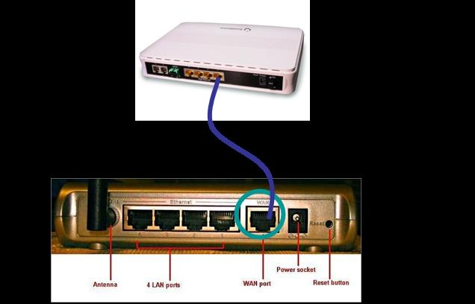

Above: Example of how an NBN Box might be plugged into a wireless router

Phones and other devices
Phone handsets and devices that make phone calls such as fax machines and alarm systems, should continue to work without problems. However, you would need to check with your service provider to be sure that your particular equipment will work. Some analogue alarm systems and analogue PABX phone systems will need to be upgraded so that they are compatible with the NBN.

Before you commit to a new service with new equipment it is recommended that you check it works over the NBN. Your service provider may also be able to help you with the testing. Whether a device works may be dependent on the capabilities of the service provider’s network and your service agreement.

Will my existing equipment give me the high speeds I want?

Current broadband equipment should be sufficient to provide a good NBN experience. However some cheap home gateways are designed only for slower connections. Cheap broadband routers can have very slow processors that can only support a low data rate and even on a DSL or HFC connection they can cause performance problems.

If you suspect your equipment might be preventing you from enjoying the full benefit of high speeds which are available, you should seek help from your service provider.

Remember that speeds will also be affected by:

- hardware and software configuration
- connection method within the premises (wireless or fixed)
- type of content being downloaded
- source of the content being downloaded, and
- number of people within a residence using the service at the same time

For people with HFC cable connections
If you are converting a broadband service from an HFC cable connection to the NBN, then you will probably need to upgrade your existing cable modem. In most cases, you can use your gateway as it will already have an Ethernet port and you would use the same type of cable to connect the gateway to the NBN box.

Will I have to pay for new wireless/satellite equipment?
If you are in a rural or remote area that will be provided with NBN fixed wireless or satellite services, the equipment needed to connect to the NBN will be provided and installed by NBN Co.

Any other satellite or wireless equipment at your premises will be a matter for you. You should only need a standard broadband gateway/router.

Will better devices be available?
Over time, expect better devices that can take advantage of the high-speed NBN connection. There may be more widespread use of, for example, home videoconferencing which will use phones with cameras and screens.

PRICE AND SERVICE QUALITY: basic info for broadband consumers

What makes up the price I am charged for broadband?
The access charge: This is what the network infrastructure owner charges your service provider. When NBN Co starts regular operations, they will charge your service provider for the use of the NBN. This will impact on the price you eventually pay.

For a basic service of 12 Mbps downstream/1 Mbps upstream, NBN Co will charge your service provider $24 per month plus GST. This charge will be the same regardless of whether the technology is fibre-optic cable, wireless or satellite.. There will also be additional variable charges that will be different for each service provider depending on their size, coverage and customer base.

Service provider costs: Service providers have their own costs to cover, for example the cost of equipment, international bandwidth, staff, and overheads.

Backhaul costs: Backhaul is the industry term for the links from local areas to a major centre. The cost for backhaul will vary depending on the amount of competition that exists, the distance these links travel and the type of terrain involved. In future, backhaul will be the links connecting NBN Co equipment in your district to the central point where your service provider keeps their computers and connects in turn to other networks and the rest of the internet.

Other costs: For people in some rural and remote areas, the property owner may be required to cover some or all of the costs of digging trenches and installing ducts if that has not already been done.

Application services: These are the extra services such as voicemail, call waiting, and newer services such as video on demand, medical monitoring and security monitoring. You might purchase these separately or together with your phone service, as you do now.

Why do we pay data usage charges in Australia?

A common complaint is that consumers in Australia are charged for data usage and held to monthly data allowances while consumers in many other countries have unlimited downloads.

One of the main technical reasons is that Australia is a small population of English-speakers a long way from other English-speaking population centres. A large proportion of our internet traffic comes from the United States which is on the end of long, expensive undersea cables.

We don’t have many international undersea cables, but more are progressively being built. The newest such cable opened in 2009 and runs 6,900 kilometres from Collaroy on Sydney’s northern beaches to Guam via Papua New Guinea. From Guam it connects to links that go to the United States and Asia.

Why is the upload and download speed different?
Most broadband services have higher download speeds (that is, the speed you can receive from someone else) compared with their upload speeds (the speed that you can send to someone else). This is because of the way the technology has been developed historically and it will also be the case with the NBN.

When upload and download speeds are different, they are called asymmetric; when they are the same, they are called symmetric.

If you are watching a video downloaded live, then it is only the download speed that is important. It will need to be high enough for you to receive a clear video stream. However, if you wish to have a two-way videoconference, then you will need to have enough bandwidth to send as well as receive your video signal, and so will your partner at the other end. In this situation, upload speed will also be important. The network links in between will also need to have enough bandwidth.

As long as there is sufficient capacity for all of your services, whether your service is symmetric or asymmetric should not matter.

Factors that can affect your broadband service
Remember that your service will be affected by:

- hardware and software configuration
- connection method within the premises (wireless or fixed)
- type of content being downloaded
- source of the content being downloaded, and
- number of people within a residence using the service at the same time

On the hardware, software and connection side, some issues are easy for consumers to check themselves, while others might need to be sorted out by the service provider.

The physical hardware
Physical hardware includes equipment such as cabling, wireless modems or access points, antennas and anything you or your service provider install.

Fibre-optic or other broadband cable
If something is wrong with the cable, it is usually easy to diagnose because no services will work at all. This will be the case if the cables coming into your home are severely damaged, or at worst, completely cut. A tree branch falling on a cable, or someone digging up an underground cable, might cause this damage. This should be reported to your service provider and they will arrange for repair.

Wireless systems
If all of your services are working poorly, or not working at all, sometimes the antenna may have moved or there could be interference from dust, heavy rain, intervening trees or unseen interference from other radio sources working at the same frequency.

Radio waves may also be blocked by moisture. Fog, heavy rain and water-soaked bushes can all block radio waves. If the problem only occurs during bad weather, your service provider might need to adjust your transmitter to a higher power signal or install a larger antenna. If the problem is always there, the antenna might have slipped and moved in which case the service provider will need to re-align it and point it towards the base station or satellite.

Household cabling
If some of your services are not working, your household cabling may be damaged, or be disconnected. Use good quality household cables, or get a registered cabler or licensed electrician to install or check your cables. Another reason one service might not be working is where equipment is plugged into the wrong socket or port. If you have changed your own cables recently, check everything is plugged into the right place.

Household wireless systems
If you or your service provider have installed an internal wireless access point (WiFi gateway) and you experience performance problems, it is possible that this household wireless system may be faulty or incorrectly set up. There may also be interference from other radio sources working at the same frequency. If you are working on a computer that is some distance from your gateway, this may also result in slower performance and signal dropouts.

Most wireless gateways can be set up to use a wide range of frequency channels. Try a few different ones, in case a neighbour or someone nearby has set up another access point using the same channel as yours.

Third Party Services
Services that are provided by third parties, for example over the internet, can originate in any part of the world, and can travel across any number of networks before reaching your home. Services provided by larger companies and governments will usually originate from large computer centres with high bandwidth links and will work well.

As long as your service provider has enough bandwidth to connect all their customers properly, external services should also work well. However if your service provider has thousands of customers and only small interconnecting links, then everything can become slow.

Quality of Service (QoS) Settings
Some types of communications need different types of bandwidth services. For example, video and phone calls will perform best if they are prioritised and don't have to wait for other traffic on your network, such as music downloads. If parts of the signal become delayed, the sound or picture quality will appear jumpy, or jittery.

The type of prioritisation that prevents this problem from happening is called Quality of Service (QoS) and your service provider should ensure that QoS settings are appropriate and enabled across all equipment – yours and theirs.

Web browsing, email and file transfers can still work if there are many things happening on your home network, as they will adapt their speed and slow down. However, services such as video conferencing, broadcast video and some applications for medical services will lose quality if they encounter overloading. Parts of the picture may be lost, or the sound quality may degrade. This is why Quality of Service settings must be properly set so there is enough bandwidth end to end.

PRIVACY AND SECURITY

Privacy
There will be less chance of unwanted monitoring of your online activity or of your phone calls on the NBN than on the current copper wire network. It is much more difficult to tap into a fibre-optic cable compared to the current phone wires. Additionally, the communications will be encrypted by the network, so anyone who does try to tap into the signal will not receive any useful information.

You should also ensure that you activate the security settings on your Wi-Fi system if setting up wireless internet at home.

Security
It is important to understand that the NBN does not lessen the need for security precautions. Everyone should have measures in place to prevent hackers and viruses from taking over their computers. Always use strong passwords for all of your home computer systems – a mixture of upper and lower case letters, punctuation marks and numbers. It is also best not to use dictionary words, names of family members or your birth date.

It is important that a ‘firewall’ system is used to protect computers within the house from internet threats. Most broadband gateways have such a firewall system built-in and most computers have firewall software that can be switched on within the computer itself.

It will remain important for every computer to have up-to-date anti-virus software.

It is also still important that a household wireless network is secured with passwords and not left open for every passing person with a laptop to connect to.

CHOOSING A SERVICE

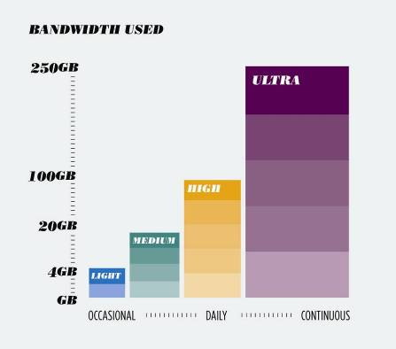

Assessing your usage patterns
To make the best choice of broadband service, think about your entire household’s potential usage.

How do you, in your home or business, use your broadband service? Do you look at the occasional web page, check emails and look at a few photos, or do you frequently download movies and transfer large files? Is there just one computer, or are there a number of computers and other devices connected to broadband across the house? Do you run a business, or work from home? Do you need to have highly reliable services such as medical monitoring, stock trading, EFTPOS or security cameras?

All of these combinations require different levels of bandwidth, or speed. Speed can be expressed in a few ways - bits per second (bps), kilobits per second (Kbps), megabits per second (Mbps) and even gigabits per second (Gbps).

Speed is not the only factor to think about. The household’s total downloads are important. Downloading many large files, such as videos, or computer programs, will add up. If you consume a lot of heavy bandwidth services you may need to sign up for a plan with a big data quota. Quotas are most often expressed in megabytes (MB) or gigabytes (GB).

For example, it is common to see advertising for a plan that will give you, say, 10GB or 100 GB per month. Often if you go over the quota, your speed will be slowed down or you will be charged excess data charges until the end of the billing month.

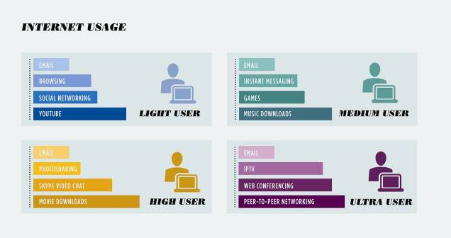
Many people also find they use communications services differently when they have high-speed broadband. In the past, most people used a regular phone, checked their email and looked at the occasional web page. Today it is common for people to watch videos on YouTube or have long video chats using Skype. Once high-speed broadband arrives, you may begin to watch TV programs, movies, or use other online services such as education or health. Check the chart on broadband speeds for guidance on how usage translates to broadband speeds.

Sample File or Service | Estimated download and upload speeds
 | 56 Kbps | 1.5 Mbps | 8 Mbps | 20 Mbps | 100 Mbps
4MB (average MP3 song) | 9 min 31 sec | 21 secs | 4.2 secs | 1.8 secs | <1 sec
350 MB (Average 1 Hour TV episode in SD) | 13 hours 53 min | 30 min 23 secs | 5 min 50 secs | 2 mins 20 secs | 28 secs
1000MB (Average 2 Hour movie in SD) | 39 hours 54 min | 1 hour 26 mins | 16 min 40 secs | 6 min 40 secs | 1 min 20 secs
10000MB (Average 2 Hour movie in HD) | 17 days | 14 hours 49 mins | 2 hours 47 min | 1 hour 7 min | 13 min 20 secs
Telephone call | Poor quality | Excellent | Excellent | Excellent | Excellent
Small window video conference | Unacceptable | Good quality | Excellent | Excellent | Excellent
Full-screen video conference | Not possible | Poor quality | Good quality | Excellent quality | Broadcast quality
SD: standard definition HD: high definition

In summary, to choose broadband services you should look at a range of factors, such as speed, data quota, the price and of course the reputation of the service provider.

Will things change after I have high-speed broadband?
- Over time, expect new services to emerge that use the high-speed capabilities that the NBN provides.
- You should think about the number of devices in your home that will use the broadband connection. It is also important that all the services you buy do not exceed the capacity of your connection. These days, with wireless networks and internet-enabled TV screens, many households have several devices that could make heavy use of a high-speed broadband connection.

COMPLAINTS

Will the NBN make any difference to the complaints arrangements?
If you have a problem that is related to NBN construction in your area or at your premises, you should contact the NBN Co Solutions Centre on 1800 881 816. Construction staff will have cards with this number on it.

There should be little or no change to complaints handling for your service.

If you are complaining about a communications service, for example your line is bad, you will still complain to your service provider. If you are not happy after that, you will still complain to the Telecommunications Industry Ombudsman (TIO).

Where would I go if I want to complain about my service or about the bill I received for my service?
Your service provider is responsible for handling any complaints you may have about your service. If the problem is beyond the service provider’s network, the service provider will work with NBN Co to have it fixed, including arranging for someone to come and check the connection on the inside or outside of your premises if necessary.

Because NBN Co does not have a direct relationship with consumers, you will not call NBN Co to get a problem fixed.

Where you subscribe to services such as security monitoring or health services that are billed separately, take your complaint directly to that provider.

What if I’m not happy with the outcome of my complaint or the way it was handled?
It is important that you first try to resolve your complaint with your service provider.

If you are not happy with the outcome of your complaint or with the way your complaint has been handled, you can usually take it to the Telecommunications Industry Ombudsman (TIO). The TIO handles complaints by residential and small business customers against the providers of communications services.

You can make a complaint online or by calling the free number 1800 062 058. The TIO investigates complaints at no charge to the customer and, if the TIO finds in your favour, can order that the service provider take whatever action is necessary to solve the problem.

Can the TIO handle all my communications complaints?
The TIO can handle complaints about your regular phone service, your mobile phone service or your internet service. If those providers supply you with other services that they bill you for, then generally, the TIO will handle that complaint also.

