Terrey Hills petroglyphs – Andrew W
Close to my favourite local cycling circuit are the Terrey Hills petroglyphs, located on Guringai country. They’re a short bushwalk along a trail winding through eucalyptus trees and long grass. On a well-hidden rock platform, you can find the “Hunting Site”. There’s a blue sign in front of the rock platform stating that it’s a protected Aboriginal site but it’s otherwise unmarked. It was first described in 1940 by Fred McCarthy, who describes it as a hunting scene: “the hunter, wearing a rayed forehead band, is shown beside a large and small kangaroo. There is a line of eight mundoes (footprints), that may represent the steps taken by the hunter as he stalks his prey, lead down the middle of the rock to his shield which he had apparently dropped. His two wives are engraved on the eastern side of the rock”. The site might be associated with creator spirits such as Baiame due to ceremonial head-dress worn by the hunter.
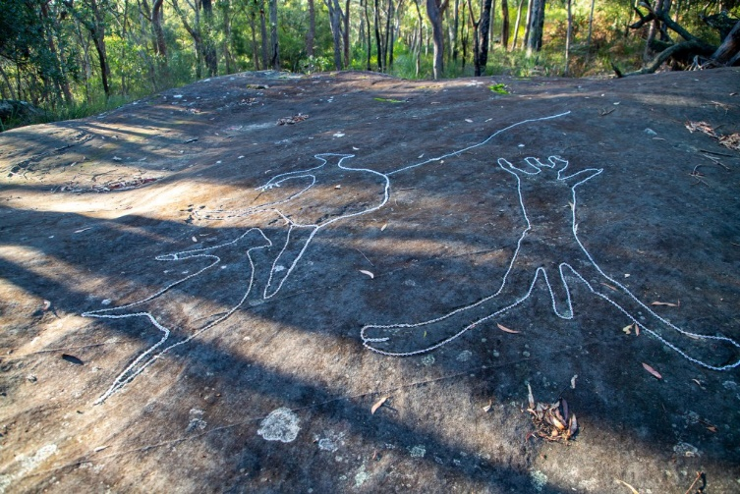
There is a second site across the creek further up the hill. There is a long series of rock platforms, one of which contains a number of engravings called the Lyrebird site. It’s named after a lyrebird carving in the middle of the site. The tail feathers indicating it’s a male bird and McCarthy describes it as “the finest portrayal among the few known of this bird”.
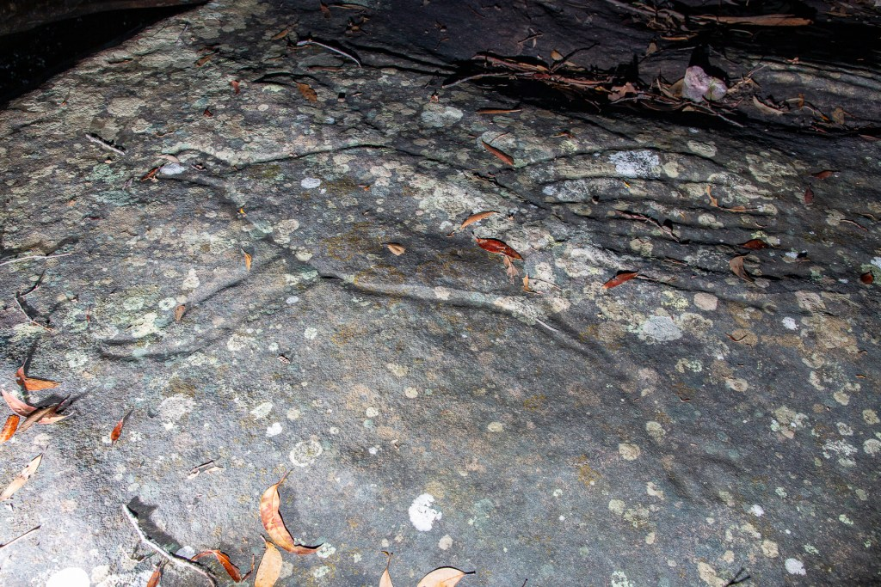
Both sites contain 46 petroglyphs.

