Reconciliation Week Activity: Rock Shelter at Undercliffe, Earlwood
My area of Canterbury-Bankstown is home to the Darug and Eora people, the original inhabitants of Canterbury and Bankstown. A surviving First Nations artwork site in this area is a rock shelter in the environs of the Cooks River at Undercliffe, Earlwood.
The artwork comprises of a midden and rock shelter. It depicts hand stencils covering the rear wall of the sandstone overhang at Undercliffe, which is a reminder of the importance of ceremony in First Nations culture and life. First Nations people lived in this shelter over many generations, and the hand stencils represent traces of their presence here. The making of artwork and stencils may also represent First Nations communities connection with ‘ancestral beings, embodied in the natural features of the country’.
This artwork is considered by archeologists to be a rarity in the Sydney region, and the paintings and etching are believed to be 1,000 to 5,000 years old.
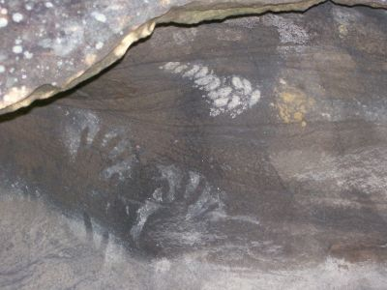
Image description: Hand stencils at Undercliffe. The stencils are sketched in white, surrounded by a brown rock midden. Image by: Tanya Koneman. Image copyright owner: Heritage Branch.

City of Canterbury Bankstown, Aboriginal history and places of significance, Link to Aboriginal history and places of significance.
Ibid.
See Earlwood Aboriginal Art Site, Link to Earlwood Aboriginal Art Site.
Cooks River Alliance, Aboriginal River along the Cooks River 2017, p. 17 Link to Cooks River Aboriginal history report.
Ibid., p.2.
See Earlwood Aboriginal Art Site, Link to Earlwood Aboriginal Art Site.
City of Canterbury Bankstown, Aboriginal history and places of significance, Link to Aboriginal history and places of significance.
See Earlwood Aboriginal Art Site, Link to Earlwood Aboriginal Art Site.

