Bummiera or Bumeira (Brown Lake) is a perched freshwater lake on Minjerribah (North Stradbroke Island) in southeast Queensland, Australia. The lake is tinged brown from the fallen leaves of the tea tree and melaleuca bushlands surrounding its shores. Lake Bummiera is of cultural significance to the Quandamooka people, who are the Traditional Owners of Minjerribah. Below I have included a poem by local artist Brendon Coghill about Bumeira.
Bumeira (Brown Lake) by Brendon Coghill
I will tell you a story of a lake they call Brown,
For we call it Bumeira where the t-trees surround.
As the women tell stories and the children all play,
Gabul the giant carpet snake protects them all day.
This snake has been seen by my peoples own eye’s,
For I know this is true for my people don’t lie.
To swim in the lake we have to ask for permission;
To enter and enjoy without any further discussion.
We are not permitted to swim to the centre of the lake,
It is where her spirit lies and sometimes she’s awake.
The black spirits that you see are our people from our past,
As we sit and tell our stories of our Dreamtime they will last.
The goanna’s near the lake are always in and out of trees,
Crawling through the sand always searching for a feed.
To come together at this lake is so special for our race,
For when we swim and tell stories we leave not a trace.
The only remains that we leave are our footprints in the sand,
Now they don’t belong to us they now belong to the land.
This painting here I’ve created is called Bumeira Spirit,
Night time we are not permitted to venture anywhere near it.
So respect this sacred woman’s lake when you visit this ancient land,
And take your time and nestle down like goanna’s in the sand.
Bumeira is very sacred to our women and children you see,
So enjoy this special place and the surrounding t-trees.
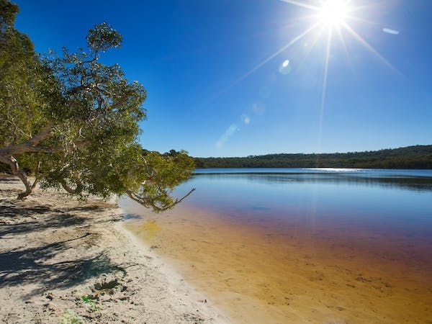
Lake Bumeira, photo taken from: https://www.queensland.com/au/en/things-to-do/attractions/p-5bbec87febfecbfd4032c16f-brown-lake

North Stradbroke Island. Brown Lake. https://stradbrokeisland.com/brown-lake/
Queensland. Brown Lake. https://www.queensland.com/au/en/things-to-do/attractions/p-5bbec87febfecbfd4032c16f-brown-lake

