Jibbon Aboriginal Rock Engravings (Petroglyphs), Bundeena
I live in the Sutherland Shire, Dharawal Country and I’m incredibly fortunate to have The Royal National Park on my doorstep. We are blessed with beautiful walking tracks and waterways, including Port Hacking which was a major food source for the Dharawal. They used the area to hunt for traditional food sources such as wallaby, possum, shellfish and fish. It was also a valuable source of plant materials for food, medicinal and ceremonial use.
Some of Sydney’s most significant remaining Aboriginal rock engravings can be found via Jibbon Beach, where a sand track will lead you into the headland area. In 2018 National Parks and Wildlife Service, in consultation with the Dharawal Local Aboriginal Land Council and Dharawal community members, undertook site protection work at the site. This included the installation of a 60-metre raised board walk and a viewing platform elevated above the engravings. Among the engravings are killer whales, turtles and stingrays. There are also figures from Dreaming themes. Senior men oversee their maintenance. Highlighting of the Aboriginal rock engravings is done by the Dharawal people, the Dharawal Local Aboriginal Land Council and the National Parks and Wildlife Service.
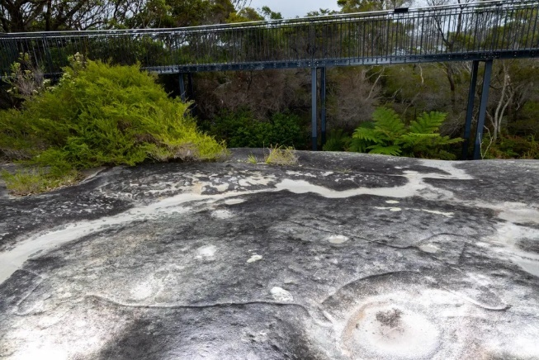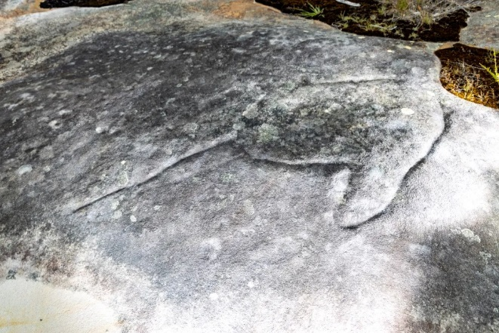
Photos from https://hikingtheworld.blog/engravings/jibbon-head-engravings/
Local Elders have identified this location as a camp site. Dharawal people created and maintained this campsite over thousands of years through the careful use of fire and plant management. They camped here in the winter months and created a habitat around the camp that attracted animals they wanted to hunt. They also ensured desired fruits and berries would grow in the area thereby creating a larder of food around their campsite.
A three metre high sand dune runs the length of the beach, it is in fact a shell midden and it’s estimated to be around 3000 years old. It contains empty oyster, mussel and periwinkle shells. There are also discarded fish, wallaby and possum bones, and the remains of cooking fires.
While I have visited this site several times, our National Reconciliation Week activity has given me an opportunity to discover the importance of the site as a winter campsite and to learn about the arrangements around the maintenance of the site by the Dharawal people.

