Cammeraygal Country: The Gadyan Track, Berry Island Reserve
I visited Berry Island Reserve located in Lower North Shore as a part of the reconciliation week activity. I love walking along the harbour foreshore and sometimes enjoyed paddle boarding around this island (it’s no longer island as it’s permanently connected to mainland) during summer without knowing much about these significant cultural sites. Visitors were advised to only walk along the Gadyan Track to avoid causing any damages to engravings and midden sites, and not removing any shells, etc.
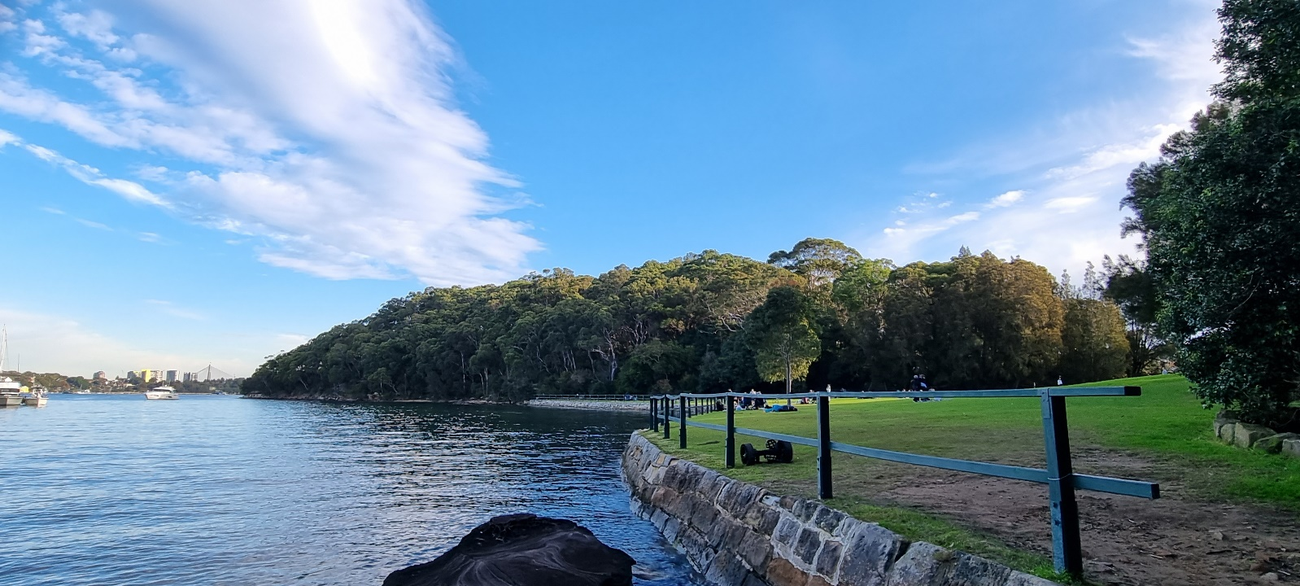

Before European arrived in 1788, local Aboriginal people spent a lot of time around the harbour shores where there was plenty of fish and shellfish to eat, especially in the summer, and sandstone overhangs for shelter. Around the water prolific signs of Aboriginal lifestyles accumulated, including middens of discarded shell and bones, charcoal and backed clay from fires, and artwork associated with their spiritual and cultural life. In many areas, this has all disappeared under development. Yet Berry Island is rich in Aboriginal history and much of evidence can still be seen. Middens and other sites around the island indicate the local Cammeraygal people were here often, gathering shellfish, camping overnight, making tools and engravings. This lifestyle began to change as early as 1789 when a disease epidemic killed large numbers of Sydney Indigenous Australians.

Engraved on the relatively flat rock surface is the outline of a large creature about 10 meters long, beside the engraving, is a small deep rock pool. Please see a simple drawing below to get some idea of engraved creatures.
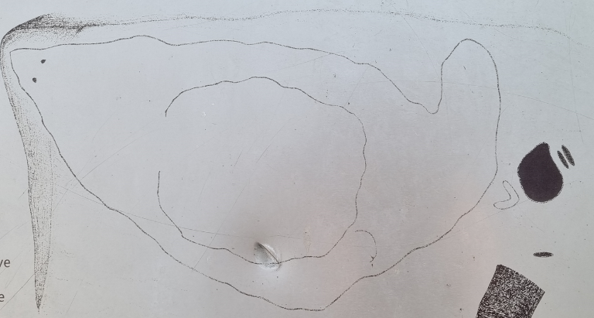

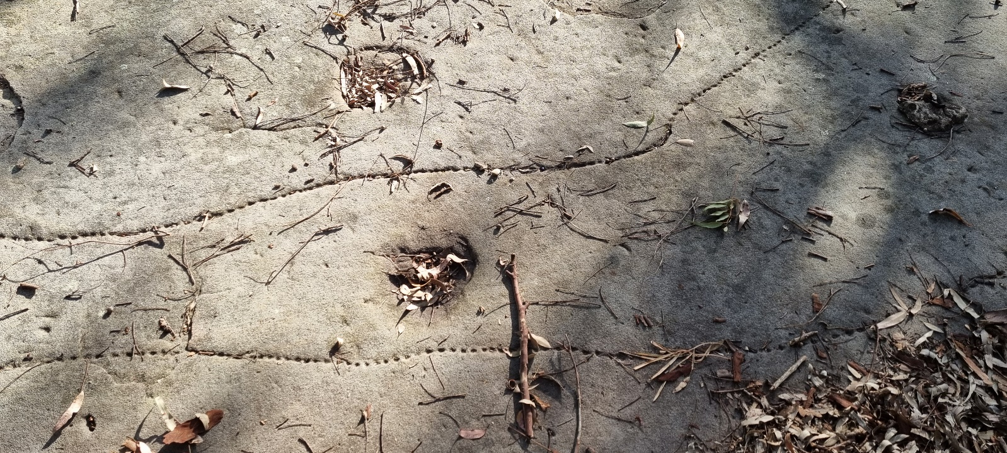
This engraving was part of the spiritual or cultural life of the Cammeraygal. Sadly, the loss of these peoples from disease and conflict means the story told by the engravings is no longer known. So, people believe it represents a stingray inside a whale, or a large sea creature being attacked or beaten off. It’s likely to be a creature from a dreamtime story. The rock here is breaking off in sheets as water and chemical action attach its outer layers. In Aboriginal culture important works are regularly re-engraved, but at present there is no-one qualified by Aboriginal lore to re-engrave this work.

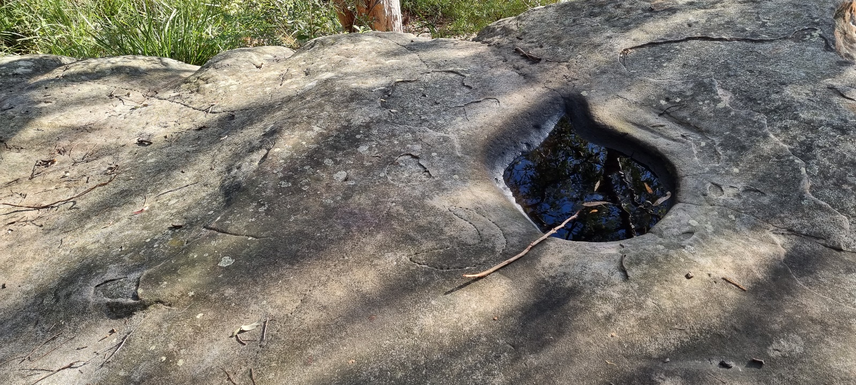
The pool collected freshwater which is an important resource in a place surrounded by salt water.

