RRRCC supports steps to improve reliability of telco services
Friday, 16th November 2018
The Regional, Rural and Remote Communications Coalition (RRRCC) welcomes the proposals flagged in a Department of Communications and the Arts consultation paper which focuses on the reliability of telecommunications services.
"Communications are now an essential part of our lives and we are pleased to see that these proposals are reflective of this reality," Australian Communications Consumer Action Network (ACCAN) Director of Policy, Una Lawrence said.
“We have been urging the government to introduce much needed reforms to underpin the delivery of the telecommunications services we all rely on for some years, and we welcome this first step in the process."
Ms Lawrence said the current rules setting timeframes for connection, fault repair and appointment keeping, applied only to fixed voice services.
"Established network performance benchmarks, measuring the number of network drop outs, are poorly designed and only cover Telstra’s copper network. These arrangements no longer reflect the way that Australians live and communicate.”
The arrangements for priority assistance customers who need faster connections and fault repairs due to medical conditions are similarly outdated, as they only apply to Telstra’s fixed voice services.
“Priority assistance customers are currently forced to be with Telstra for their fixed line voice service, which means they’re not getting the benefits of the competition the NBN is meant to bring to the market. Turning priority assistance into a broad based industry obligation that applies to broadband as well as voice will address this anomaly,” Ms Lawrence said.
“Some of the key concerns that we hope to see addressed through the consultation process include the effectiveness of incentives for industry to comply with future safeguards, and that performance benchmarks are set at a level that that will deliver for the community and small businesses – for both mobile and fixed networks. We’d like to see the Government move quickly on these important reforms, and roll them out at the earliest possible opportunity,” she continued.
National Farmers' Federation CEO Tony Mahar said, as a member of the RRRCC, the Federation had consistently reminded Government and providers that regional, rural and remote people should be able to expect similar levels of high levels of service and reliability, as to that received by urban-based Australians.
“This reform is one five key asks that we have been seeking since the RRRCC was formed nearly two years ago.
"The proposals recommended are very welcome and will be providing a very supportive submission to the process.”
“However, as with anything success of reforms depends on a well-resourced regulator that has the tools and capacity to monitor and enforce where required.
“RRRCC will be talking closely to with their members and consumers generally to make sure their interests are fully represented in this important consultation.”

Member organisations:
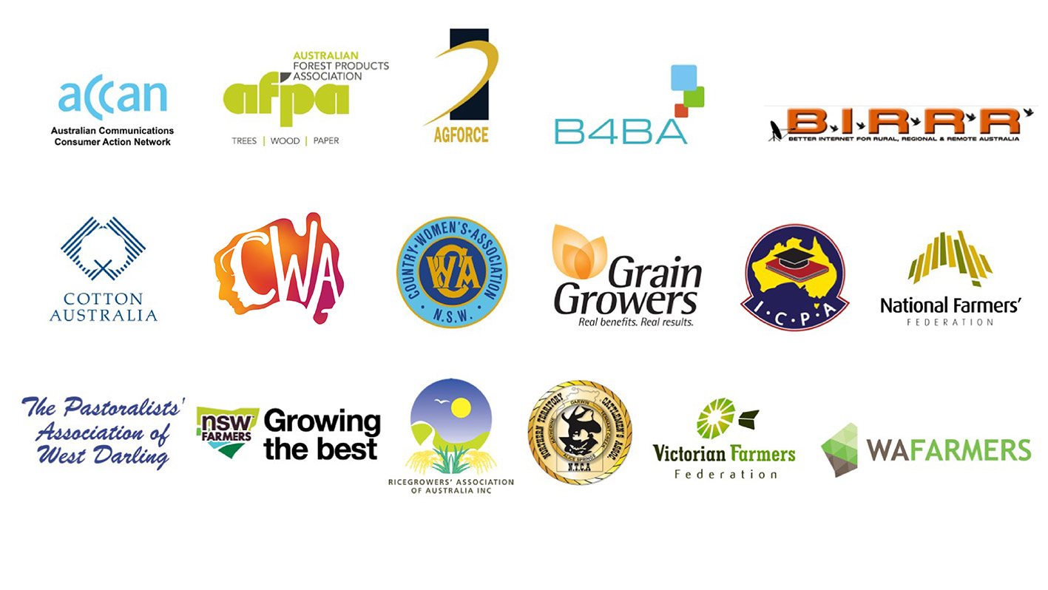

Members of the Coalition are:
  - ACCAN
  - AgForce Queensland
  - Australian Forest Products Association
  - Better Internet for Rural, Regional & Remote Australia
  - Broadband for the Bush Alliance
  - Cotton Australia
  - Country Women’s Association of Australia
  - Country Women’s Association of NSW
  - GrainGrowers
  - Isolated Children’s Parents’ Association
  - National Farmers’ Federation
  - Northern Territory Cattlemen’s Association
  - NSW Farmers
  - The Pastoralists' Association of West Darling
  - Ricegrowers’ Association of Australia
  - Victorian Farmers Federation
  - WA Farmers

