17 October 2016

Communications Alliance
Level 12, 75 Miller Street,
North Sydney NSW 2060
Attn. Craig Purdon:
By email: c.purdon@commsalliance.com.au

The Australian Communications Consumer Action Network (ACCAN) is pleased to have the opportunity to comment on the operation of the Mobile Premium Service Code (C637:2011 Incorporating Variation No.1 – 2014) (‘the Code’).
Background
It has been over two years since the Code was last reviewed. Since that time, there have been a number of important developments in technology, consumer habits and the law about mobile premium services (MPS) and related services such as direct carrier billing (DCB). As a result, ACCAN strongly believes that the Code should now be revised.
Over the last two years, complaints about third party billing (which include both MPS and DCB) have almost doubled to 2% of new complaints to the TIO. The most recent quarterly statistics show that third party billing (TPB) complaints remain at these consistently higher levels (see table below).
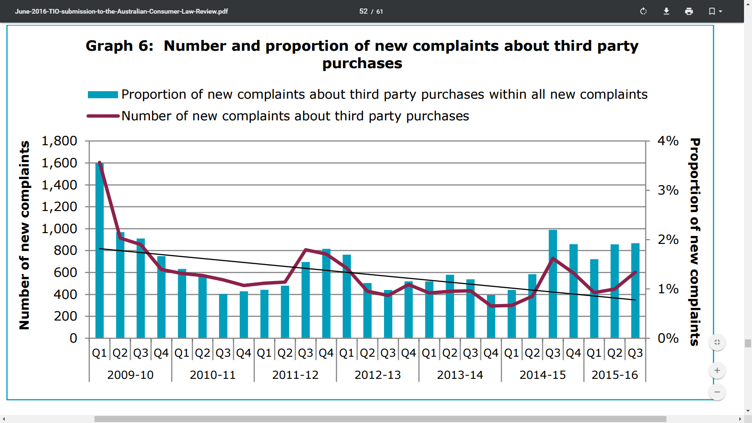

ACCAN also believes that these complaint figures may underrepresent the extent of the problem. In 2015, ACCAN commissioned a Galaxy Poll on telecommunications complaints. The survey found that only 9% of consumers who were dissatisfied with the provider’s response to a complaint actually made a complaint to the TIO. This reduced to 5% of consumers when also taking into account those who had a problem but didn’t contact their provider in the first instance. Accordingly, we believe that it is possible that a larger group of consumers are not speaking up but are suffering detriment from the operation of these services.
ACCAN has long been concerned that the underlying business model behind MPS/DCB services relies on a percentage of consumers who will tolerate paying for a one off charge/short term subscription, rather than go through the inconvenience of contacting their provider and then the content provider to dispute the charge. Consumers in this situation may have not subscribed to these services or have subscribed inadvertently, or been subscribed by minors who had access to caregivers’ phones.
Furthermore, ACCAN remains concerned that CSPs continue to enter into contracts with Content Suppliers who have little market reputation and therefore little incentive to comply with any form of regulation. Over the years through several submissions, ACCAN has pointed out the poor sales practices of some of these companies and the difficulty in contacting them, many of whom are based overseas.
These issues are not unique to MPS. Over the years, ACCAN has witnessed these issues across other telecommunications products based on the same business model. The first of these was the introduction of 1900/1902 premium call numbers, often advertised on late night TV. Then, in the early 2000s, MPS gained traction amongst consumers as smartphone penetration increased, particularly among younger consumers. Recently, Direct Carrier Billing has emerged. All of these services operate quite similarly and sometimes in ways that create risks for consumers. History tells us that consumers need strong protections and transparency when using these services.
We recognise that MPS and DCB is an area where CSPs have tried to risk manage by distancing themselves from direct responsibility for issues that arise, on the basis that they are merely billing conduits and not responsible for any complaints. However, we believe that CSPs are practical intermediaries. As such, they need to take on more responsibility for how these services operate and how problems can be prevented in the first place. This is particularly the case as CSPs derive income from the services.
Clearly, the time has come for the Code to be significantly updated to take into account these issues. We note the following key issues that should be addressed in the review of the Code.
- Direct Carrier Billing
ACCAN strongly advises that the Code should cover services provided through Direct Carrier Billing. Direct carrier billing is where mobile providers allow third party businesses to bill customers for services via the customer’s phone bill. At present, DCB is only available for digital content (for example games, apps and media content). However, there is evidence to suggest that direct carrier billing will extend to payments for other goods and services including online auction sites and other online retailers and in-store purchases. In the UK, consumers can charge bus tickets and magazines to their phone bills. We also note that direct carrier billing services require a financial services licence in some countries, including across Europe.
Direct Carrier Billing operates on a very similar basis to MPS, however it does not fall within the current scope of the Code. In addition to the similarities with MPS, DCB presents a unique challenge; this is that DCB has a far greater audience reach because it provides access to content that is very popular. This includes the entire Google Play catalogue of movies, TV shows, music and music streaming services, eBooks and high quality apps including games.
We believe that the increase in third party billing complaints to the TIO can be significantly attributed to the rise in direct carrier billing. As noted above, DCB is substantially similar to MPS services. Because of this, consumers have the same problems with DCB as they have had with MPS over the years. These include:
- unsolicited services;
- no or poor cost information included in advertising ;
- unawareness of subscribing or incurring charges until costs have been incurred;
- the lack of mandatory double-opt-in process;
- customer awareness of barring;
- reminder notifications about spending; and
- difficulties obtaining refunds.
The various updates to the MPS Code over the years have adequately addressed some of these issues. Accordingly, we believe that all of the Code’s protections should be extended to include services provided through Direct Carrier Billing.
- Raising consumer awareness of barring
The last Code review inserted an obligation for CSPs to inform customers about barring when customers make a complaint. This requirement was transferred to the Code from a legislative determination. This requirement was later repealed from the determination in October 2014. At this time, other sections of the determination were also removed. This includes section 12(3), which required CSPs to notify customers about barring at the time of purchasing a new mobile phone service. In August 2014, ACCAN supported transferring this obligation into the Code. We also repeated this view when ACMA was considering whether to remove the point-of-sale requirement from the legislative determination. This requirement was not transferred to the Code. ACCAN continues to support its incorporation into the Code.
Other protections removed from the determination in October 2014 included the listed specific information below that in telling customers about barring, CSPs should include:
- Describing what a premium SMS and MMS service is;
- How charges are incurred;
- How MPS may be barred;
- The barring process; and
- Complaint mechanisms.
We believe that this information does not unduly limit the ability of providers to communicate with their customers in a way that suits them.
We believe that lack of consumer awareness of barring for DCB has a very detrimental impact on vulnerable consumers, particularly children. Until now, to download paid Google Play content (for example a paid app or an in-app purchase), children have needed the password to a parent’s Google Account which had credit card details on file. If the child did not have access to this password, then they could only download free content. With DCB, the child can simply “pay” for apps and other Google content to the phone account (which may be in the parent’s name). This includes music, movies, TV shows, eBooks and magazine subscriptions. Children may also download a free game, and then inadvertently buy an in-app purchase using direct carrier billing. The parent account holder may not find out about this until the monthly bill is received. According to providers’ own instructions, activating DCB does not require any authentication from the CSP account holder, such as a special account password.
In addition, many providers are now incentivising direct debit bill payment by charging a fee for any payment method other than direct debit. If using direct debit, consumers are less likely to check their monthly bills because the money comes straight out of their bank account. Even if the customer does notice that a particular month’s bill is higher than normal, the small amounts involved or the difficulty in getting a refund means that most consumers will not make a complaint.
We believe that some of these risks can be reduced if customers are told about barring at the time of acquiring a mobile service.
- Better transparency about subscriptions
The TIO’s position statement on third party purchases states that “providers should have appropriate spend management tools in place to assist the consumer to monitor and take timely action to manage their spending on these types of purchases”.
We also believe that Content Suppliers need to take more action to remind consumers about ongoing subscriptions. Currently, the Code has a requirement for Content Suppliers to send a reminder notification to customers at the end of each calendar month. However, many TPB services are subscription-based and billed on a weekly basis. By the time customers receive a notification at the end of the month, they have often spent $20 or more. Accordingly, consideration should be given to sending customers using MPS/DCB subscription services a reminder text prior to each individual subscription charge, to give customers the opportunity to cancel the service if they wish before the next charge is applied. Customers should be able to opt out of such reminder texts if desired. .
ACCAN also considers there should be greater transparency of ongoing subscriptions. We are aware of cases where customers have enabled barring under the false assumption that enabling barring will cancel existing subscriptions.
- Complaint handling issues
ACCAN also believes that providers need to take greater responsibility for the relationship they have with Content Suppliers and Aggregators. In practice, CSPs are not simply billing conduits. . The CSP position is very similar to that of a bank providing a credit service. In those cases, a bank provides customers with a chargeback facility to dispute any costs that the customer has not or cannot resolve with the merchant. The situation is very similar to the relationship between the CSP and the client.
We also endorse the TIO’s view that providers should play a more active role in the resolution of MPS complaints, particularly where the customer has not been able to resolve the issue with the Content Supplier, for example where the resolution offered by the Content Supplier is not fair, or effective, or offered within a reasonable time.
- Compliance and reporting requirements
ACCAN supports reintroducing reporting and monitoring requirements that were removed from the Code in the 2014 review. Since that time, TCB complaints have now doubled to 2%. We also believe that ACMA should publish a summary of compliance reports in order to refresh public awareness of TPB, increase accountability by unscrupulous TPB providers, and drive better practices.
Finally we believe that the review should consider increased obligations on CSPs to better assess risks of third party billing services before entering into contracts with Content Suppliers. We believe that some international examples provide a useful model that the review could consider, for example the UK regulator’s Code and Guidance on risk management between CSPs and Content Suppliers.
Conclusion
There is a compelling case to review the Code and ensure that it provides a high level of protection for Australian consumers. ACCAN looks forward to working with the Alliance and its members on the Code review.
Should you have any questions about these comments, please do not hesitate to contact me on (02) 9288 4000.
Yours sincerely,
Jax Arnold
Policy Officer

Telecommunications Industry Ombudsman, Submission to the Australian Consumer Law Review, 16 June 2016, available at <https://www.tio.com.au/__data/assets/pdf_file/0018/221265/June-2016-TIO-submission-to-the-Australian-Consumer-Law-Review.pdf> at p.44, 46.
Galaxy Research, ‘Telco and ISP complaints’, prepared for Australian Communications Consumer Action Network, May 2015, available at <http://accan.org.au/files/Reports/ACCAN%20Galaxy%20Survey%20May%202015.pdf> at p. 8.
ACCAN, ‘Submission to the CA Review of the Mobile Premium Services Industry Code’ 15 August 2014, available at <http://accan.org.au/files/Submissions/ACCAN%20Submission%20MPS%20Code.pdf>; ACCAN, Response by the Australian Communications Consumer Action Network to the Government review of communications regulation - Supplementary submission: MPS and Performance Reporting’, 19 May 2014, <http://accan.org.au/files/Submissions/ACMA%20reporting%20requirements%20ACCAN%20supplementary.pdf>.
Will Hernandez, ‘Boku brings direct carrier billing into the physical world thanks to license’, Mobile Payments Today, 2 October 2014, available at <http://www.mobilepaymentstoday.com/articles/boku-brings-direct-carrier-billing-into-the-physical-world-thanks-to-license/>.
E-Money Directive (2009/110/EC), entered into force 30 April 2011, available at <http://eur-lex.europa.eu/legal-content/EN/TXT/?uri=CELEX:32009L0110>.
Optus, Google Play Store Billing, “What stuff can I buy on Google Play?”, available at <http://www.optus.com.au/shop/mobile/apps/Google-Play-Store-Billing>.
Section 12(6) of the Telecommunications Service Provider (Mobile Premium Services) Determination 2010 (No. 1) (‘Determination No 1’).
Determination No 1 was amended by Telecommunications Service Provider (Mobile Premium Services) Amendment Determination 2014 (No. 1) (Cth).
ACCAN, ‘Submission to the CA Review of the Mobile Premium Services Industry Code’ 15 August 2014, available at <http://accan.org.au/files/Submissions/ACCAN%20Submission%20MPS%20Code.pdf> at p. 2
ACCAN, Response by the Australian Communications Consumer Action Network to the Government review of communications regulation - Supplementary submission: MPS and Performance Reporting’, 19 May 2014, <http://accan.org.au/files/Submissions/ACMA%20reporting%20requirements%20ACCAN%20supplementary.pdf> at page 5.
For a historical version of the Determination No 1, go to: <https://www.legislation.gov.au/Details/F2013C00123>.
See, for example, Optus, Google Play Store Billing, “Frequently Asked Questions – How does it work”, available at <http://www.optus.com.au/shop/mobile/apps/Google-Play-Store-Billing>.
Telecommunications Industry Ombudsman, ‘Managing Usage and Expenditure on a Service’, 11 March 2016, available at <https://www.tio.com.au/__data/assets/pdf_file/0011/163397/Managing-usage-and-expenditure-on-a-service_Mar-2016.pdf> at p. 3.
This reminder notification is required if the spend is less than $30 per month. If the spend is more than $30, customers receive an “Expenditure Update” under section 4.4.11 of the Code.
TIO, ‘Submission on the Review of the Mobile Premium Service (MPS) Code, April 2014, available at <https://www.tio.com.au/__data/assets/pdf_file/0003/156738/Mobile-Premium-Services-Code-C637_2011-Review.pdf> at page 6.
See, for example PhonepayPlus Code of Practice for Premium Rate Services 2016, 14th edition, came into force 12 July 2016, available at <http://www.phonepayplus.org.uk/~/media/Files/14th-Code-of-Practice/PhonepayPlus_Code_of_Practice_14th_Digital.pdf> at section 3.1.3; PhonepayPlus, ‘General Guidance Note: Due diligence; risk assessment, and control on clients’, available at <http://www.phonepayplus.org.uk/~/media/Files/13th-Code-of-Practice/Guidance-and-Compliance/10_Due-diligence-risk-assessment-and-control.pdf>.

