Domestic mobile roaming declaration inquiry
Submission by the Australian Communications Consumer Action Network to the Australian Competition and Consumer Commission
November 2016

About ACCAN
The Australian Communications Consumer Action Network (ACCAN) is the peak body that represents all consumers on communications issues including telecommunications, broadband and emerging new services. ACCAN provides a strong unified voice to industry and government as consumers work towards availability, accessibility and affordability of communications services for all Australians.
Consumers need ACCAN to promote better consumer protection outcomes ensuring speedy responses to complaints and issues. ACCAN aims to empower consumers so that they are well informed and can make good choices about products and services. As a peak body, ACCAN will represent the views of its broad and diverse membership base to policy makers, government and industry to get better outcomes for all communications consumers.
Contact
PO Box 639
Broadway NSW, 2007
Email: info@accan.org.au
Phone: (02) 9288 4000
Fax: (02) 9288 4019
Contact us through the National Relay Service

Contents

Executive summary 5
Introduction 6
Response to questions 7
The relevance of government subsidies (question 1) 7
Co-location, facilities access and transmission 9
Existing co-location agreements between MNOs (question 2) 9
Domestic Transmission Capacity Service (DTCS) (question 5) 9
Current regulation of co-location (question 3) 10
Practical barriers to co-location (question 4) 11
International examples (questions 6 and 8) 12
Existing roaming agreements (questions 11 and 13) 13
Competition in metropolitan and regional mobile services markets 13
Existing monopoly characteristics (question 32) 13
Competition in regional mobile services markets (questions 17, 20 and 23) 14
The role of MVNOs in increasing competition (question 20) 14
The Telstra “price premium” and the extent of Telstra’s legacy advantage 15
Telstra’s price premium? (question 18) 15
First mover advantage (question 34) 15
Consumer needs and perspectives 17
Telstra is the dominant choice for regional, rural and remote consumers (question 22, 24(a) and 26) 17
Consumer needs - congestion 18
Consumer needs - cost 18
Scope of declared mobile roaming service 19
Geographic scope of the roaming service (question 30) 19
Technical scope of roaming service (questions 44, 45 and 46) 20
Effect of declaration on incentives to invest 20
What are the incentives to invest? (questions 35 and 41) 20
Price of declared service (questions 28 and 48) 21
Miscellaneous 22
Data sharing with ACMA and DoCA 22
New coverage reporting obligations 22
Enhancing ACCC expertise in mobile services 22
Appendix 1 – Data for assessing network investment 23
Appendix 2 – Questions answered 24

Executive summary
ACCAN welcomes the opportunity to contribute to the ACCC’s Domestic Mobile Roaming Declaration Inquiry 2016. For many years, ACCAN has been a strong advocate for better coverage and improved competition in regional, rural and remote areas (regional, rural and remote). ACCAN’s engagement with regional and remote Australia has continually highlighted to us the importance of improved mobile communications.
During ACCAN’s consultation with members on mobile roaming, there was some divergence of views about whether roaming would improve services and better meet communications needs. However, our consultation further confirmed the key issues facing regional, rural and remote consumers. ACCAN members consulted for this inquiry include representatives from the agricultural sector , telecommunications engineers, advocates for remote education and schooling, Indigenous health and communications groups as well as individuals who live, work and travel in regional, rural and remote communities.
First and foremost, consumers and small businesses in regional, rural and remote areas want additional coverage in areas where they live, work and travel. This includes highways, small remote communities, inside homes and in-paddock reception. Secondly, the existing mobile network needs to be upgraded to improve capacity and reduce congestion. These are the two improvements that would go the furthest in improving the lives of non-metro consumers on a daily basis.
While competition is desirable, it should not be introduced if it is at the expense of investment in additional coverage and improved capacity. As one ACCAN member stated, “competition and coverage are like oil and water, they just don’t mix well”. At the same time, there is keen awareness among ACCAN members of the benefits of competition, particularly for those living or operating in remote communities where there is a greater percentage of low income users.
At this stage, ACCAN does not support the regulation of domestic mobile roaming. However, there may be scope for the government to regulate open-access roaming or co-location on future government-funded sites, particularly as the proportion of government funding increases.
ACCAN has also made suggestions to improve competition through existing mechanisms, such as monitoring of non-domestic transmission capacity service (DTCS) backhaul and co-location issues, with a view to further regulatory oversight if required. Similarly, ACCAN also recommends that the industry be required to provide updated coverage data to the ACCC on a regular basis. Finally, ACCAN supports improving transparency around advertising of Mobile Virtual Network Operator (MVNO) coverage so consumers can better understand the service they will receive.

Introduction
Mobile services are critical to people who live, work and travelling in or through regional and remote areas on a daily or frequent basis. Whether out in the farm field or driving long distance every day, consumers in these areas are very mobile in their activities and are less likely to be house or office-based. The distance between fixed premises means that mobiles and satellite phones are the only way to communicate in an emergency. Access to the internet is also essential for consumers to run their businesses, access critical services such as online banking and government services and enjoy the many other benefits that the internet offers. However, unlike their metropolitan counterparts, consumers generally do not have as readily access to reliable fixed broadband and WiFi hotspots. This means that they are more dependent on mobile services to access the internet on a daily basis. In non-urban areas, the proportion of Australians with smartphones as their main mobile tripled from 19 to 60 per cent in the four years to 2015. Those in regional areas also have the highest rate of accessing the internet only through a mobile phone.
For internet access, mobile provides significant advantages over fixed satellite and ADSL services. Mobile services do not have the same latency and capacity issues as satellite services, even when compared to the more advanced nbn SkyMuster satellite service. For example, SkyMuster satellite services have capped downloads (compared to unlimited ADSL broadband plans in many urban and larger rural areas). ADSL also sometimes provides poor performance in regional, rural and remote areas which are often far from the local telephone exchange. One ACCAN member noted that the mobile network (where available) is often faster than SkyMuster. Recent ACMA research shows that non-urban consumers use mobile broadband more than any other group, even exceeding the national average.
In addition, some members noted the advantages of using Telstra mobile broadband because it provides unmetered access to a range of education websites. This is a cost saving for those SkyMuster customers who can access Telstra mobile services, especially if the SkyMuster service may be unavailable or impaired depending on the weather. nbn has advised that in some areas, weather conditions mean SkyMuster will be degraded or unavailable for up to 10 days a year.
Given these limitations, mobile broadband is an important complement to SkyMuster for those living in its footprint. Mobile internet also has other benefits including the ability to prepay for services, and to purchase low levels of data for basic use. As discussed later in this submission, these prepaid offerings may be more suitable for people on low incomes, many of whom reside in rural and remote areas.

Response to questions

The relevance of government subsidies (question 1)
Government programs have been critical in establishing Mobile Network Operator (MNO) positions in rural and remote areas but have not provided a significant advantage in larger regional areas.
In the last 2 years and going forward to 2017, MNOs are eligible to apply for funding under the Mobile Blackspots Programme (MBSP). The federal government has committed $220 million dollars for three rounds of the Programme. In addition, five state governments have co-contributed towards round 1: NSW ($24 million), Victoria ($21 million), Queensland ($10 million), Western Australia ($32 million) and Tasmania ($0.35 million). An additional $1.7 million has been provided by local governments, businesses and community organisations. Under Round 1 of the Program, the government awarded funding for 499 base stations.
Telstra received funding for 429 base stations, with Vodafone receiving funding for the remaining 70 stations. Optus’ application was refused because it failed to satisfy key program requirements.
Outside of the MBSP, some state governments have also provided funding through their own dedicated programs, including significant funding in Western Australia. In addition, as outlined in the discussion paper, the Federal Government has provided funding over the last 15 years for Vodafone and Telstra to increase coverage on highways. In 2014, Telstra received $30 million funding from the Northern Territory government to increase mobile coverage.
In 2008, the Federal Government announced its ‘Mobile Connect’ program which offered $8 million, including subsidies of up to 100 per cent of the capital costs. MNOs did not submit any applications for this program. The government department responsible for the program stated that MNOs were “at (or very close to) the limits of their commercial interest in further mobile phone coverage. This is particularly the case for locations with no accessible backhaul”.
Telstra places great importance on its regional coverage as a key plank of its value proposition (the “national coverage claim”). The funding from MBSP and other government programs has definitely helped Telstra to entrench its position as the best non-metro provider... From a government perspective, choosing Telstra for extending mobile coverage has probably have been the most cost effective use of public funds. This is because Telstra already has the most geographically extensive network, the largest number of towers and can therefore achieve efficiencies when establishing new coverage sites. As noted below at page 15, one of the main advantages that Telstra has is access to its own backhaul network across Australia, which other MNOs do not have.
Vodafone has not traditionally been a strong player in the regional mobile services market. However, the funding that it received through the MBSP may increase its appeal to both its metropolitan customers who might travel to regional areas, as well as those who live, work and travel in regional areas on a regular basis. There are increasing signs that Vodafone is pursuing regional markets more vigorously (although it is not clear if this investment is limited to larger inner and outer regional areas, excluding rural and remote areas). For example, Vodafone will be building 70 new towers under the MBSP and has announced plans to invest in 32 base stations in regional areas outside of the MBSP. It is not known whether Vodafone would have made this investment if it had been unsuccessful in Round 1 of the MBSP. However, there may have been network efficiencies for Vodafone in purchasing greater amounts of new equipment to cover both MBSP and non-MBSP funded towers.
Optus has not accessed government funding to increase its regional coverage. Optus has also not been selected for funding for previous government-funded coverage improvement programs. However, we understand that Optus is participating in the bidding process under the second round of the MBSP. As discussed later in regards to costing and co-location, Optus is maintaining some regional advantage over Vodafone despite an extensive roaming and co-siting/co-location agreement in other areas. This suggests that Optus values its regional coverage and may be looking to expand it in the future.
The very existence of the MBSP and other government funding programs indicates that MNOs are reluctant to invest in any new coverage where there is no or low return on investment. It now appears that MNOs may be investing in very small coverage improvements if the improvements are funded solely through their own funds. An example of this is the increasing use of “small cells” and similar technology.
Optus and Telstra are using small cell technology which is a small piece of equipment compared to the standard mobile tower. Small cells provide small amounts of new coverage, ideal for very rural and remote areas. The cells give coverage within 200-300m of the transmitter.
The transmitter (which is the size of a briefcase) can be attached anywhere where there is existing fibre backhaul. Fibre backhaul is commonly available across the Telstra network which links its 50,000 exchange and sub exchange buildings across the country. Telstra is rolling out 250 small cells at its own cost, announced simultaneously with MBSP Round 1. This demonstrates just how important government funding programs are to incremental levels of new coverage. Optus is also rolling out small cells in the Northern Territory using satellite backhaul. Just as Telstra has a competitive advantage in its easy access to fibre, Optus benefits from its ownership in six geostationary satellites. It is important to recognise the limitations of small cells. Most importantly, the small 200-300m range does not help address highway coverage, which is a significant issue for those living in regional areas. These incremental improvements suggest that in order to address the need for mobile extended mobile coverage over larger geographical areas it is likely that greater public contributions will be needed.

Co-location, facilities access and transmission
ACCAN believes there may be scope to adjust existing regulatory settings around co-location, facilities access and transmission services to improve the likelihood of competition in mobile networks in non-metro areas. While the suggested changes may only make a small difference, ACCAN believes that consumers in regional Australia would benefit from even modest increases in competition.

Existing co-location agreements between MNOs (question 2)
There is little public information on the extent of co-location of infrastructure in regional areas as distinct from metropolitan areas. Accordingly, our response includes our combined understanding of co-location arrangements across both regional and metropolitan areas. However, according to a Vodafone-commissioned study, co-location of mobile facilities is not common in regional areas where Telstra owns the vast majority of mobile base stations.
Optus and Vodafone have made a number of co-location agreements. In 2004, Optus and Vodafone agreed to a shared roll-out of 2000 base stations including both co-located sites and shared sites. In 2012, Optus and Vodafone agreed to build 500 new sites over four years in capital cities, Geelong and on the NSW Central Coast. In addition, the agreement also gave both companies access to the others’ existing towers and infrastructure, including allowing Vodafone to use Optus’ backhaul.

Domestic Transmission Capacity Service (DTCS) (question 5)
It order to extend mobile coverage a connection from the tower to the rest of the network is required. This is known as ‘backhaul’. The DTCS regulates some of these connections and is a critical input to mobile coverage. Its importance is even more pronounced in extending regional coverage where MNOs without their own transmission must pay significant costs (despite regulation) to move traffic from regional areas to the rest of their network. As the ACCC noted in 2015, backhaul is likely to be the most significant constraint to smaller incumbent MNOs competing in regional areas. The recent reduction in DTCS pricing is likely to extend coverage by the other providers; a representative from Vodafone commented that the reduction in prices meant that it would now be able to bid on MBSP sites that would have otherwise been “previously unattainable”. It will take several years to see the pricing effects in the marketplace.
It is also important to note that the DTCS does not apply to all backhaul transmission. ACCAN is aware that Telstra has developed a specific product to offer other MNOs for backhaul from MBSP Round 1 sites to the local exchange. Given that prices for this new fibre is not regulated, Telstra is able to charge whatever amount it wishes, particularly in areas where it is the only backhaul provider. The Guidelines for Round 2 have been updated to say that MBSP backhaul must be provided at a price that is “more favourable than the regulated prices set under the ACCC Domestic Transmission Capacity Service Final Access Determination (DTCS FAD)”. One suggestion may be for the Department of Communications and the Arts (DoCA) to update the guidelines to say that the discount must be applied on a permanent basis and not as a once-off. There may also be scope for the ACCC to take other action, for example through ongoing monitoring of MBSP tower-to-exchange fibre pricing. Given that backhaul is the largest ongoing cost for a tower, it is important that the market operates fairly.
It is also useful to note other limitations of the DTCS. It has no application in remote places that use satellite backhaul. Optus is able to leverage its ownership of core satellite assets to provide satellite backhaul, whereas Telstra only uses satellite backhaul in emergency situations. There may be scope in the future for the ACCC to explore the economic feasibility of regulating access to satellite backhaul owned by an Australian MNO or Skymuster in order to provide a level playing field for access to backhaul in these situations.
ACCAN is also aware of issues in Round 1 of MBSP that affected the ability of an MNO to co-locate. Specifically, it is important that technical requirements for co-location are based on the needs of all three MNOs, and cannot be unreasonably confined by the lead MNO. It is critical that the DoCA monitors these situations to ensure that MNOs are not intentionally undermining the ability for another MNO to co-locate on government subsidised tower sites.

Current regulation of co-location (question 3)
The Facilities Access Code and the Telecommunications Act provide a low level of regulation for access to transmission towers, tower sites and underground facilities. As part of the 2013 Code review, all three MNOs agreed that the Code generally facilitated efficient commercial outcomes between carriers. However, Vodafone raised several concerns in the review process.
The underlying message in Vodafone’s argument was that extending coverage was not favourable when there is an increased chance of uncertainty through delaying tactics, mandatory arbitrations or predatory behaviour by the incumbent holder of the tower. Following the 2013 review, the ACCC committed to continue to monitor facilities access issues to determine whether the dispute resolution provisions of the Code are adequate or need to be varied.
ACCAN believes that it may be appropriate to reassess regulation for access to towers especially in government funded mobile sites. There is a strong public interest in MNOs being prevented from leveraging their ownership of tower sites to charge unfair ongoing access fees in cases where the site has been substantially funded by government investment. On the other hand, the increased requirement to share the publically funded infrastructure may affect decisions of MNOs to extend coverage. In these circumstances, increased public subsidies may be required to ensure that the investment is still attractive to MNOs.
In addition, ACCAN considers that the ACCC has a role in approving guidelines for future government investment programs in mobile coverage (including future rounds of the MBSP). The ACCC, as the competition regulator, holds the institutional knowledge and expertise to determine the appropriate framework to reduce anticompetitive outcomes.

Practical barriers to co-location (question 4)
Separate from the formal regulation of mobile towers and sites, there are also several practical issues that reduce the likelihood of co-location on existing sites. These have been identified as:
- Repeating planning and design work to assess the feasibility and practicality of locating new equipment at a site;
- Strengthening the structure to manage weight;
- Building additional support facilities; and
- Upgrading power supply to the site.
This means that a number of the costs incurred when the site was first established are re-incurred to provide co-location by a second or third MNO. Although it will still be cheaper to co-locate than build a new site, the costs can be prohibitive if the traffic generated by a site is modest, which is often the case for many rural and remote locations.
In addition to these upfront costs, a co-locating MNO will face ongoing access fees which are not regulated. Telstra owns most of the towers in non-metro areas and does not provide much opportunity for co-location. Because of its monopoly status in many mobile markets, Telstra can set the price for co-location even if the amount is commercially unreasonable. ACCAN suggests that the ACCC seek information from all three MNOs about the rates offered for regional co-location and the reasons for refusal to co-locate. This information should be collected on an ongoing basis and would be useful in determining if an MNO was acting anti-competitively in setting rates or refusing access to a site.
Many of the difficulties with co-location could potentially be avoided if MNOs agree to co-build sites. ACCAN understands that there is no regulation requiring MNOs to engage in good faith negotiations to achieve co-building. Under an Industry Code registered with ACMA, it is suggested that MNOs consult one another when proposing to build a new mobile facility. MNOs do this on a periodic basis through the Mobile Carriers Forum. Co-building should be promoted, especially for sites funded through government co-investment, as this would allow a greater return on government investment as MNOs would share the build costs.

International examples (questions 6 and 8)
Australia’s sheer land area, challenging topography and population density are issues that smaller countries do not face (including France and New Zealand). Therefore ACCAN does not consider that overseas examples are directly relevant in assessing whether roaming would be appropriate in Australia. That being said, the Canadian example is the most relevant out of the jurisdictions because of its geographic size and population density.
In 2014, Canada passed laws to set a cap on prices for domestic roaming following a finding that roaming was not being offered on a non-discriminatory basis and that a large carrier was using exclusivity clauses to prevent smaller carriers roaming with other carriers. In 2015, the regulator decided to set specific regulated rates which took precedence over the legislative caps. At the time of setting rates, the regulator said that the three largest national carriers could “maintain rates and impose terms and conditions that would not prevail in a competitive market”.
It is important to remember that the Canadian regulator’s decision was designed to allow new entrant MNOs to roll out their own physical infrastructure over the next five years. It is not clear that Vodafone is in the position of a new entrant, having been in the market for over 15 years. It is also important not to rule out the potential for a new entrant to the market who may require access to roaming. For example, TPG has recently purchased $85 million worth spectrum including across regional NSW, Tasmania, regional Victoria, regional South Australia.
It is worth noting that the Canadian regulator took into account that there would be an imbalance in spectrum holdings between national MNOs and smaller wireless carriers in the short to medium term. ACCAN is aware that competition restrictions apply to spectrum auctions, however we have no further information on whether there is a spectrum imbalance in the Australian context. As a result, the Canadian example provides only limited utility when considering the feasibility of regulating mobile roaming.
ACCAN has been unable to find any reliable information on the impact of regulation of mobile roaming on competition and investment internationally.

Existing roaming agreements (questions 11 and 13)
Telstra and Vodafone have a roaming arrangement for Vodafone post-paid subscribers on particular highways in Victoria and Tasmania. Services covered include 2G voice and SMS only (but not data). It is unclear whether the agreement will be extended to 3G given the impending switch-off of the 2G network). Vodafone still advertises the Tasmanian roaming arrangement on its website.
In 2012, Vodafone and Optus announced a roaming agreement due to commence in April 2013 to allow Vodafone users to roam onto the Optus network in ‘selected regional areas’ for 5 years. It is not clear where the roaming occurs, what service types are included (call, SMS and data) or the quality of the service (3G/4G/4G Plus access).
Under the roaming arrangement, Optus is Vodafone’s exclusive roaming partner, although it is not clear if this exclusivity applies only to the regions Optus is providing roaming access to, or whether it extends to prohibit Vodafone making any new roaming agreements with Telstra, or extending its existing arrangements (the Victoria and Tasmania arrangements outlined above).
ACCAN has no information to comment on the likelihood of future roaming agreements in areas with limited infrastructure. It depends entirely on the willingness of MNOs to pay the market rate for roaming, and whether they feel the investment will deliver a commercial return either directly (increased customer base in certain regional areas) or indirectly (challenging Telstra’s national coverage claim and acquiring part of its market share).

Competition in metropolitan and regional mobile services markets

Existing monopoly characteristics (question 32)
In 2015, the Regional Telecommunications Independent Review Committee made the following observation about mobile services:
“infrastructure-based competition becomes more difficult in areas where there is insufficient traffic and higher costs. This reflects the natural monopoly character of parts of the telecommunications market, and prompts different policy responses.”
ACCAN agrees with this conclusion. The Committee did not specifically note the parts of the market with natural monopoly characteristics. ACCAN believes these parts include the extensive reach of Telstra’s fibre network and Telstra’s practice of not co-locating in regional areas in order to protect their coverage advantage. These two elements of fixed infrastructure are the clearest parts of the market with a monopoly character.

Competition in regional mobile services markets (questions 17, 20 and 23)
Due to the national pricing system used by MNOs, there is no regional variation in price, inclusions, terms and conditions among MNO offerings, where coverage of that MNO is available. This means that non-metro customers do benefit to some degree from the competitive pressure on prices in large urban markets. However, where MNOs have cheaper plans they usually do not have extensive coverage, meaning consumers without this coverage are not able to avail of these plans.
Additionally, there are several Mobile Virtual Network Operators (MVNOs) who target non-metro markets including Southern Phone and Bendigo Bank Telco, both Optus MVNOs. These providers offer some competition in the marketplace for regional mobile services however their attraction is limited by reduced access to coverage (as discussed in the next section).
Finally, it is imported to note that regional consumers may not able to take advantage of the included value of plans because of congested networks. These issues are less likely to occur in metropolitan areas where MNOs are better incentivized to ensure consistently high speeds even during periods of network congestion. If roaming does takes place, it may place additional capacity constraints on some congested areas across regional areas.

The role of MVNOs in increasing competition (question 20)
Greater competition can also be delivered by allowing MVNOs to access the full service that their overarching MNO provides to its own customers. The factors that currently differentiate MVNO and MNO services include geographic scope, available technologies, and potentially network priority during periods of congestion.
At present, MVNOs only receive specific areas of coverage from an MNO’s network. For example, on page 28, we have compared the coverage between Telstra retail customers and Telstra MVNO customers across Queensland and New South Wales. As the images show, Telstra does not provide any coverage to its MVNO customers in areas where there is a limited choice of provider, even in cases where its base station has been partially funded through public investment, such as under the MBSP. Telstra is the sole provider in many areas across the country, including on major highways. ACCAN supports MNOs increasing coverage to their MVNOs, particularly in cases where a site has been partially subsidised under the MBSP or similar government programs.
Competition could also be increased by improving MVNO access to a higher quality the service. For example, MNOs may limit speeds for MVNO customer, for example by only allowing access to 3G speeds. Currently, all three MNOs provide some of their MVNOs with access to the 4G spectrum in some coverage areas. It is not clear if MVNO customers are given a lower priority on the network compared to MNO customers. These factors should be disclosed to consumers as it may impact on their decision of which provider to choose.
Accordingly, ACCAN believes there would be merit in the ACCC monitoring MVNO advertising of coverage and the quality of service that provided relative to the customers of its lead MNO. There should also be simpler comparison tools that let consumers compare MVNO coverage with the MNO coverage on the same map (this is not currently available). This would allow consumers to make an informed choice about whether an MVNO service will meet their coverage needs.
These changes would allow consumers to make an informed choice about whether an MVNO service will meet their coverage needs.
The Telstra “price premium” and the extent of Telstra’s legacy advantage

Telstra’s price premium? (question 18)
As noted in the Discussion Paper, Vodafone commissioned a study in 2015 about the so-called Telstra “price premium”. The report found that Telstra charges, on a weighted average basis, $9 a month more for mobile services than other MNOs. The report noted that the premium reflects “both limited competition and differences in service quality”.
In 2016, Choice Magazine also investigated the so-called ‘Telstra premium’. In that report, Choice found that ‘consumers pay a premium…for Telstra's wider network coverage, and – before this year – the peace of mind that Telstra's network was safe from the continual failures that had plagued other providers’. By examining only a small range of Telstra’s services, Choice found that Telstra charges more than other MNOs and MVNOs.
Telstra responded to the report in strong terms, stating that it was “misleading”. Choice had failed to include its full range of plans, including some of Telstra’s most popular plans. Telstra also stated that Choice’s comparison did not take into account other benefits of being a Telstra customer.

First mover advantage (question 34)
Telstra has had a huge advantage when extending into regional Australia. In mobile and fixed line services this has provided it with several specific advantages compared to its competitors.

A comprehensive fibre network for backhaul
Backhaul generally refers to the medium and long distance optical fibre that connects Telstra exchanges and the majority of mobile towers across Australia. While other backhaul is used (for example microwave and satellite), fibre is the preferred form of because of its greater capacity. Backhaul is the largest ongoing cost for a tower and given the low traffic in rural and remote areas, MNOs are unlikely to receive the volume-based discounts for backhaul available in metropolitan areas. In 2012, Telstra was estimated to have over 90 per cent of its backhaul as fibre, Optus had around 60 per cent fibre and VHA had 25 per cent.
By 2001 Telstra already had a comprehensive fibre access network comprising 140,000km sheath of broadband optic fibre cables. In terms of raw kilometers covered, Telstra claims that it has 22,500km of optical fibre, a significant portion of which is used to connect its 51,031 exchange and sub exchange buildings to its core network. There is no precise information on how much of the fibre had already been laid before the first tranche of Telstra’s privitisation in 1998.
In 2001, Optus had some 8,200 kilometres of fibre. In 2016, Optus’ fibre network extended over 48,000km across Australia. However this is not the raw distance, but rather takes into account multiple cables laid across the same route. As the image on page 31 shows, by 2001 Telstra had fibre across a significant part of the country. As the image on page 30 shows, Optus currently only has fibre running along the southern tip of WA through to Brisbane via Sydney, Melbourne, Adelaide and Canberra, but not over the top of the country from Brisbane to Darwin or Darwin through to Perth. Together with Vodafone, Optus leases all other fibre backhaul from other providers (although Optus has access to its own significant satellite backhaul). It is not clear if Optus and Vodafone lease backhaul from Telstra.
The first real movement toward competition in regional backhaul markets did not occur until 2011 when Nextgen Networks completed new links funded under the Regional Backbone Blackspots Program, and even then it was restricted to particular areas. However, even with competition, Telstra still has a significant advantage as it does not have to pay for transmission costs. This means that without government investment in more backhaul, it is likely that coverage will only increase marginally.
Telstra also has significant advantages when upgrading its fibre network. This is because the upgrade costs are subsidized across the broad suite of Telstra’s services; the same fibre network are likely used to provide services across multiple products including mobile networks, the internal network transmission of Telstra’s fixed line voice and ADSL services between exchanges, and Telstra’s wholesale fibre network that it provides to resellers to on-sell to business end-users.
Telstra also has reduced costs to access infrastructure needed to make upgrades to fibre, including a network of Telstra Exchange Buildings, existing mobile phone towers, ducts and outdoor trenches. Access to mobile towers and ducts is not price-regulated, while access to Telstra Exchange Buildings is not regulated at all.
The first mover advantage can be graphically shown by comparing the extent to which Telstra’s mobile coverage is geographically co-extensive with its fibre network.
The images at page 31 compare the Telstra fibre network in 2001 with the reach of mobile coverage in 2006 and again in November 2016. Significant additions in coverage between 2006 and 2016 include major highway coverage connecting Western Australia to South Australia in south of Western Australia and Western Australia to the Northern Territory in the north. Telstra received $40 million from the WA government to roll out mobile coverage along the WA-NT route, where it already had fibre. Telstra committed cash and in-kind contributions of $66M - including provision for the operation, upgrade and maintenance of each RMCP tower for a minimum period of ten years, as well as free access for State emergency services organisations - bringing the total project value to $106M. However, Telstra made no progress on increasing coverage along these highway routes in the absence of this funding. This is not to criticize Telstra, but rather indicates just how much government funding is needed to achieve large coverage improvements. Subsidised improvements increased Telstra’s mobile coverage footprint by 31%, further entrenching it as the provider of “choice” throughout WA. As recently as October 2016, Telstra received funds from state and federal governments to lay new fibre across 600km in Central West Queensland to provide ADSL and 3G mobile services.
As noted earlier in this submission, access to the fibre network has also allowed Telstra to roll out new coverage at reduced costs through its small cells program. A small cell can be connected anywhere where there is Telstra fibre, and in Telstra’s own words, the small cell program is designed to be ‘low-cost’ and 'the budget for each small cell deployment precludes expensive transmission upgrades’. This allows Telstra to gain new market share in areas that have never had mobile coverage before at a lower cost than other MNO are likely to achieve (due to DTCS transmission costs).

Consumer needs and perspectives

Telstra is the dominant choice for regional, rural and remote consumers (question 22, 24(a) and 26)
ACCAN members report that they choose Telstra because it is more “reliable”. Our members overwhelmingly support greater geographic coverage (as distinct from population coverage). Telstra is chosen because it has the best coverage when they travelled in regional, rural and remote areas. . Surveys by the NSW and Victorian Farmers Federations show that 95% and 91% of respondents used Telstra. ACCAN members in remote areas consider Telstra is almost universally the provider of choice (by default because it was the only provider).
The clear message from our members is that they want new coverage as soon as possible. Additional coverage not only improves the safety and well-being of people living in remote areas, it also means the ability to engage in the digital economy. This allows engagement in business, access to essential government services and more ready participation in Australian society. It is clear that government has a vital role to play in ensuring that people in non-metro areas are not left behind in a world where mobile communications becomes ever more important.
ACCAN members support any kind of coverage improvements, including small cells. Experience shows that coverage is often non-contiguous, even in areas where Telstra is the only provider. It is hoped that the MBSP and other similar programs will address many of these areas, particularly on highways. The majority of members did not mention price or competition as a significant issue.

Consumer needs - congestion
On the ground experience shows that where there is existing coverage, it is often heavily congested. Several ACCAN members report capacity issues caused by “grey nomads” and other tourists, while others referred to congestion on a daily basis. For example, congestion occurs in Alice Springs on a daily basis when children in the town finish school for the day, making the network slow to almost unusable speeds. In the Fleurieu Peninsula area of South Australia, high levels of congestion are caused by tourists to the local conservation park.
The Regional Development Australia Central West provided a telling example of the commercial effects of congestion. Residents in Forbes have reported significantly congested coverage at the Central West Livestock Exchange. With a population of over 7,500 Forbes is not a small town. Congestion is particularly bad on cattle sale days. The lack of a reliable connection impacts on buyers and sellers being able to access real-time prices and contact livestock processors, clients and agents. The exchange currently sells 1,800 cattle per sale day but soon plans to increase this to 2,600 following a successful grant from Infrastructure Australia in October 2016. As a result of the productivity improvements, the exchange will soon increase its capacity to processing 105,000 head of cattle a year worth $84,000,000 to the Australian economy. Without greater investment in mobile capacity, important projects like these will be unable to reap the benefits of a connected economy.

Consumer needs - cost
ACCAN members have reported that they are largely prepared to pay a modest impost to access greater coverage and reliability of services.
However, some members noted that the benefits of competition are important for consumers in driving down prices, particularly for those on low incomes, those in remote communities and some Indigenous consumers. Such consumers are more likely to be “mobile-only” users of communications. This is problematic when considering the higher rates of low income earners in regional, rural and remote areas. As the table below shows, those living outside urban areas are more likely to be on a pension, other government benefits or to be a part of low income or jobless families with children.
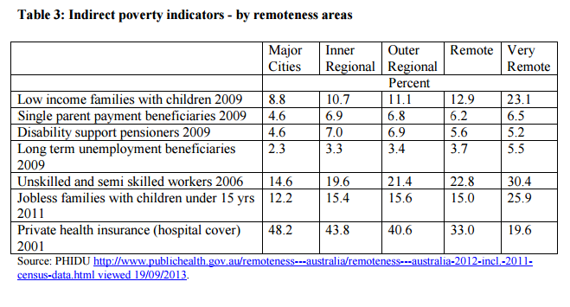
It is questionable whether regulated roaming would actually deliver competition benefits to these consumers, in the absence of significant ongoing public investment.
However, any improvement in competition would potentially provide relief to low-income consumers who are already struggling to meet their communications needs, while also allowing them to increase their engagement with digital services.

Scope of declared mobile roaming service

Geographic scope of the roaming service (question 30)
There is significant divergence among ACCAN members about whether roaming should be regulated. As a result, ACCAN does not support roaming at this point in time. However, there may be potential to mandate roaming in the future for future publically-funded coverage extensions where the government’s financial contribution exceeds a certain monetary threshold (for example 70%).
In the event that the ACCC does declare roaming, it should be restricted based on a comprehensive analysis of the negative effects on carrier investment in new coverage and upgrades to existing coverage (including capacity and speed improvements)

Technical scope of roaming service (questions 44, 45 and 46)
If the ACCC declares a service, it should be technology neutral (that is, it should not be limited to 3G or a similar future benchmark). In addition, roaming should cover all standard services currently used over the network including voice, data and SMS. In 2005, the ACCC justified not including data and SMS within a potential service description because of their “relative immaturity”. Today there would be no case to exclude data and SMS from roaming. This is particularly so for areas where there is no access to WiFi hotspots, and there are capacity issues with satellite services. Data is also important as voice calls are increasingly being conducted over data networks, either through OTT providers such as Skype, Facebook Messenger and WhatsApp, or as Voice over LTE services, such as those offered by Telstra.

Effect of declaration on incentives to invest

What are the incentives to invest? (questions 35 and 41)
There are several incentives for carriers to invest in areas of Australia with low population density. First, carriers are able to leverage coverage as a marketing tool to attract or retain customers. For example, Telstra often says that its “national coverage claim’ – that is, its substantially greater population coverage than Optus – is a key commercial asset.
Second, the growth in demand for data will benefit carriers through greater network use than was previously the case when customers only used their mobile phones for calls and SMS. People in regional Australia have a strong demand for data on the go and are willing to pay at least some kind of premium to ensure a high quality of service. There is a growing appetite for data for commercial needs, in particular across the agricultural sector where technology is used to track and report farming operations and in markets for livestock and equipment. The broader business market would also benefit from better mobile coverage just as businesses do in metropolitan areas. Regional tourist attractions and accommodation providers also have a strong demand for coverage when they visit for tourism.
Thirdly, a further incentive benefit for MNOs to invest is that it enables them to offer bundled services to customers. For example, an MNO may offer a mobile service together with fixed broadband, pay television, IoT devices, security systems and other products that are frequently bundled. However, bundling of these services may not be available in regional areas due to decreased choice of providers (for example, Telstra, Optus and Vodafone do not offer SkyMuster satellite services).
Traditionally, MNOs generally invest in new macro towers where it is likely to generate a return on investment. This means that there will need to be sufficient traffic to justify investment. In ACCAN’s Community Consultation Kit, we have outlined several factors that MNOs may consider when deciding whether there will be a return on investment. The following criteria were developed in consultation with industry and independent experts:
- The level of co-investment and in-kind support from all levels of government and the community,
- Communities with significant populations and/or expected high population growth,
- Communities adjacent to a major industrial or resources based project,
- Communities with a concentration of public facilities (schools, hospitals, libraries, police stations, fire stations) not currently serviced by high capacity networks,
- A community aligned with a significant Federal/State Government development policy such as the Regional Centres Development Plan, known as the “Super Towns” project in Western Australia,
- Communities close to proposed new infrastructure corridors, highways and transport routes,
- A community served by an existing digital community hub or resource centre.
There is little public information on the specific costs involved in extending a network into regional, rural and remote areas. The commercial decisions and strategies of each individual MNO are hard, if not impossible to predict and assess without access to commercially sensitive information. The value of the current inquiry is that it provides the ACCC with an opportunity to give greater scrutiny to this commercial information and to assess the legitimacy of public claims by rival networks. We have made suggestions as to what information would assist in these considerations in Appendix 1.
Many ACCAN members have strong concerns about the effect of roaming on incentives to invest. For example, there is concern that if roaming was declared, Telstra may no longer upgrade existing towers them with the latest speeds or invest in increased capacity. There is also concern that Telstra may consider not upgrading its backhaul in more remote areas to accommodate 4G because there is no commercial incentive. This would mean people in these areas will not be able to benefit from faster internet and more reliable voice called through advanced 4G LTE technology.
In addition, it is also not clear whether new mobile technologies, which provide faster speeds, will be able to achieve the same physical range as existing technologies (such as 3G). This is an important factor given the low population density and need for coverage over highways. It may be that increased government investment is needed to provide both high speeds and greater geographic coverage in rural and remote areas.

Price of declared service (questions 28 and 48)
If roaming were declared, , ACCAN questions whether access seeker MNOs would be prepared to pay the access price of a network in most areas that are below an economical threshold. The price is likely to be high, given that it must allow the access provider (generally Telstra) to recover its costs in providing the network. Additionally it may also compensate Telstra for the loss of part of its national coverage claim and for any additional costs that are required to make roaming technically feasible.
Assuming that Optus and/or Vodafone do pay for roaming, it is highly likely that consumers would pay for roaming access through increased plan pricing at a national level or through a surcharge when roaming. There is precedent for passing through increased costs in the international roaming market. It is unlikely that MNOs will simply absorb the costs. This increase in prices may cancel out any benefits that competition would ordinarily provide.
However, there is a narrow possibility that a new entrant with no infrastructure may enter the market and request access to roaming services. As noted above at page 12, TPG has recently purchased spectrum in regional areas. If the ACCC does decide to declare roaming on the basis of a potential new entrant, consideration should be given to a specific restricted time period to allow the new entrant to establish its own infrastructure.

Miscellaneous

Data sharing with ACMA and DoCA
ACCAN recommends that the ACCC share with the DoCA and the ACMA all the mobile coverage data that it has received from MNOs as part of the roaming inquiry process. Government has not collected any coverage data from MNOs since 2011. This data will be immensely useful to the DoCA’s Bureau of Communications Research and the ACMA when advising government about future policy approaches in this area. The data need not be made publically available.
New coverage reporting obligations
We recommend that the ACCC require that MNOs provide government with a new map every time new coverage is rolled out, with specific locations of new coverage. The current situation of manually logging onto MNO public websites to see if coverage has expanded is an unacceptable approach. As public MNO websites do not show historical coverage, having MNOs provide updated coverage data on an incremental basis would ensure that government can evaluate the effectiveness of government funding in expanding coverage, separate from MNO’s private investments.

Enhancing ACCC expertise in mobile services
Mobile sites are fundamental to communications along with the NBN, the Unbundled Local Loop, the Mobile Terminating Access Services and the proposed regulation of Superfast Broadband Access Services. Given the importance of mobile for all Australians, ACCAN urges the ACCC to develop and maintain strong engineering and technical expertise across mobile services in order to assess whether markets are operating effectively. This expertise should include an understanding of all inputs for mobile services including DTCS transmission, non-DTCS backhaul, microwave backhaul, satellite backhaul and engineering requirements for co-location and internal carrier approval process for co-location.

Appendix 1 – Data for assessing network investment
In order to determine whether roaming will affect incentives to invest, ACCAN notes that the following information which is not currently available would be required by the ACCC:
Existing roaming arrangements
- Specific geographical areas where Vodafone roams onto Optus
- Specific geographical areas where Vodafone roams onto Telstra
Carrier forward work plans for the next 3 years
- Carrier forward work plans with specific tower locations, indicating for each site:
  - The location of each site
  - What specifically the money will be spent on:
    - Additional coverage:
      - The amount of square kilometres to be covered
      - The amount of population to be covered
    - An upgrade for capacity (e.g. to allow 200 people to use a tower simultaneously instead of 100?)
    - An upgrade of technology (3G to 4G, 4G to 4GX)
    - An upgrade to backhaul that services a tower as well as local fixed line telephone system, ADSL and Telstra commercial fibre customers (i.e. the money will largely benefit non-mobile services).
Amount of money spent on increasing regional, rural and remote coverage in the last 3 years
- The number of square kilometers of:
  - additional coverage provided by MNOs in regional, rural and remote areas over the last 5 years
  - upgraded quality of service for existing sites (for example 3G to 4G)
  - additional capacity for existing sites and the level of public funding used to implement these improvements
Miscellaneous
- The number and location of any co-location requests at any carrier-owned or leased regional, rural and remote site that have been rejected in the last 10 years

Appendix 2 – Questions answered
1. How relevant have government funding programs been in assisting the MNOs in establishing their competitive positions in the mobile services market in regional areas? Please provide reasons for your view.
2. What is the extent of mobile network co-location of infrastructure (or infrastructure sharing) in:
a. regional Australia?
b. metropolitan Australia?
3. How effective is the facilities access regime in promoting access to mobile network infrastructure, in both regional and metropolitan areas? Are there any limitations of the facilities access regime in facilitating the expansion of mobile networks in regional Australia?
4. Would more extensive co-location requirements be an effective substitute for mobile roaming services?
5. To what extent does regulation of the DTCS, including through regulated pricing, assist MNOs in extending their mobile networks in regional Australia? Please explain your views.
6. Are international arrangements for the regulation of mobile roaming relevant to the Australian market? Please provide reasons for your view.
7. Where have international regulators made decisions not to regulate domestic mobile roaming services? Are such decisions relevant to the regulation of mobile roaming in Australia? Please provide reasons for your views.
8. What has been the impact of regulation of mobile roaming on competition and investment internationally? If possible, please outline whether it has impacted investment in regional and metropolitan areas to different extents.
11. Please describe any mobile roaming arrangements currently in place and whether such arrangements have changed since the previous inquiry? Are current arrangements or agreements limited in terms of geographic scope or technology, and if so how?
13. Are roaming agreements for areas where there is limited infrastructure based competition likely to be reached in the future? Please provide reasons for your views.
14. Is competition effective in the mobile services market and how does it differ in metropolitan and regional areas of Australia? Please provide evidence and reasons for your views.
15. How does Telstra’s coverage advantage in areas where it is the only MNO affect its ability to compete for customers in the national retail mobile services market? How does this compare to its ability to compete for consumers in regional areas? Please provide evidence and reasons for your views.
16. What are the key drivers of competition for mobile services in metropolitan and regional areas of Australia?
17. Is there any regional variation (e.g. price, inclusions, terms and conditions) in retail mobile services offered in Australia? If yes, please provide evidence to support your views.
18. How does the price and range of Telstra’s retail offers compare to those of other mobile service providers? Do you consider that the higher prices charged by Telstra in comparison to other mobile services on the market constitute a premium? What factors do you think contribute to Telstra’s ability to charge a higher price? Please provide information about the level of any premium and evidence to support your views.
19. Is the extent of competition for mobile services in regional areas likely to change in the future in the absence of declaration? Please provide reasons for your views.
20. How would declaration affect competition in markets for wholesale mobile services?
21. How would declaration affect competition for retail mobile services in regional areas and nationally? Please provide reasons and any available evidence for your views.
22. To what extent do consumers in regional Australia see Telstra as the most viable choice of service provider? If so, please provide an estimate of the proportion of such consumers and evidence to support your views.
23. To what extent do consumers in regional areas benefit from competition in the national retail mobile services market? Please explain your response.
24. What are the key factors that influence consumer choice of service provider in:
a. metropolitan areas?
b. regional areas?
25. How important is geographic coverage, as distinct from population coverage, to consumers living in metropolitan areas?
26. How important is geographic coverage to a mobile service provider’s ability to compete in the national market for mobile services?
28. How is declaration of a mobile roaming service likely to benefit consumers in regional areas and more generally? Is it likely to disadvantage consumers or any groups of consumers in any way?
30. How may the scope of the declared service (such as geographic scope and technologies to be included) affect the extent to which declaration of a mobile roaming service may promote competition in the relevant markets?
32. Do mobile networks in regional Australia exhibit natural monopoly characteristics? Please provide reasons to support your view. If so, what are the implications of this for the assessment of the effect of declaration on the efficient use of, and investment in, infrastructure?
34. What is the extent of the first mover advantage when extending into regional Australia? Has Telstra’s position as the incumbent provider (for both fixed and mobile services) provided it with advantages in building a mobile network in regional areas? Please provide reasons and evidence to support your views.
35. What are the incentives to build or extend a mobile network in areas of regional Australia where population density is low?
41. How would declaration affect the incentives of an access seeker to make investments in mobile infrastructure in order to:
a. extend their network coverage?
b. upgrade their existing network ?
Please provide evidence to support your views.
44. If the ACCC were to declare a mobile roaming service:
a. How should the service be described?
b. What would the appropriate geographic scope for the service be?
c. Should the service description be technology neutral or limited to certain technologies (e.g. 3G networks)? Please provide reasons for your views.
45. Should a declared mobile roaming service include mobile voice, SMS and data services?
46. Are there services that should be included or explicitly excluded? Please provide reasons to support your view.
48. How is the setting of a regulated price for a declared mobile roaming service likely to impact competition in the mobile services market? Would the costs of accessing a declared roaming service likely to be passed onto consumers by access seekers and if so, in what form (eg. higher retail prices)? Please provide reasons to support your view

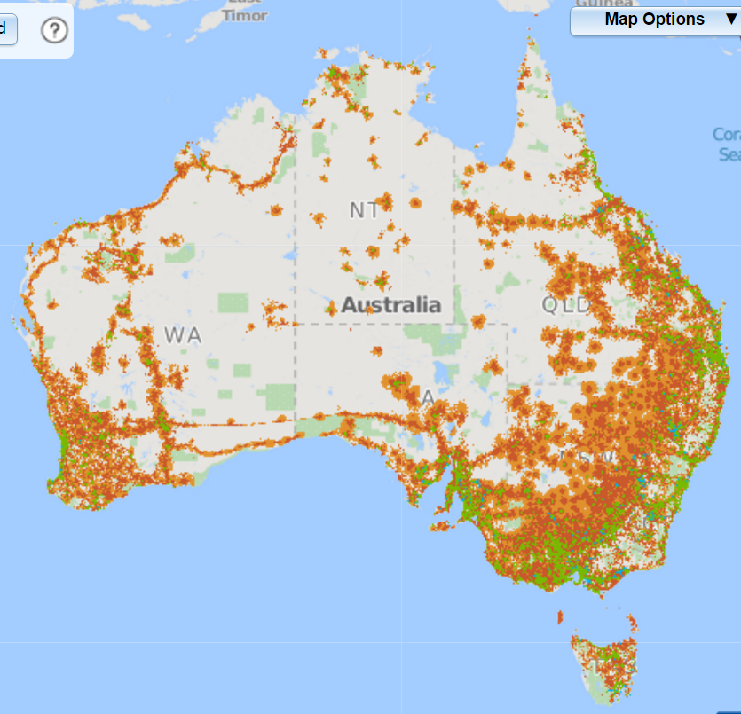
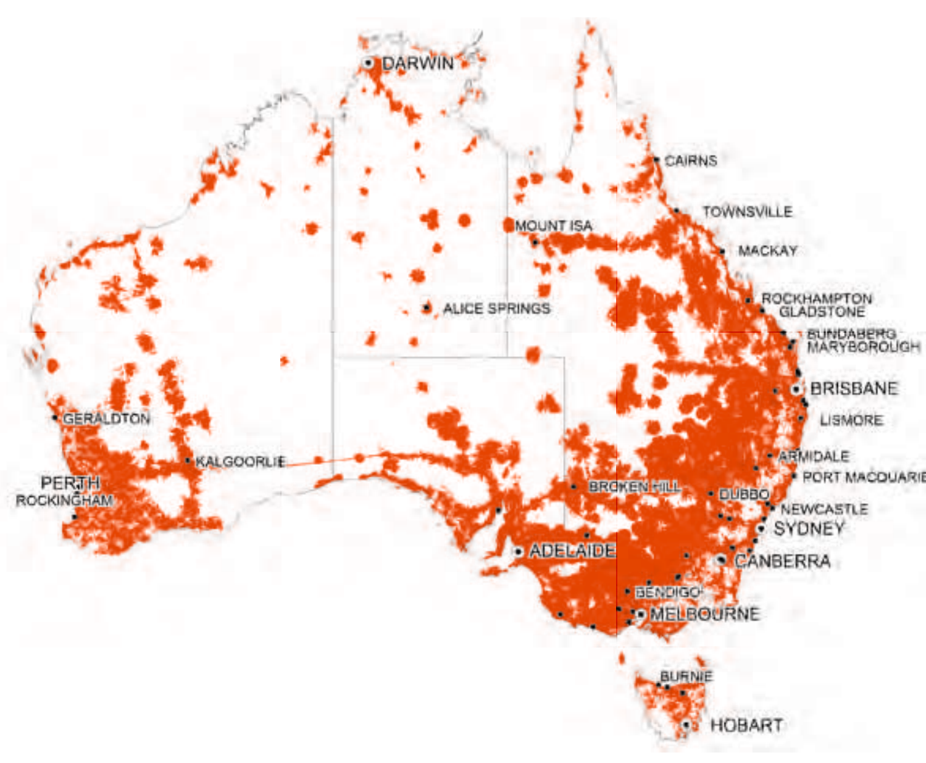
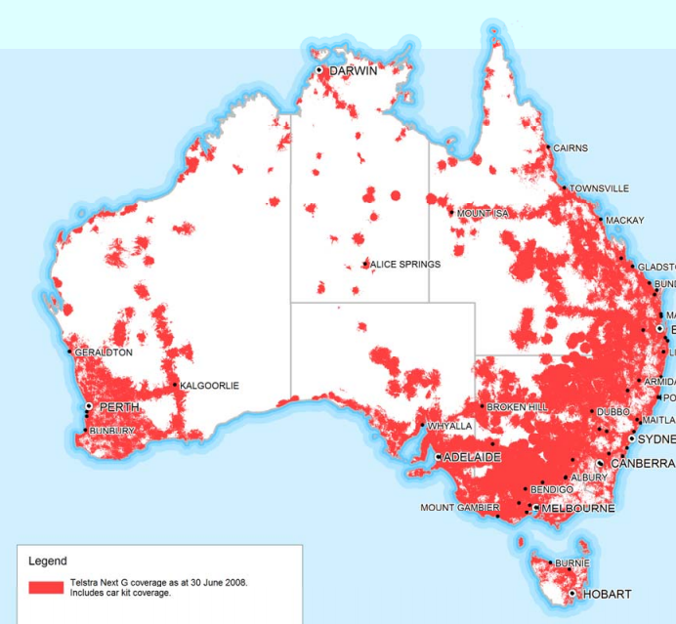
Figure 1: Telstra Coverage in 2006

Figure 2: Telstra Coverage in 2011

Figure 3: Telstra Coverage in 2016

2016 – Telstra Coverage
WA north west highway extension subsidized by $40 million contribution from WA Government (Telstra $66 million investment cash and in-kind) (see footnote 72).
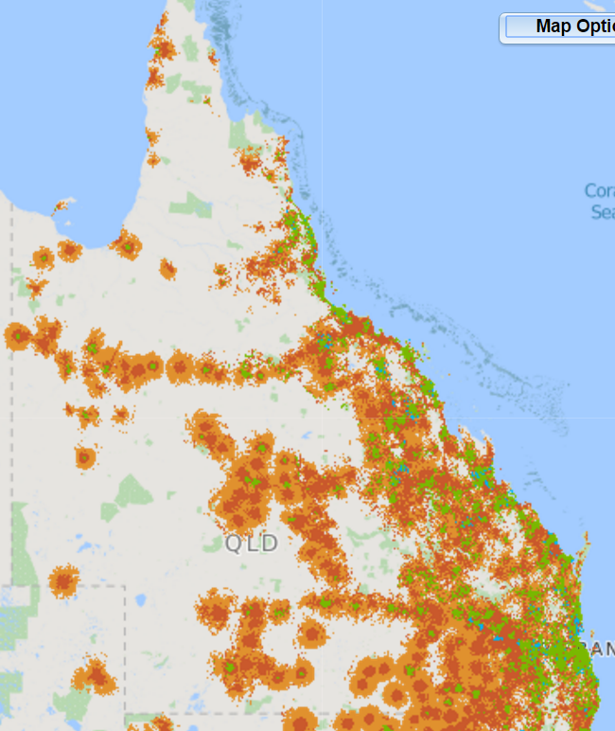
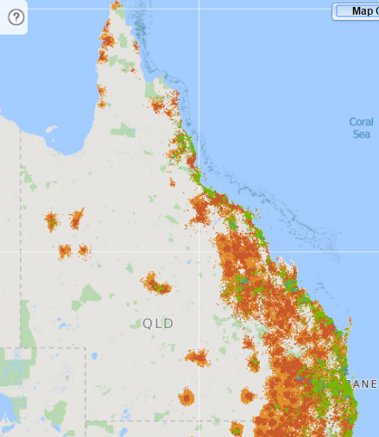
Figure 4: Telstra retail customer coverage - Queensland

Telstra Retail Customer Coverage - Queensland
Telstra MVNO Coverage (Aldi Mobile) - Queensland

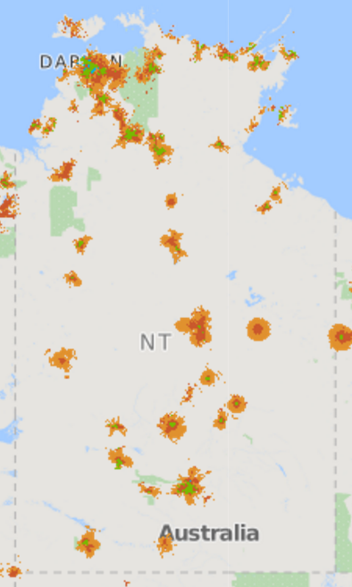
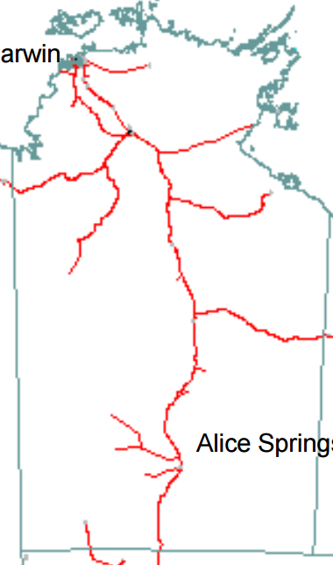
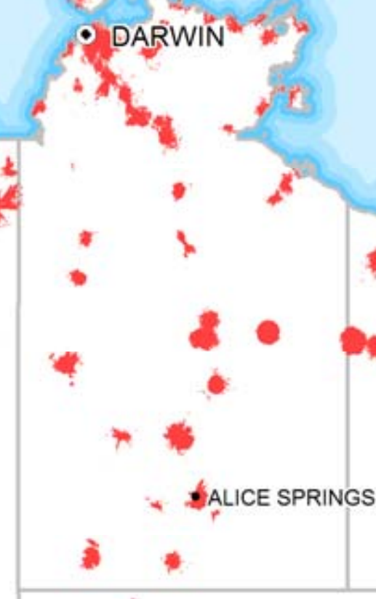
Figure 5: Telstra NT Fibre in 2001

Figure 6: Telstra NT Coverage in June 2006

Figure 7: Telstra NT Coverage in November 2016
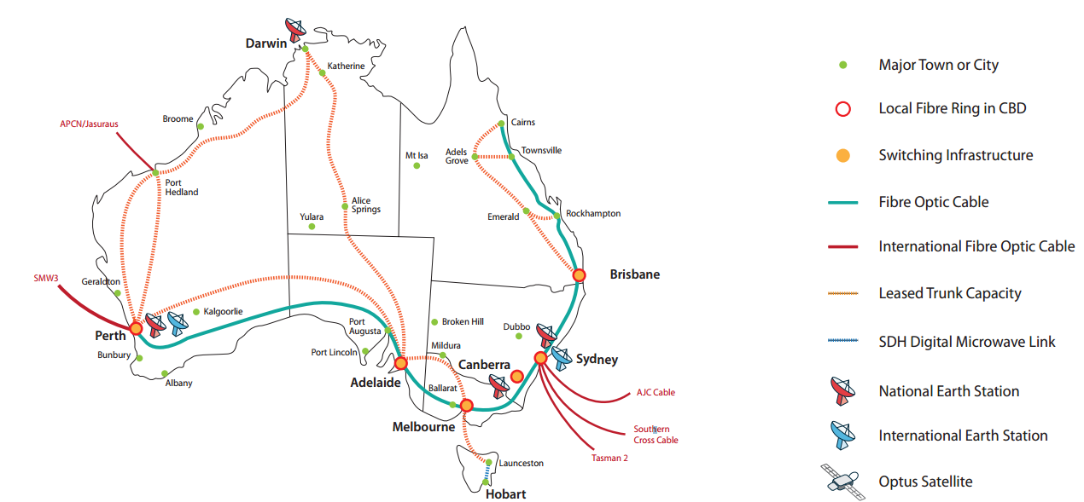
Optus owned and leased fibre - 2016

Figure 8: Optus owned and leased fibre as at 2016

Figure 9: Telstra Fibre Network - 2001

Figure 10: Telstra Coverage – Nov 2016

Figure 11: Telstra Coverage – June 2006

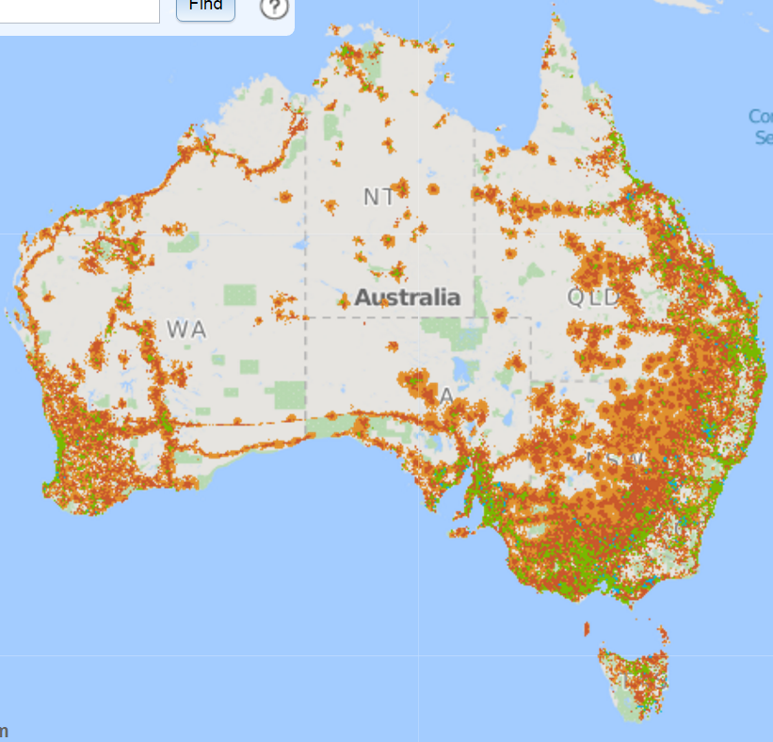
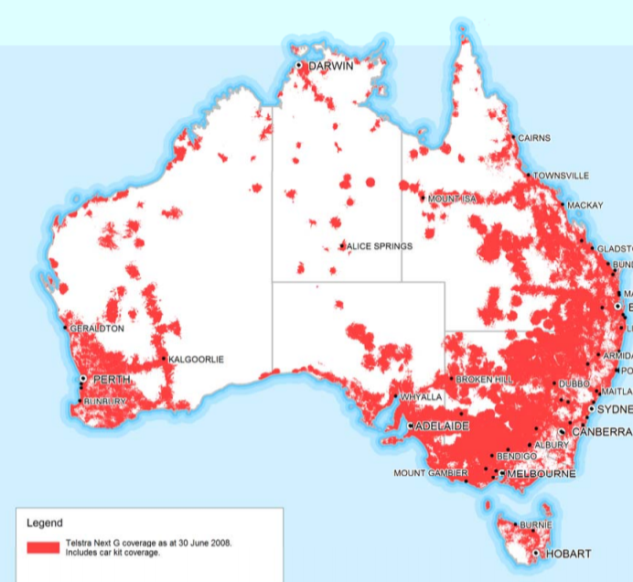
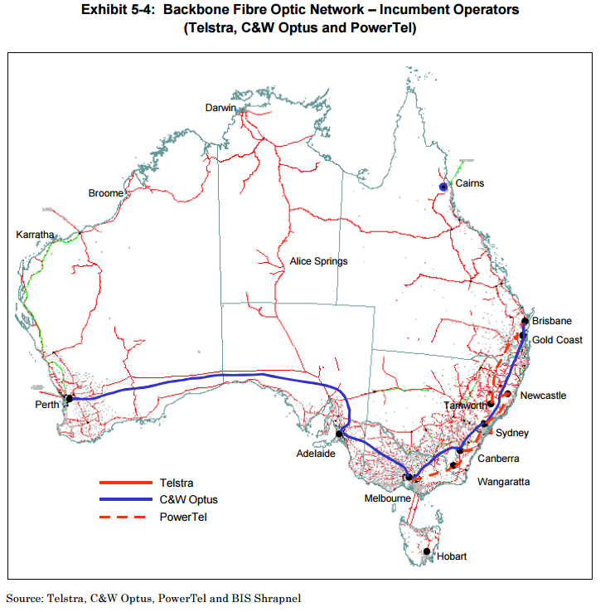

Broadband for the Bush Alliance, Submission to the RTIRC Review, 14 July 2015 at p. 2.
ACMA, ‘Regional Australians online’, 28 April 2016.
ACMA, ‘Australians get mobile’, 9 June 2015 at Figure 2.
nbnco, ‘Broadband satellite data boost’, 14 December 2015.
ACMA, ‘Regional Australians online’, 28 April 2016, at Figure 3. Mobile broadband means broadband through a tablet, laptop or wireless modem. It does not include mobile broadband through a smartphone.
Consultation with Isolated Children and Parents Association (Aust.)
ACCAN, ‘Guide to SkyMuster services’, 2nd ed., at page 9; Isolated Children’s Parents’ Association Qld Inc, ‘Applying for an nbn Sky Muster LTSS Service’, at page 1.
National Rural Health Alliance, ‘Submission to the Senate Inquiry into the Extent of Income Inequality in Australia Income inequality experienced by the people of rural and remote Australia’, October 2014 at page 5.
In these areas, commercial roaming arrangements and regulatory measures have increased competition in inner and outer regional mobile services markets. However issues involving new fibre and colocation have been significant impediments to better competition.
Liberal Party of Australia, ‘Turnbull Government commits $60 million to Mobile Black Spot Programme’, 24 May 2016.
Department of Communications and the Arts, Mobile Blackspots Program – Round 1.
Department of Communications and the Arts, Mobile Blackspots Program – Round 1.
Department of Communications and the Arts, Mobile Blackspots Program – Round 1.
ANAO, ‘ANAO Report No.10 2016–17 Award of Funding under the Mobile Black Spot Programme’, 1 September 2016 at page 9 at para [12].
See for example Western Australia’s, Regional Telecommunications Project (RTP) and the now completed Regional Mobile Communications Project: Department of Commerce WA, ‘Regional Mobile Communications Project completed sites’, last updated 2 June 2016; see also NT Media Release - Northern Territory’s $30m investment with Telstra in 2015 and Telstra Media Release,
ACCC, Discussion Paper on Inquiry into the declaration of a domestic mobile roaming service, October 2016 at page 17; See, for example, Vodafone and Telstra’s funding under the Spots Highway Initiative and Mobile Phones on Highways program: Peter Costello – Treasurer, ‘Queenslanders to get better mobile coverage on highways’, 15 August 2002, Telstra’s funding under the WA Government Wireless West programme, Commonwealth of Australia, Parliamentary Debates, Senate, 13 September 2005 (Senator Eggleston), at page 93.
Northern Territory’s $30m investment with Telstra in 2015 and Telstra Media Release.
Department of Broadband, Communications and the Digital Economy, ‘Mobile Connect’.
Department of Broadband, Communications and the Digital Economy, ‘Mobile Connect’.
Vodafone, ‘Vodafone builds on regional commitment with 32 new sites’, 30 May 2016.
Telstra, Submission to the Productivity Commission Issues Paper on Natural Disaster Funding Arrangements, 6 June 2014 at p.8.
Telstra, ‘Telstra 4G Small Cells Guide’, 25 November 2016, at p.7 (slide 3).
Mike Wright, ‘Telstra will build 429 new mobile towers in regional Australia’, Telstra Exchange.
Optus, ‘Optus lights up Northern Territory mobile coverage with innovative satellite small cell connectivity’, 25 August 2016.
Optus, ‘About Optus Satellite’, accessed 28 November 2016.
The Centre for International Economics, ‘Australia’s telecommunications market structure – the price premium paid by consumers - prepared for Vodafone Hutchison Australia’, June 2015, at p. 12.
James Hutchinson, ‘ Optus, Vodafone to build 500 joint sites’, 3 May 2012, itNews and Optus Media Release.
ACCAN conducted a search of the Radio Frequency National Site Archive on 1 November 2016. We found that Optus and Vodafone’s joint venture has now reached 4107 sites. It is not clear how many of these sites were in regional areas.
ACCC, ‘Competition limits advice for 1800 MHz spectrum in regional areas’, May 2015 at para [3.4.2]
Simon Thomsen, ‘The ACCC's just opened the door for mobile from Optus and Vodafone in regional Australia’ Business Insider Australia, 21 April 2016.
Department of Communications and the Arts, Mobile Black Spot Programme—round 2 guidelines, version 1.1 at p. 18 at para [5.4.4].
Telstra, Submission to the Productivity Commission Issues Paper on Natural Disaster Funding Arrangements, 6 June 2014, at p.8.
Vodafone, ACCC, ‘draft decision to vary Facilities Access Code - response to the ACCC’s draft decision’, 31 May 2013, at p. 2; SingTel Optus Pty Ltd, Optus Submission to the Facilities Access Code 1999 Review (public version), 24 August 2012 (Optus Submission on the Discussion paper) at p.1; Telstra, Response to the Commission’s Discussion Paper on the Facilities Access Code, August 2012, at p. 3.
ACCC, Final Decision An ACCC Final Decision to vary “A Code of Access to Telecommunications Transmission Towers, Sites of Towers and Underground Facilities (October 1999)”, September 2013, at p. 9.
Optus, Submission in response to Mobile Coverage Programme Discussion Paper, February 2014 at p. 9 at para [2.17].
Optus, Submission in response to Mobile Coverage Programme Discussion Paper, February 2014 at p. 9 at para [2.17].
Optus, Submission in response to Mobile Coverage Programme Discussion Paper, February 2014 at p. 9 at para [2.17].
The Centre for International Economics, ‘Australia’s telecommunications market structure - the price premium paid by consumers’, prepared for Vodafone Hutchinson Australia, June 2013 at page 12.
Clause 3.1.2(e) in Communications Alliance, ‘Industry Code C564:2011 Mobile Phone Base Station Deployment’, December 2011, at page 12.
AMTA, Submission to the Regional Telecommunications Infrastructure Review Committee Issues Paper, at p.9.
CRTC, Telecom Regulatory Policy CRTC 2015-177, 5 May 2015 at para [7] and para [10].
Final decision and interim pricing at: Canadian Radio-television and Telecommunications Commission, ‘Telecom Regulatory Policy CRTC 2015-177’, 5 May 2015. For pricing since May 2015, see: Canadian Radio-television and Telecommunications Commission,’ Follow-up to Telecom Regulatory Policy CRTC 2015-177 : 8638-C12-201505661’, page last updated 3 December 2015.
CRTC, Telecom Regulatory Policy CRTC 2015-177, 5 May 2015, at para [74].
CRTC, Telecom Regulatory Policy CRTC 2015-177, 5 May 2015, at para [194].
TPG, ‘TPG Telecom acquires 1800MHZ spectrum’, 5 February 2016.
CRTC, Telecom Regulatory Policy CRTC 2015-177, 5 May 2015 at para [66].
Vodafone, 'National Roaming'.
Vodafone, 'National Roaming' .
Optus, ‘Optus accelerates 3G and 4G expansion via extended site sharing arrangement’, 3 May 2012
Regional Telecommunications Independent Review Committee, ‘Regional Telecommunications Review 2015’ at p. 4.
https://www.southernphone.com.au/
https://www.bendigobanktelco.com.au/
Southernphone, ‘2015 Regional Telecommunications Review’, 14 July 2015,
Andrew Sadauskas, ‘Telstra opens its 4G network to MVNOs’, itNews.com.au, 28 April 2016
Vodafone, ‘VHA to take over Lebara’s Australian mobile business’, 13 September 2016,; Optus, ‘MNO and MVNO – When great partnerships zing’, 7 June 2016; Andrew Sadauskas, ‘Telstra opens its 4G network to MVNOs’, itNews.com.au, 28 April 2016
See for example ALDI Mobile Coverage map (Telstra MVNO).
The Centre for International Economics, ‘Australia’s telecommunications market structure - the price premium paid by consumers’, prepared for Vodafone Hutchinson Australia, June 2013,
The Centre for International Economics, ‘Australia’s telecommunications market structure - the price premium paid by consumers’, prepared for Vodafone Hutchinson Australia, June 2013, at p. 5.
The Centre for International Economics, ‘Australia’s telecommunications market structure - the price premium paid by consumers’, prepared for Vodafone Hutchinson Australia, June 2013, at p. 1.
Daniel Graham, ‘How much more does a Telstra plan cost?’, Choice, last updated 10 July 2016,
Daniel Graham, ‘How much more does a Telstra plan cost?’, Choice, last updated 10 July 2016,
Stuart Bird, ‘Choice gets it wrong with flawed comparison’, 10 July 2016, Telstra Exchange Blog.
ACMA.
Alcatel-Lucent, ‘National Broadband Network - Wireless and Satellite Access’ at p. 5.
ACCC, ‘Competition limits advice for 1800 MHz spectrum in regional areas’, May 2015 at para [3.4.2]
BIS Shrapnel, ‘Telecommunication Infrastructures in Australia 2001 A Research Report prepared for ACCC’, December 2001, at p. 83.
Telstra, Submission to the Productivity Commission Issues Paper on Natural Disaster Funding Arrangements, 6 June 2014, at p. 8.
BIS Shrapnel, ‘Telecommunication Infrastructures in Australia 2001 A Research Report prepared for ACCC’, December 2001, at page 83.
Optus, ‘Broadband Network’.
Available here and here.
Consultation with Indigenous Remote Communications Association.
Western Australia’s, Regional Telecommunications Project (RTP) and the now completed Regional Mobile Communications Project: Department of Commerce WA, ‘Regional Mobile Communications Project completed sites’, last updated 2 June 2016.
Penny Griffin, ‘Broadband in the Bush Presentation 20150716’ at page 2.
Prime Minister and Cabinet Ministers, ‘Regional Telecommunications boost for Central West Queensland’, 26 October 2016.
Telstra, ‘Telstra 4G Small Cells Guide’, 25 November 2016, at p.7 (slide 3).
Broadband for the Bush Alliance.
National Farmers Federation, ‘National Farmers’ Federation Submission to the Productivity Commission Review into the Telecommunications Universal Service Obligation: Issue Paper’, July 2016, at page 11
Indigenous Remote Communications Association and the Centre for Applied Technology.
Consultation with RDA Central West, AMSANT.
NSW Farmers Federation and Indigenous Remote Communications Association.
Parawa Agricultural Bureau.
Consultation with AMSANT, NSW Farmers Federation, Indigenous Remote Communications Association, Isolated Childrens and Parents Association (Aust).
Example provided by the Centre for Applied Technology.
Consultation with Parawa Agricultural Bureau.
Regional Development Australia Central West is a state and Commonwealth funded non-profit organization responsible for the economic development and long term sustainability of the NSW Central West.
Infrastructure Australia, ‘NRSF Round 3 – Successful applications’, available at page 1.
Consultation with Isolated Childrens and Parents Association (Aust) and National Farmers Federation.
Consultation with Aboriginal Medical Services Alliance Northern Territory (AMSANT), Centre for Applied Technology, Cotton Australia, Indigenous Remote Communications Association, National Farmers Federation, NSW Farmers Federation, Broadband for the Bush Alliance.
SACOSS and ACCAN, ‘Connectivity Costs - Telecommunications Affordability for Low Income Australians’, November 2016 at p. 11.
National Rural Health Alliance Inc, ‘Submission to the Senate Inquiry into the Extent of Income Inequality in Australia Income inequality experienced by the people of rural and remote Australia’, October 2014 at page 5.
ACCC, ‘Mobile Services Review Mobile - Domestic Inter-carrier Roaming Service - Draft decision on whether or not the Commission should declare a mobile domestic inter-carrier roaming service’, October 2004, at p. 15.
Consultation with NSW Farmers Federation and Broadband for the Bush Alliance.
Mike Wright, 16 September 2016, Telstra Exchange Blog.
Consultation with Central West RDA, Isolated Childrens and Parents Association (Aust.), NSW Farmers Federation.
ACCAN, ‘Community Consultation Kit’, 2nd ed., p.13.
Consultation with Indigenous Remote Communications Association.
See for example ACCC, ‘Mobile Services Review International inter-carrier roaming’, September 2005 at page 15 at para 4.1;
ACMA, ‘Communications Report 2010-11’ at p. 38.
Given the importance of highway coverage, population coverage based on residential location is not useful on its own.
Telstra coverage map as at 1 November 2016.
ACMA, ACMA Communications report 2010–11, at page 38.
ACMA and ACCC, ‘Communications Infrastructure and Services Availability in Australia 2008’ at p. 27.
Aldi Mobile Coverage Map as at November 2015.
Telstra Coverage Map as at November 2016.
Telstra Coverage Map as at November 2016.
BIS Shrapnel, ‘Telecommunication Infrastructures in Australia 2001 A Research Report prepared for ACCC’, December 2001, at page 83.
ACMA and ACCC, ‘Communications Infrastructure and Services Availability in Australia 2008’, at page 27.
Optus, Optus Wholesale, at p.3.
BIS Shrapnel, ‘Telecommunication Infrastructures in Australia 2001 A Research Report prepared for ACCC’, December 2001 at page 83.
Telstra Coverage Map as at November 2016.
ACMA and ACCC, ‘Communications Infrastructure and Services Availability in Australia 2008’, at page 27.

