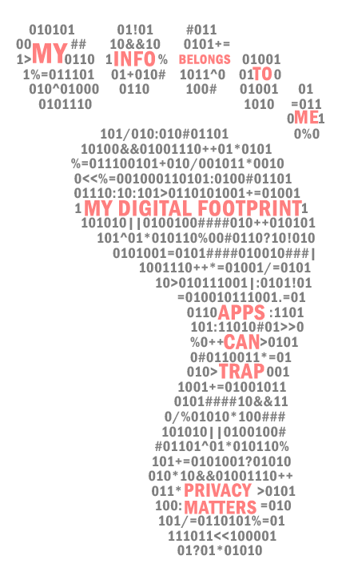
Children’s digital privacy – what are the risks? (summary)
DID YOU KNOW?
• Many popular children’s apps collect information about the children that use them.
A lot of this information is sold on or shared with third parties.
- Some of the information that apps collect is useful for the app to function, or to help the developer improve the app – but often the reason is to collect as much information about the user as possible. This is called data mining, and it is very big business.
- There are no child-specific laws or rules in Australia to protect your children’s privacy online.
WHAT INFORMATION DO APPS COLLECT?
The most common types of information that children’s apps collect are:
- Personal information like your name, address, email and age.
- Online activity. This is often called your Advertising ID and will give an app access to the things you do online. For example, what you like or share on Facebook, or what you buy or search for online.
- Camera and microphone. These can be used to listen to your voice and see through your camera.
- Location. Sometimes not just whilst you are using the app but tracking everywhere you go with the device.
- Gameplay. Records behaviour when playing a game.
- Photos. Access to the photos and videos stored on your device.
- Contacts. Your friends and family’s details or your social network contacts.
WHAT ARE THE RISKS FOR CHILDREN?
- Identity theft and fraud. The more information collected about your child over time means they become more vulnerable to identity theft and fraud as they get older. Data breaches are very common.
- Online Predators. The more personal information about your child that can be accessed online, the more vulnerable they become to being targeted by online predators.
- Psychological Exploitation. Children don’t have the developmental capacity to understand the persuasive power of targeted advertising. This makes them more vulnerable to manipulation from advertisers. When teenagers start spending money online, the risk of fraud also increases.
- Digital Addiction. The more time your children spend on any platform (especially games and social media), the more information can be gathered about them. Developers use persuasive design and algorithms based on your child’s activity to make their platforms absorbing (i.e. ‘sticky’) and addictive. Digital addiction is linked to poor academic performance, low self-esteem, anxiety, stress and depression.
- Digital Footprint. Children don’t have any control about how their digital footprint may be used in the future. It’s important to think about how their online information could be used to shape, influence and impact their future lives and prospects.
****************************
Produced in partnership with the  Macquarie University  Department of Psychology. | ACCM acknowledges the support of the  Australian Communications Consumer Action Network (ACCAN) which funded the research for, and publication of, this document.

