Tuesday, 20th November 2018
Bush communications coalition welcomes report into rural and regional NBN
The Regional, Rural and Remote Communications Coalition (RRRCC) welcomes the recommendations of the Joint Standing Committee on the National Broadband Network’s inquiry into the rollout of the NBN in rural and regional areas.
In December 2017, the bipartisan committee announced that it would conduct a review of the NBN, focusing on the capacity and reliability of NBN satellite, fixed wireless and fixed line networks.
The RRRCC is pleased to see that the Committee has taken on board the concerns of regional Australia, and applauds recommendations that Sky Muster services be customised to meet the consumer needs. The RRRCC notes that these echo initiatives recently announced by NBN, including the announcement of NBN Sky Muster Plus and a Sky Muster Business Enterprise Plan.
“The Coalition has long been calling for Sky Muster satellite services that are fit for purpose,” said ACCAN Director of Policy, Una Lawrence. “These recommendations, along with the new NBN product announcements are a considerable step in the right direction and we look forward to their arrival early next year.”
Other positive recommendations are better public information about fixed wireless congestion, and published mapping of each NBN technology footprint, as well as options for moving from satellite to fixed wireless where available.
NSW Farmers President James Jackson acknowledges the recommendations aimed at alleviating congestion on fixed wireless towers are a step in the right direction.
“Regional customers have been impacted by fixed wireless congestion due to a higher than anticipated migration to this product. While this is positive, it now requires NBN to take requisite measures to balance this inequality on fixed wireless and ensure an effective and reliable broadband service. “
One of the key concerns that the RRRCC and its members raised in the consultation process is the need for long-term planning when it comes to the communications needs of regional Australians.
“ADSL and copper services are very important for regional, rural and remote consumers. As the future of ADSL services is uncertain, we applaud the Committee’s call to gather data on the number of ADSL users in the Sky Muster footprint so that they can consider these consumers before undertaking future plans for the NBN,” Ms Lawrence said.
“Regional, rural and remote Australians deserve to be able to expect the same level of reliability of service as their metropolitan counterparts; to ensure this occurs it is important that the Federal Government continues to consult with members of the community to identify their needs and create long-term plans to safeguard against future issues,” said National Farmers' Federation CEO Tony Mahar.
The RRRCC also urges the Federal Parliament to pass legislation currently before it that would create guaranteed access to broadband for all premises. Additionally, it is important that regional services are appropriately and sustainably funded in the longer term.
The RRRCC will be monitoring the Federal Government’s response to the Joint Standing Committee on the National Broadband Network’s report on the rollout of the NBN in rural and regional areas.
Member organisations:
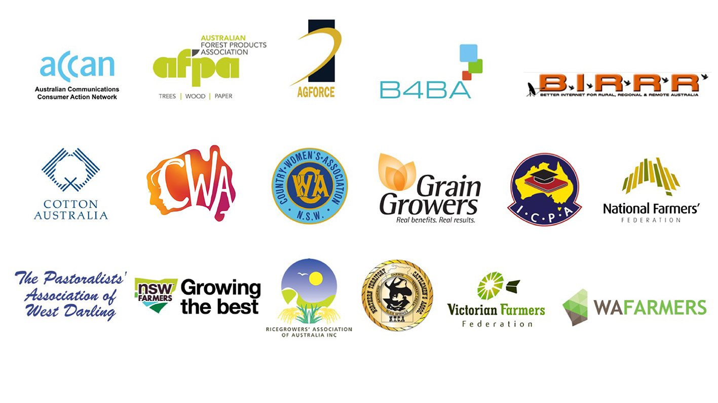

Members of the Coalition are:
  - ACCAN
  - AgForce Queensland
  - Australian Forest Products Association
  - Better Internet for Rural, Regional & Remote Australia
  - Broadband for the Bush Alliance
  - Cotton Australia
  - Country Women’s Association of Australia
  - Country Women’s Association of NSW
  - GrainGrowers
  - Isolated Children’s Parents’ Association
  - National Farmers’ Federation
  - Northern Territory Cattlemen’s Association
  - NSW Farmers
  - The Pastoralists' Association of West Darling
  - Ricegrowers’ Association of Australia
  - Victorian Farmers Federation
  - WA Farmers

