Small Business

Understanding your options for broadband connection
With so many options on the market it can be confusing and challenging to choose a broadband service that suits your business. The information below aims to help you understand the available broadband options for small businesses so you can make the best choice for the operational needs of your business.

What products are available?
The product you choose should be the one that best matches your usage requirements. If your business operates in a single location and only needs the internet for email and a small amount of web browsing, then a standard consumer grade retail plan will be fine. However, if your needs are more complex or you have a high demand for reliable high speed services then it may be worth engaging someone to do a full assessment of your telecommunications needs on a commercial basis.

Digital Subscriber Line (DSL)
Digital Subscriber Line (DSL) technologies are the most commonly available broadband connection type in Australia today. DSL enables high speed data transmission over copper wire telephone lines. DSL comes in a range of types according to upload and download data rates, often referred to as the ‘speed.’ The actual performance will also depend on how long the copper wires are between your premises and the service provider’s equipment as well as the quality of those wires.
Table 1 DSL types perform differently
DSL Type | Max send rate  (upload) | Max receive rate  (download) | Max distance
ADSL | 800 Kbps | 8 Mbps | 5.5 km
ADSL2 | 1 Mbps | 12 Mbps | 2.5 km
ADSL2+ | 2 Mbps | 24 Mbps | 2.5 km
HDSL | 1.54 Mbps | 1.54 Mbps | 8.8 km
SDSL | 2.3 Mbps | 2.3 Mbps | 6.7 km
VDSL | 16 Mbps | 52 Mbps | 1.2 km
VDSL2 | 1-4 Mbps | 50-250 Mbps | 0.5-1 km
(Note: Mbps refers to megabits per second and is a measure of the amount of data that can be sent each second over a communications link).
In a DSL system the amount of data that can be transferred drops rapidly as the distance increases. Which type of DSL is best for your business depends on how much data you need to upload and download and the distance of your premises from the service provider’s equipment, usually located at the nearest Telstra exchange. Alternatively, this equipment may be located in the basement of your building. Unfortunately, the data rate you are able to receive is difficult to determine without connecting an actual service as the quality of copper wire installed across Australia varies.

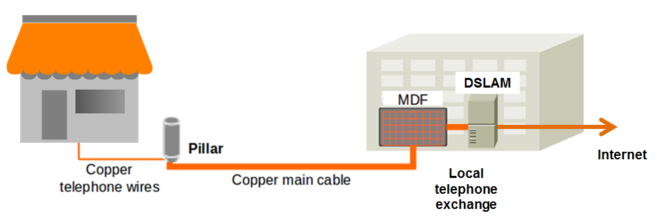
The basic components of a DSL service are a modem on your premises which connects to the main distribution frame (MDF) and then to the service provider’s DSL Access Multiplexor (DSLAM).
Although DSL is widely available across Australia, some premises cannot be connected because of their distance from a telephone exchange or poor quality copper wire. The suitability of the line will be determined by your service provider. Another potential issue is the lack of an available DSL port at the exchange.

ADSL
Asymmetric DSL (ADSL) is provided over the existing telephone wires, and includes a traditional fixed line telephone number. This means that a single telephone connection can be used for both broadband access and phone calls at the same time. ADSL offers download speeds of up to 8 Mbps (ADSL 1) or 20 Mbps (ADSL 2+).

Naked DSL
Naked DSL is an ADSL service installed on the copper telephone wires that doesn't have a standard telephone service associated with it. It is particularly suitable for businesses that only use mobile phones, or for those using Voice-over-Internet Protocol (VOIP) services like Skype. This product is not available from all service providers.

VDSL
Very high data rate DSL (VDSL) is a short range, high data rate system. It is also the basis for ‘Fibre-to-the-Basement’ (FTTB) or ‘Fibre-to-the-Node’ (FTTN) systems. For the highest possible speeds it is necessary to have your equipment located within 200m of the service provider equipment.

HDSL, SDSL
High data rate DSL (HDSL) and Symmetric DSL (SDSL) are other types of DSL available and suitable where your business uploads a lot of data. This might be the case where you are offering high quality streaming video services.

Bonded DSL
Bonded DSL refers to systems where multiple pairs of copper wire are used. In this way the capacity of the link is increased.

Hybrid Fibre Coaxial (HFC) Cable
Originally installed for Pay TV services, Hybrid Fibre Coaxial (HFC) cable broadband services (usually just called ‘Cable’) are provided in Australia by Optus and Telstra and in some private housing estates by other private operators. HFC services currently provide download speeds up to 100 Mbps. The speed you get in reality will depend on the number of your neighbours also using the network at the same time, the quality of the cables and the version of the system in use.

Fixed wireless
Fixed wireless broadband involves installing an antenna on your premises in a position where it always has ‘line of sight’ access to the service provider’s transmission tower. In some cases this uses the same technology as mobile phone networks.

Satellite
In rural and regional areas, as well as premises on the suburban fringe or in other ‘black spots,’ the lack of ADSL, cable or line of sight wireless access will mean that satellite delivery is the only option for broadband services. This will require the professional installation of an accurately aligned dish antenna.

3G/4G mobile broadband
This is typically an expensive way to access a broadband service, but mobile broadband is often available where many of the other options are not. It can be provided via a dongle/SIM card (one device) or a wireless router that you can connect several computers or other devices to. 4G speeds are quite fast and compare well with ADSL2+. If your business relies on mobility or you move locations, you can take your broadband with you as long as it’s still within the service provider’s network footprint.

Optical fibre
'Optical fibre' and 'fibre optic' cables are the same thing and are usually just called 'fibre.’ This technology provides the backbone for Australia's national and international telecommunications, but can also be connected to individual premises.
Fibre can provide broadband speeds at extremely high data rates. For residential services, however, data rates of up to 2.5 Gbps (gigabits per second) and beyond are possible, but most customers connected directly with fibre today will initially receive less, for example 100 Mbps download speeds.

Fibre-to-the-Node
Fibre-to-the-Node (FTTN) uses fibre optic cable that runs from a telephone exchange to a cabinet (node) in a local neighbourhood. Connecting this to your business is achieved using the existing copper wire in the street and into your premises. Typically, a FTTN cabinet serves a few hundred customers in a radius of about 1.5km. FTTN services provided by the NBN will initially offer lower range speeds, but higher speeds should become available as the service matures.

Fibre-to-the-Premises
Fibre-to-the-Premises (FTTP) connects directly to your premises; it does not need to use the existing copper wire to reach your building. Most NBN customers who are connected via FTTP will have access to speeds of 100 Mbps.

Other fibre combinations
Your provider may offer other combinations such as Fibre-to-the-Kerb (FTTK) or Fibre-to-the-Basement (FTTB). This simply means the high capacity optical fibre connects at a different point along the way to the service provider equipment that distributes the signal to you.

National Broadband Network (NBN)
The National Broadband Network (NBN) is intended to provide fast broadband for all Australians. Network construction commenced in 2011, and some Australian premises are already connected using fibre optic cable. Future connections will be provided using fibre in combination with one or more of the technologies described above.

